



[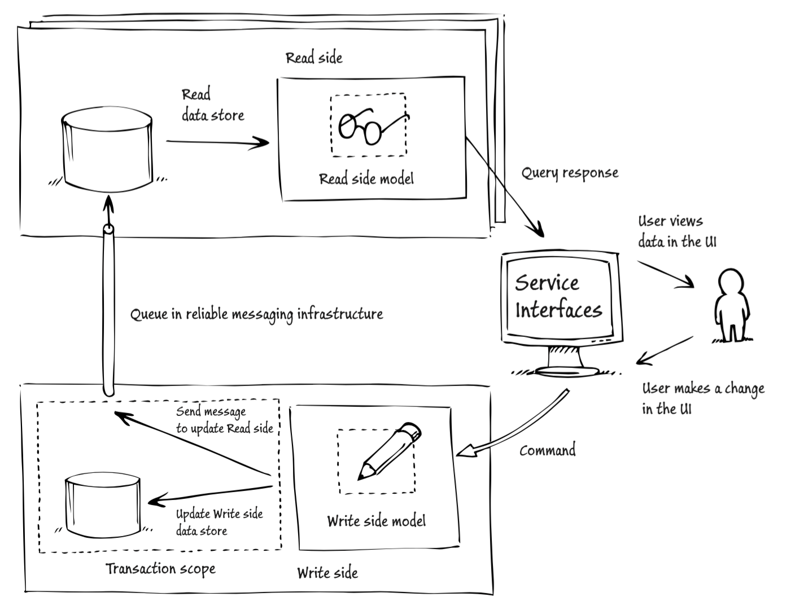](https://www.google.be/url?sa=i&rct=j&q=&esrc=s&source=images&cd=&cad=rja&uact=8&ved=2ahUKEwjlg5OgsabfAhVHL1AKHaawAacQjRx6BAgBEAU&url=https://blog.codecentric.de/en/2016/08/cqrs-es-akka/&psig=AOvVaw2puXOdI9p5-EOJUV1an7rx&ust=1545119582455866)

CQRS in Practice

**By Emmanuel Nuyttens – December 2018**

**Senior .NET & Azure IoT Solutions Architect - Connected Company - Realdolmen**

|  |  |  |
| --- | --- | --- |
| History | | |
| Date | Description | Version |
| 18/12/2018 | Initial version | 0.1 |
| 18/12/2018 | Task-based interface | 0.2 |
| 19/12/2018 | Commands and queries in CQRS | 0.3 |
| 19/12/2018 | Update doc module 4 | 0.4 |
| 20/12/2018 | Appendix C and D | 0.5 |
| 23/12/2018 | Recap commands and queries | 0.6 |
| 04/01/2019 | Refactor GetListQueryHandler to Dapper | 0.7 |
| 05/01/2019 | Separate Read Model | 0.8 |
| 14/01/2019 | State driven projections | 0.9 |
| 18/01/2019 | Event driven projection , Summary | 1.0 |

Contents

1. Introduction 3

2. Course Outline 5

3. Module-1 : CQRS, its origin and benefits 6

3.1. Introduction to CQRS and CQS 6

3.2. Why CQRS ? 9

3.2.1. Scalability 9

3.2.2. Performance 10

3.2.3. Simplicity 10

4. Module-2 : Introducing a CRUD-based Sample Project 11

4.1. Introduction and Domain Model 11

4.2. The CRUD API 12

4.3. UI Example 12

4.4. Application Code Introduction 13

4.4.1. Logic Project 13

4.4.2. Api Project 16

4.4.3. Database 25

4.5. Application Code Drawbacks 27

5. Module-3: Refactoring Towards a Task-Based Interface 34

5.1. Introduction 34

5.2. CRUD-Based Interface 34

5.3.1. Definition 34

5.3.2. Problems with CRUD-based Interface 35

5.3. TASK-Based Interface 39

5.3.1. Definition 39

5.3.2. Untangling the Update Method from the CRUD-Based implementation 40

5.3.3. Recap: Untangling the Update Method 49

5.3.4. Refactor to TASK-based User Interface 50

5.3.5. Dealing with Create and Delete Methods 54

5.3.6. Recap 57

6. Module-4: Segregating Commands and Queries 57

6.1. Introduction 57

6.2. Introducing a First Command 58

6.2.1. Inspecting the GetList endpoint 58

6.2.2. Inspecting the Register endpoint 59

6.2.3. Inspecting the remaining endpoints 59

6.2.3. General rule for REST 59

6.2.4. Separate classes for Commands and Queries 60

6.3. Command in CQS vs. Command in CQRS 66

6.4. Commands and Queries in CQRS 67

6.5. Commands and Queries in the Onion Architecture 70

6.6. Commands vs. DTOs 71

6.7. Leveraging ASP.NET Core Dependency Injection to Resolve Handlers 73

6.8. Introducing a Query 75

6.9. Finish up the Refactoring 79

6.9.1. Register 80

6.9.2. UnRegister 81

6.9.3. Enroll 83

6.9.4. Transfer 85

6.9.5. Disenroll 87

6.9.6. Some final Refactorings 89

6.10. Recap: Introducing Commands and Queries 90

7. Module-5: Implementing Decorators up Command and Query Handlers 90

7.1. Introduction 90

7.2. Cross-Cutting concern requirement : Resilience 90

7.3. Introducing a Database Retry Decorator 92

7.4. Introducing an Audit Logging Decorator 93

7.5. Streamlining the Decorator Configuration 94

7.5.1. Drawback of Current Implementation 94

7.5.2. Create a Handler Registration Class 95

7.5.3. The AuditLog and DatabaseRetry Attribute classes 100

7.5.4. Replace of UnitOfWork 101

7.5.5. Test Decorator Attributes 102

7.6. Dependency Injection Framework Alternative 102

7.7. Decorators vs. ASP.NET Middleware 103

8. Module-6: Simplifying the Read Model 103

8.1. Introduction 103

8.2. The State of the Read Model 103

8.3. Separation of the Domain Model 107

8.4. Simplifying the Read Model 110

8.4.1. Define the ConnectionString Settings Class 110

8.4.2. Refactor the Startup.cs ConfigureServices Method 110

8.4.3. Update the appSettings.json file 111

8.4.4. Refactor the SessionFactory class 111

8.4.5. Refactor the GetListQueryHandler 112

8.4.6. The Read Model and the DDD Onion Architecture 114

9. Module-7: Introducing A Separate Database for Read-Side 116

9.1. Introduction 116

9.2. Scalability vs Performance 117

9.3. Master Storage vs Queries Storage 118

9.4. Separation at the Data Level in the Real World 118

9.5. Designing a Database for Queries 120

9.6. Creating a separate database for Queries (Read-Side) 123

9.7. Scalability 125

10. Module-8: Synchronizing the Commands and Queries Database 127

10.1. Module Content 127

10.2. Introduction 127

a. State-driven projections 128

i. Database Trigger Synchronization 130

ii. Domain model based Synchronization 131

b. Synchronous State-Driven projections 132

c. Examples of Synchronous and Asynchronous Projections 133

d. Event-driven Projections 133

e. Consistency 134

f. Eventual Consistency 135

g. Versioning 136

h. CQRS and the CAP Theorem 137

11. Module 9: CQRS Best Practices and Misconceptions 139

11.1. Introduction 139

11.2. CQRS and Event Sourcing 139

11.3. Evolutionary Design 140

11.4. Using Commands and Queries from Handlers 141

11.5. One-Way Commands 143

11.6. CQRS vs. the Specification Pattern 143

12. Course Summary 144

Appendix A : Brief Introduction to MVVM Architecture Pattern 145

Appendix B : WPF User Interface Explained 147

Appendix C : CQRS in Context of DDD 149

Introduction 149

What is Domain Driven Design (DDD) ? 150

Domain-driven design: concepts and terminology 151

Domain model 151

Ubiquitous language 151

Entities, value objects, and services 152

Aggregates and aggregate roots. 153

Bounded contexts 153

Anti-corruption layers 154

Context maps 154

Bounded contexts and multiple architectures 154

Bounded contexts and multiple development teams 156

Maintaining multiple bounded contexts 156

CQRS and DDD 156

Appendix D : Introducing the Command Query Responsibility Segregation Pattern 157

What is CQRS ? 157

Read and Write Sides 158

CQRS and domain-driven design 159

Introducing commands, events, and messages 160

Important difference between commands and events 160

Separate data stores for the read and for the write side 161

Why should we use CQRS ? 161

Scalability 162

Reduced complexity 162

Flexibility 163

Focus on the business 163

Facilitates building task-based UIs 163

Barriers to adopting the CQRS pattern 164

When should I use CQRS? 164

When should I avoid CQRS? 164

Summary 164

# Introduction

The CQRS[1] pattern has become quite popular in the concept of Domain Driven Design. This course will set the basics on how to apply CQRS in a real-world application.

CQRS is pattern which “separates” the “read-side” (queries) from the “write-side” persistence through command-handlers, this to make applications both more performant and more scalable. In this course we will see next:

* Should (and when) we use CQRS with event sourcing ?
* Should you always have separate databases for “reads” and “writes” ?
* How to implement “command-handlers” using modern frameworks like ASP.NET Core.
* Should you make the synchronization between “reads” and “writes” asynchronous ?

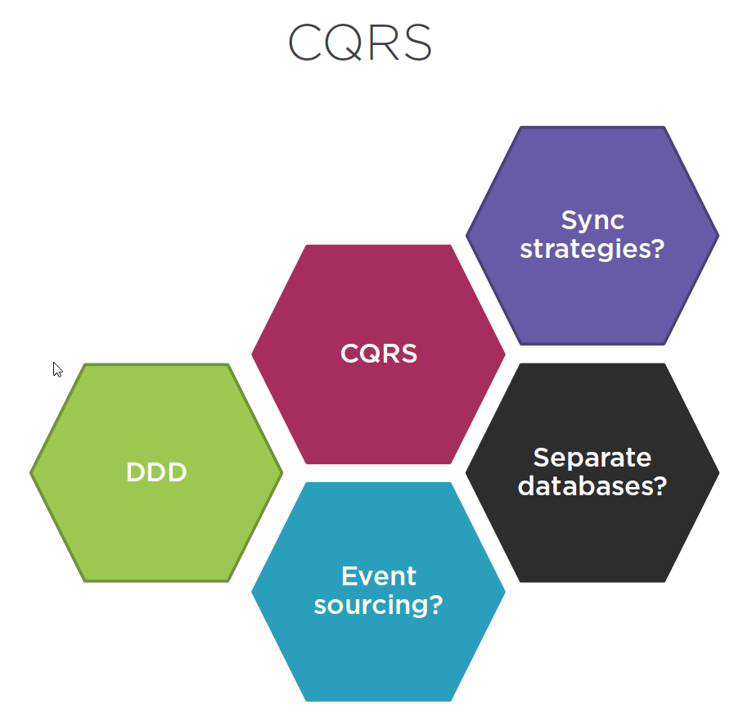

This course will try to answer all this questions and more. We will discuss things like: (among others …)

* Refactoring towards “task-based” interface.
* Implementing command and query.
* Extracting a separate data storage.
* Common best practices.

We will try to understand the main principles of CQRS, what CQRS pattern really is, the benefits that it can provide for our projects, when to use it and when not …

We will see a “detailed” step-by-step process of implementing this pattern in practice through a sample project.

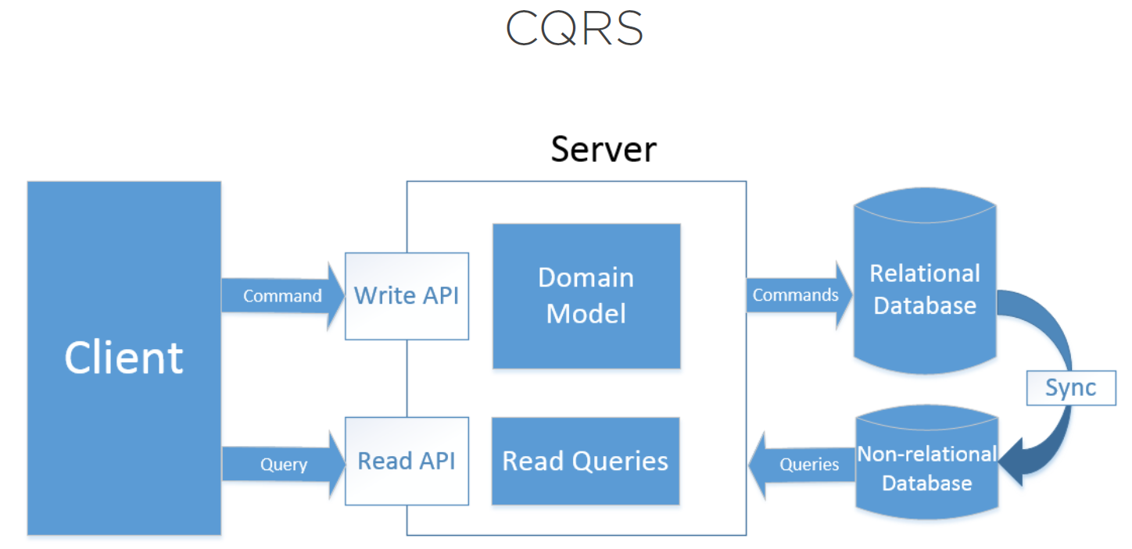

The image above shows what CQRS is all about. It has some core concepts:

* Separate read and write model.
* Read-model contains queries.
* Write-model contains commands/events.
* Read-model is typically stored in a “de-normalized” non-relational database (NoSQL type database).
* Write-model is typically stored in a “normalized” Relational-database.
* Read-model should be synchronized with write model, this is typically done through “events” sent from the Write-model to the Read-model.

# Course Outline

Here is a quick outline of the course:

* Module 1 :
  + First we will talk about what CQRS is, it’s origin and benefits.
* Module 2:
  + Next we will introduce an CRUD-based “online-student-management” system, implemented “without” CQRS-pattern in mind !
* Module 3:
  + Refactor the CRUD-based application towards Task-Based application.
* Module 4:
  + Segregate Commands and Queries.
* Module 5:
  + Implement decorators.
* Module-6:
  + Simplify the “read” model by by-passing the model and the ORM when reading from the database.
* Module-7:
  + Introduce separate Database for Read-Side.
* Module-8:
  + Implement synchronization between the “read” and the “write” model.
* Module-9:
  + Here we will talk about “CQRS Best-practices”.
  + We will also talk about “CQRS Misconceptions”.

# Module-1 : CQRS, its origin and benefits

## Introduction to CQRS and CQS

CQRS stands for “Command and Query Responsibility Segregation”. The idea behind the pattern is quite simple and states that instead of having 1 unified model (both for reading and writing), you introduce 2 models, on specific optimized for reads, the other one specific optimized for writes, and that is basically it.

* Classis “one-unified-model”.

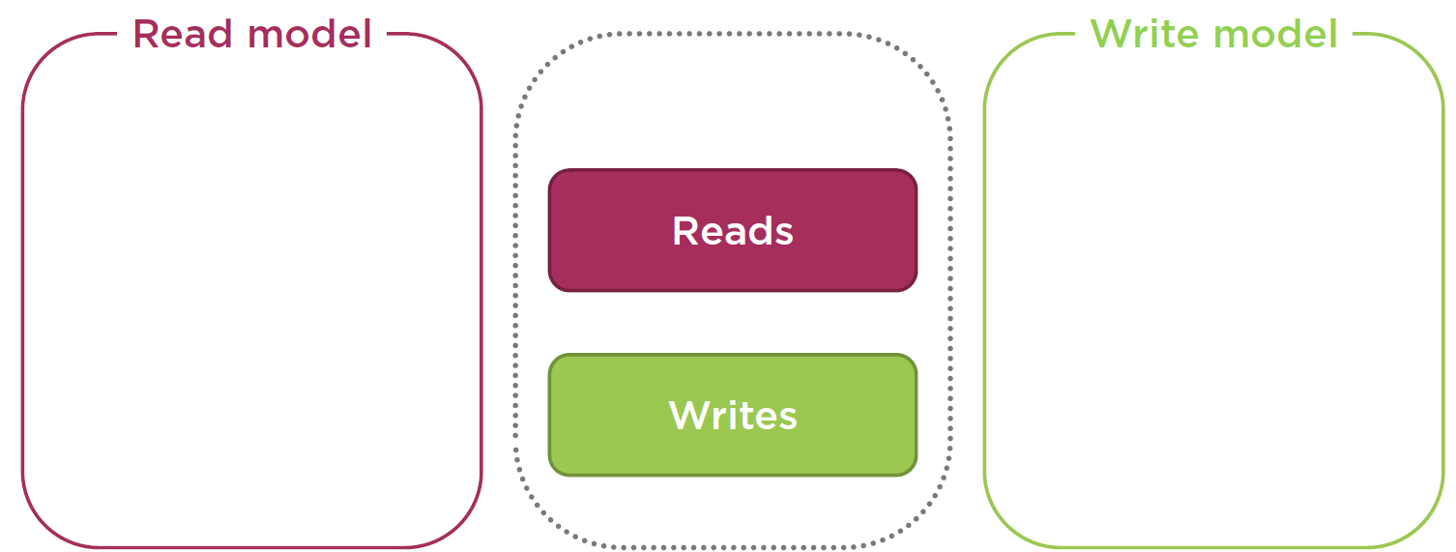

* CQRS separation into “two-separate-models”.

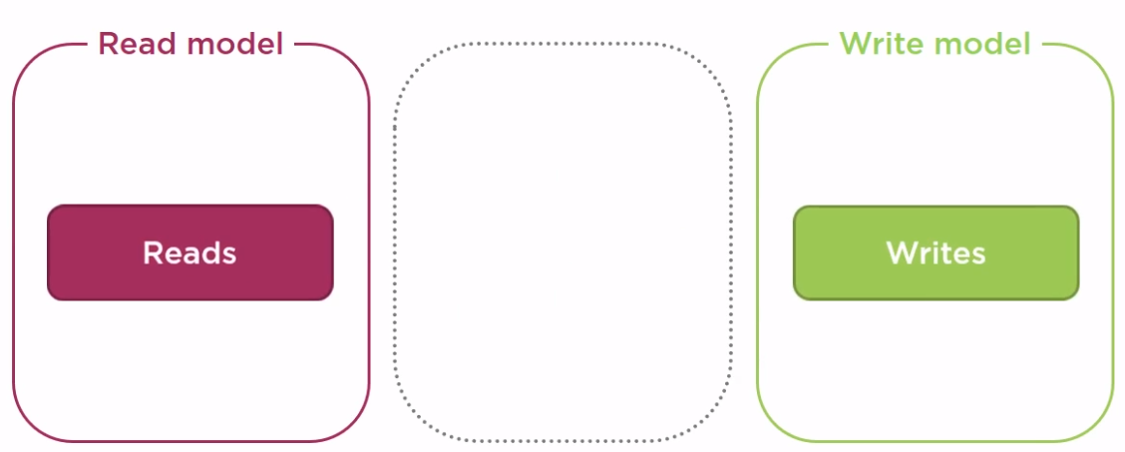

* CQRS was introduced by a person called **Greg Young**, back in 2010 ! But Greg’s ideas were based on another pattern called **Command-Query separation Principle** invented by a person called **Bertrand Meyer** .

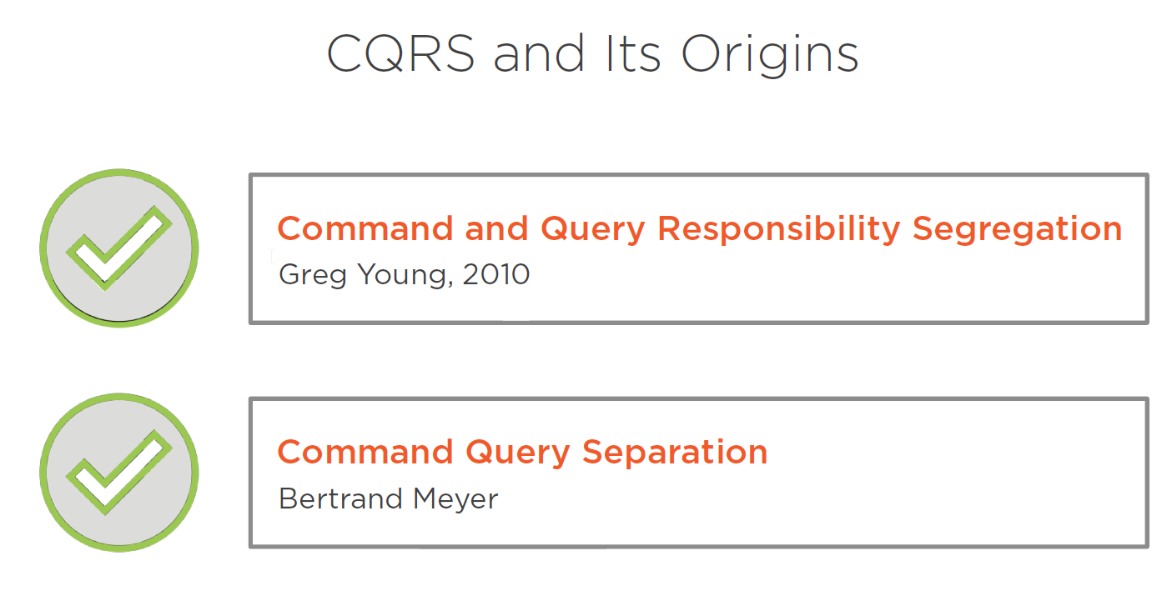

Command-Query-Separation (CQS) states that every method should either be a “command” that performs “an action”, or a “query” that returns data to the caller, but not both !

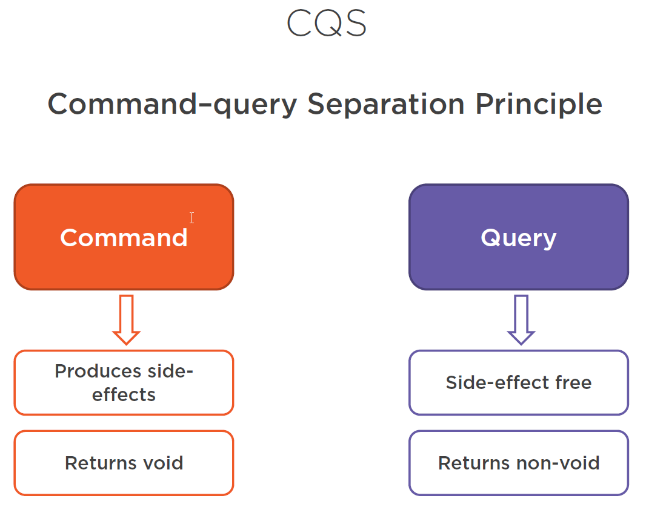

* In case of a “Command”, state is changed and after persistence void (nothing) should be returned.
* In case of a “Query”, state is not changes and data is returned, so query returns “non-void”.

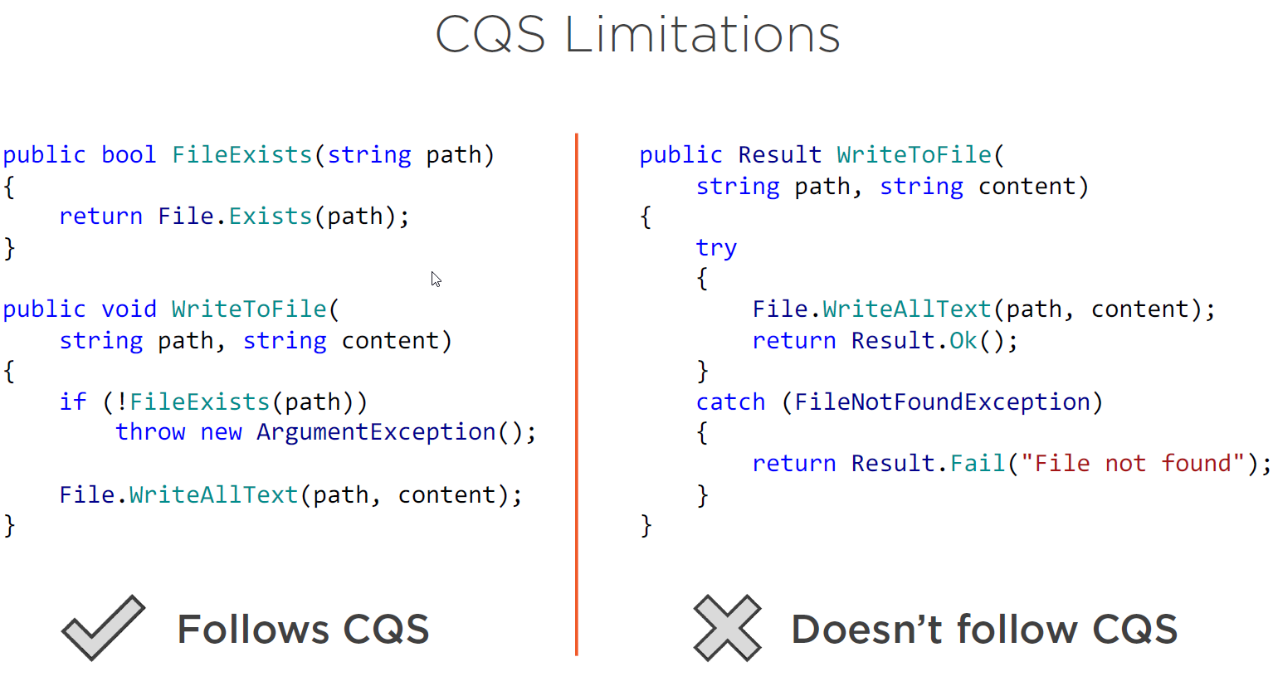

But … CQ(R)S also has limitations. In the example above where we try to write to an (existing) file, the application of CQS is not appropriate. E.g. we apply CQS principle because we have a separate method that “read” (FileExists()) from a source and a separate method that “writes” to a source (WritToFile()). But here using CQS does not make any sense because it can result in non-atomic actions. Problem here is that after checking for the existence of the file, when we write to the file, the file can already been removed by another process, so we must create a “atomic” (transactional) method in this case which both does the “read” and “write” side, this is shown on the right of the image !

Another example where CQ(R)S based patterns may not be appropriate (or even not be applicable) are **multi-threaded** environments where you also need to **ensure** that each operation is **atomic** (transactional correct).

So to conclude, what is now the relation between **CQS** and **CQRS ?**

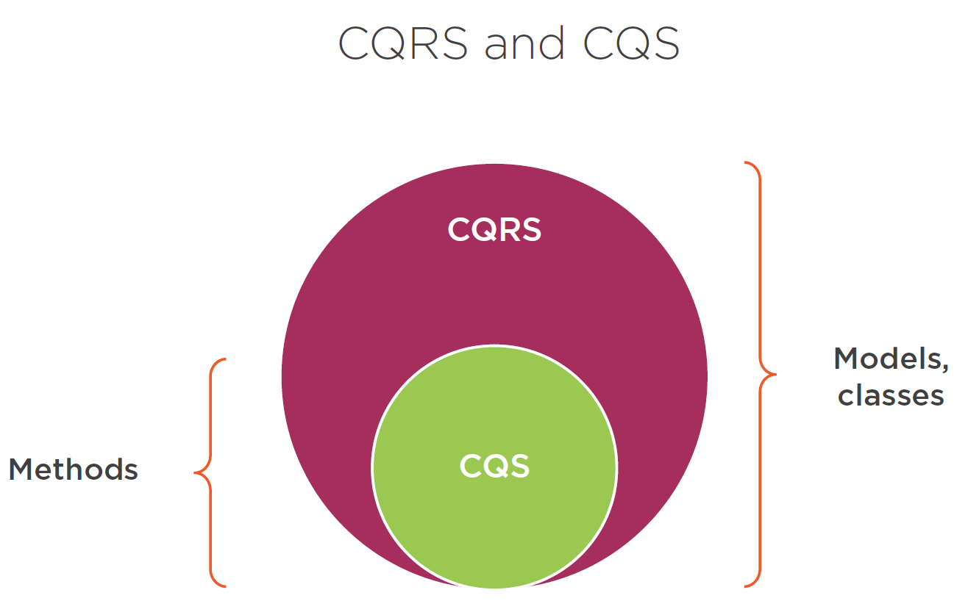

* **CQRS** takes the same idea from CQS but extends it to a higher level. Instead of methods like in **CQS** , CQRS rather focuses on the “model” and “methods” and “classes” in that model, and then applies the same principles to them.

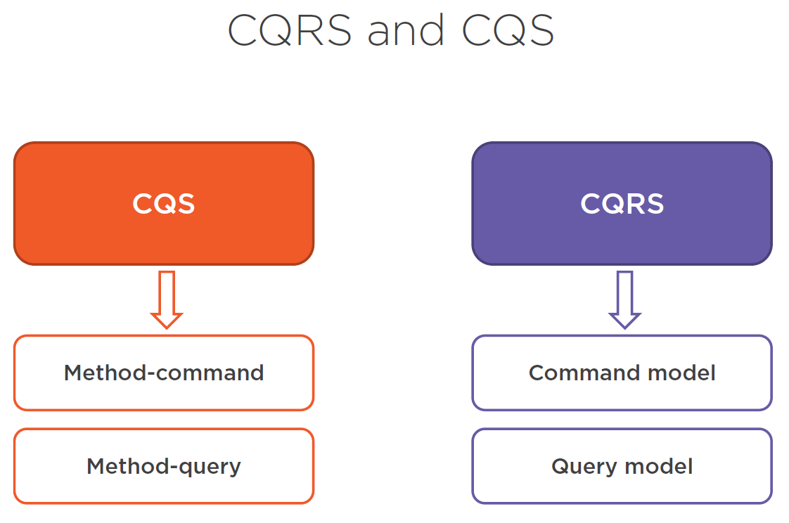

* Just like CQS encourages to split a method into 2, a “command” and a “query” CQRS encourages to adapt a single unified **domain model** into 2 models, one for reading (query) and one for writing (command).

## Why CQRS ?

Like said before CQRS is all about separation of a “single” model into two distinct models: one for read, and one for write. But this is of course not the goal itself, there should be a benefit for doing this.

So what are the benefits that the CQRS pattern brings us ?

### Scalability

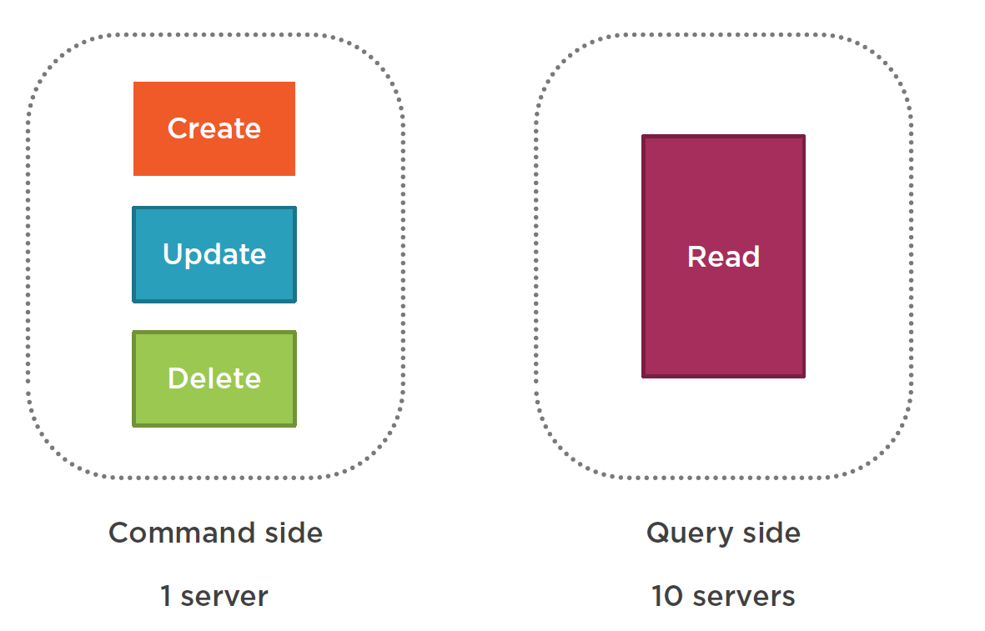

When we have a look at a typical “enterprise-wide” application, among the operations (create, read, update, delete), the most used is usually “read”. So it is important to scale these so-called CRUD operations independently from each-other (even serve them on a separate server if appropriate …).

### Performance

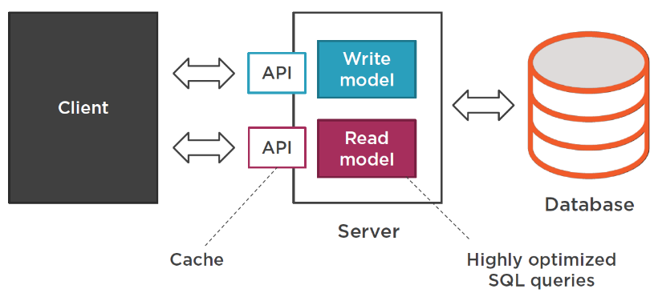

Performance is also related to scalability of course, but it is not the same thing ! Even if you decide to “host” reads and writes on the same server, you can still apply optimization techniques that wouldn’t be possible with a single unified model. E.g. just have a set of “separate” APIs for “queries” allows you to setup a “Cache” for that specific part of the application.

It also allows you to use “database specific features” like hand-crafted highly sophisticated SQL for reading data from the database without looking back at the command side of the application (for the Create, Update, Delete part), where you specifically would apply some ORM.

### Simplicity

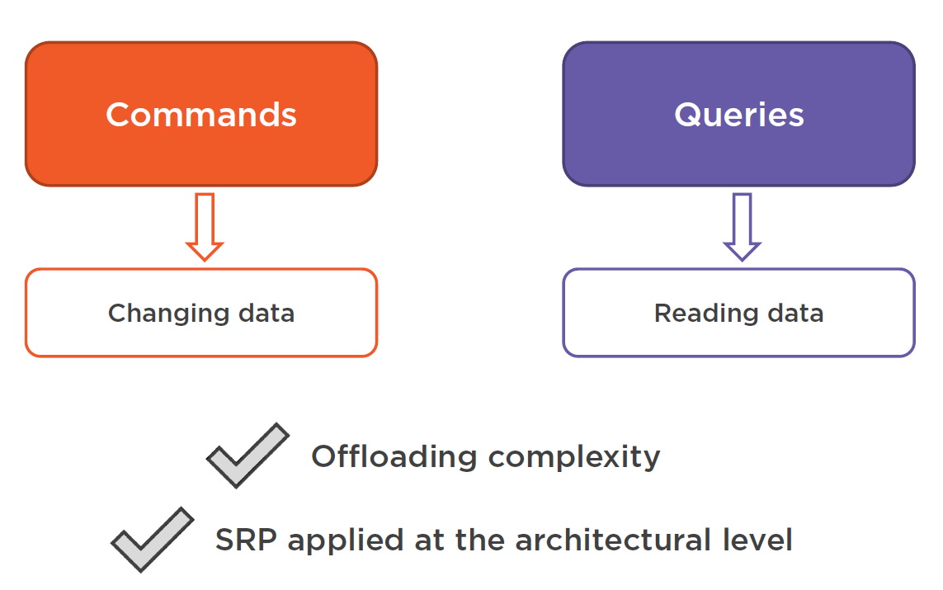

As the command side (create,update,delete) and the query side (read) have drastically **different needs**, it’s good to **separate them**. By introducing explicitly 2 separate models instead of 1, you can “offload” a lot of complexity from your code-base, so you don’t have to worry to handle 2 separate use cases with the same code anymore. You can focus on each of them independently and create a **separate solution** which is adapted to each case. We can see this as a SRP[2] applied on the architectural level. You get 2 models, each of does only one thing in a specific way and does it well.

# Module-2 : Introducing a CRUD-based Sample Project

## Introduction and Domain Model

The application where we will start from is a non-CQRS based API for a student management system, SMS in short.

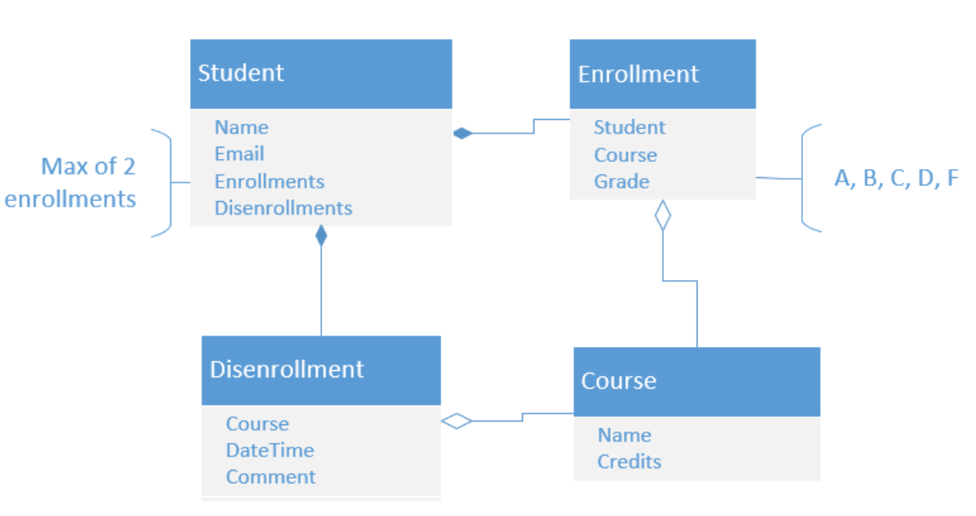

Core object is the **Student** class, where each student is uniquely defined by its **email**, a student has a name and a possible collection of **Enrollments** and **Disenrollment’s** to/from a C**ourse.**

The number of enrollments that a **Student** can have is limited to 2. Each **Enrollment** has a **Student, Course** and **Grade.**

The **Course** class has a unique name and a number of **Credits** that a **Student** can receive for the Course.

The **Disenrollement** class shows the **Courses** which where discontinued for a certain **Student**.

**Comment** and **Grade** are mandatory fields. So when a **Student** enrolls for a course, a Grade should be specified. And when a **Student** discontinues a course, a **Comment** of discontinuation should be added.

## The CRUD API

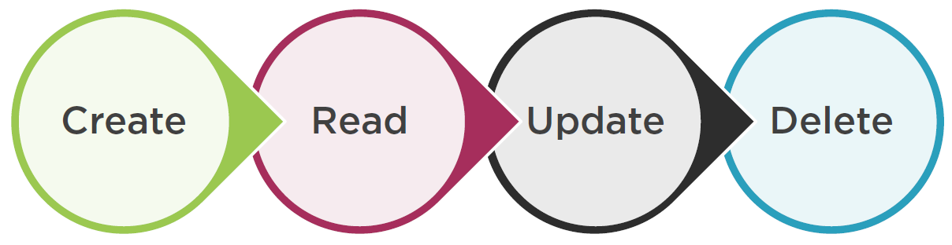

The API of the SMS exposes the “standard” so-called “CRUD” operations.

## UI Example

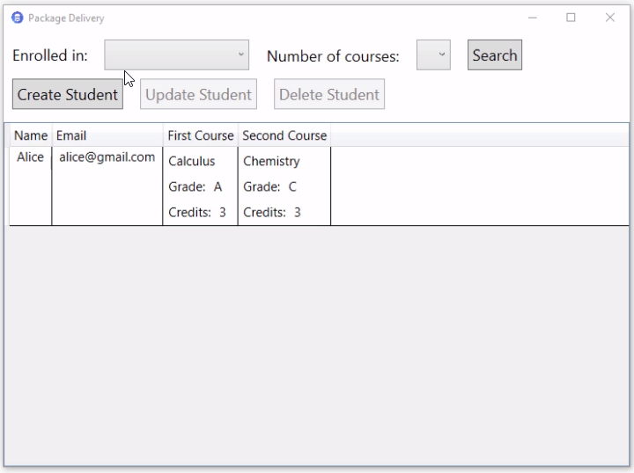

Next is the UI interface which is used by our backend API. It uses a typical JSON based Web API to interact with and execute (Create, Read, Update and Delete) actions.

The core of the UI represents a list of students (with their name, email, first and second course (if any …)). Students can only be “enrolled” in maximum 2 courses.

The application provides the Create, Delete & Update operations too.

## Application Code Introduction

We will start from a **“none-CQRS”** enabled project which contains 3 projects:

* Api:
  + The API is a .NET Core application which targets .Net Core 2.1.
* Logic:
  + Logic also targets .Net Core 2.1.
  + Contains the domain models.
  + Uses NHibernate to-do the model to database-table mappings.
* UI:
  + The UI is a desktop based application written in WPF[3], which targets the “full” .NET Framework version 4.7 !

In the solution you can also find the **script** which will create the initial database schema, this script is called: **Databaseinitial.sql.** It contains both the database structure and data to be used by our application.

### Logic Project

Some explanations of the code:

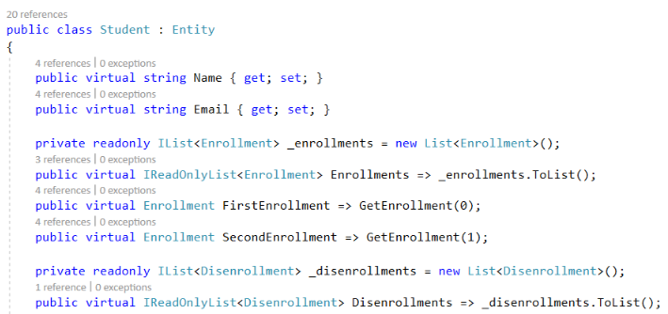

In the **Student** domain class, we have a **collection** of **Enrollments.** The pattern that you see here is a good way to work with collections in domain classes.

The **IList** field is what the **ORM** maps to when loading **Enrollments** from the database, but … instead of exposing this collections AS-IS you make it **private (IList)** and create a **public property wrapper** around it **(IReadOnlyList)**. This shows to the **client-code** that it **cannot modify**  this collection and has to use **separate** public-domain-model “methods” to-do that.

That is **called “encapsulation”** in OO-design (OOD[4]) and is a good way to **abstract** the client for **inner-workings** of the domain model by just exposing **public-method wrappers** that the client can call, without the knowledge of the internal implementations !

We also see 2 constructors in the Student class:

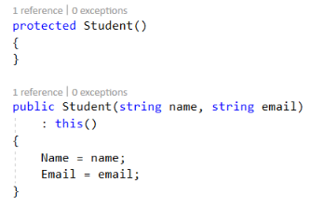

The **protected** variant of the class constructor is used for the ORM.

The **public** variant of the class constructor is used for the client code, which, in order to create a student must provide a student name and email address.

The Student class also provides a **public interface** to interact with student objects, the public interface has 3 methods defined:

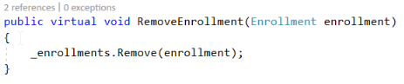

A method to remove an enrollment from the student’s enrollments.

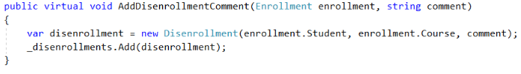

A method to add a dis-enrollment’s comment when a student discontinues for a course enrollment.

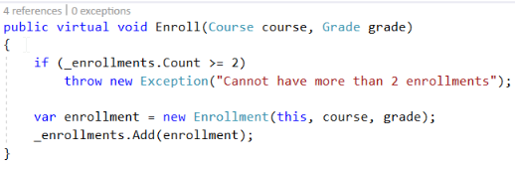

And finally a method to enroll a student to a new course.

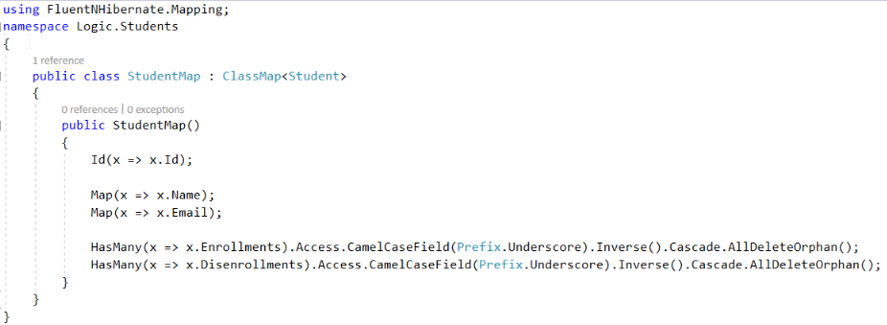

There is also a **StudentMap** class to map with NHibernate for persistence purpose.

The part of the mapping : **.Access.CamelCaseField(Prefix.Underscore)** tells NHibernate to map directly to the backing field :





The **Inverse** setting is the one that determines the value of the **StudentID** column in the student database table, and **Cascade.AllDeleteOrphan()** is needed for NHibernate to delete all enrollments/dis-enrollments from the database table in case we delete them from the collections.

### Api Project

The BaseController class contains some methods for us to use in other derived controllers.

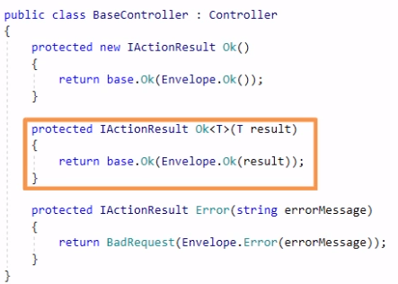

For example we can call “OK” with some resulting object and this method will wrap the result into an **“envelope”** before passing it to the client.

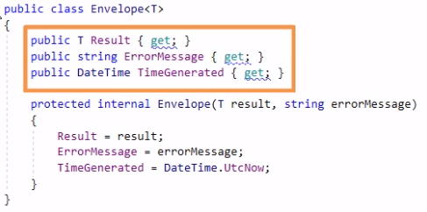

The envelope is a class that helps to keep the structure of all responses from the server (as our API is a backend server application returning a httpresponse to the client) **consistent.**

As you can see from the “envelope” class, the class does not only contain the plain “message” (represented by T Result variable), but also contains a possible **error message** and a **timestamp** when the **response message** was generated and sent to the client.

Next we have th **StudentController** class which contains the actual application API functionality.

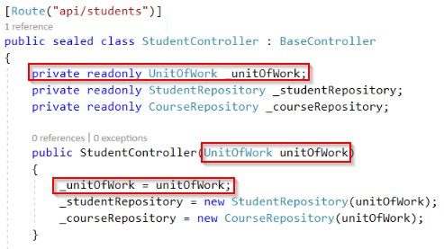

It accepts a **UnitOfWork** which is a “wrapper” on top of NHibernate’s **session and transaction** :

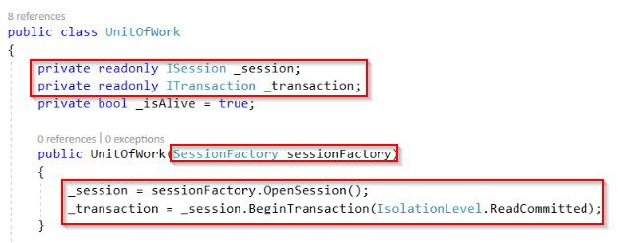

The StudentController also create 2 repositories in its constructor:

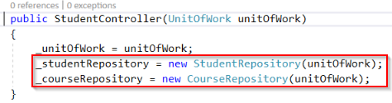

These are the repositories that we are going to need to create students and enroll/dis-enroll students from their courses.

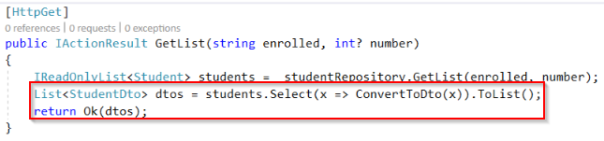

Next the GetList() method is what returns the **students** to display in the **data grid**  on the user interface. It accepts 2 parameters, the name of the course where the student is enrolled in (enrolled) and the total number of courses (number). Please note that the returned “domain entity” student is converted to a DTO[5] before returning to the client. The “Ok” method is also delegated to it’s base class and wrapped into the **envelope** response message type, as shown below:

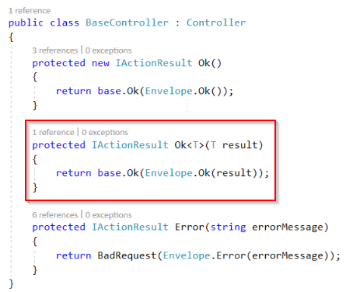

Finally we have the **repository** method of the **studentRepository** class which does the real data access and filtration of the data.

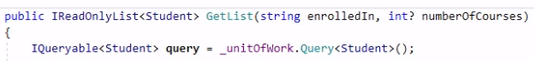

We first create an IQueryable which represents a SQL-Query that NHibernate will generate for the database.

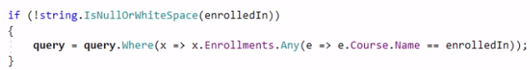

Next, if the course name is specified we build this query by adding a where clause to it.

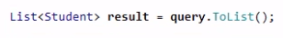

After that we force NHibernate to execute it and give us back the resulting list of **Student** objects (entity objects).

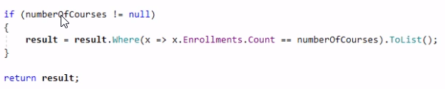

And then if the second filter (number) is set we return only students who have these exact number of courses enrolled. And finally we return the result to the **StudentController.**



As already mentioned before, our API Controller will convert the retrieved objects from the student repository (which are domain entity types) into **DTO** types and finally **“wrap”** them in a **response message** using a **message envelope.**

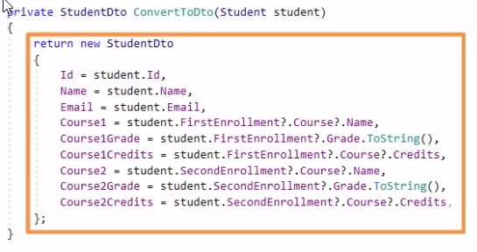

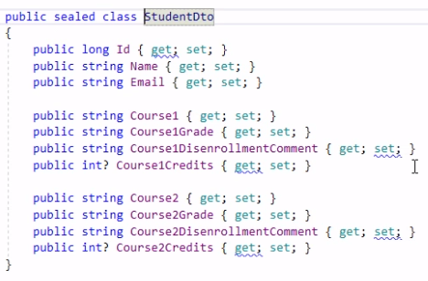

The DTO contains an Id, name, email of the student and it also contains specific information about his/her enrolled courses (if any). In fact we do not return “domain objects” here but compound objects which are in the right shape for the UI.

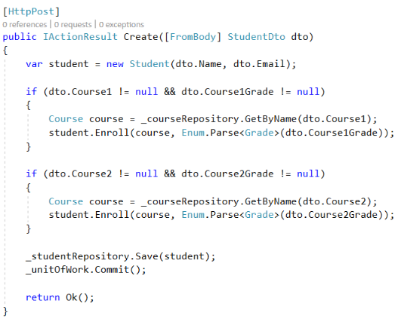

The **“Create”** method of the StudentController creates a new Student (domain object) from a Student DTO returned from the UI. Next if courses are enrolled it creates a Course (domain object) for each Course contained in the supplied DTO. Finally we save the Student (domain object), commit the transaction and return an “OK” response message to the calling client.

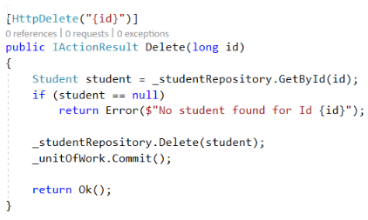

The “Delete” method of the StudentController get’s a Student (domain object) by Id and deletes it from the underlying database through the student repository.

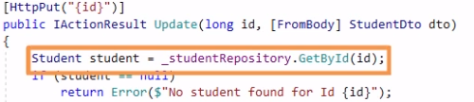

Most of the complexity lies in the “Update” (PUT) method of our StudentController API. Here we also find the Student first by supplied Id,

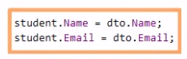

next we update the properties of the retrieved Student (name and email in our case) and then start the **synchronization process.**

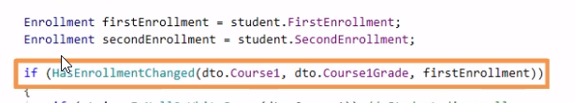

We first check if there are differences between the incoming DTO and the first enrollment.

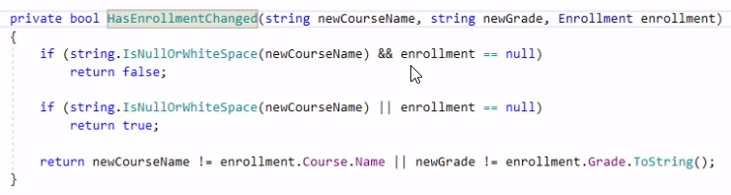

To check if the enrollment (assignment of course to student) has changed, we use the private method **HasEnrollmentChanged.** The full update code is shown next:



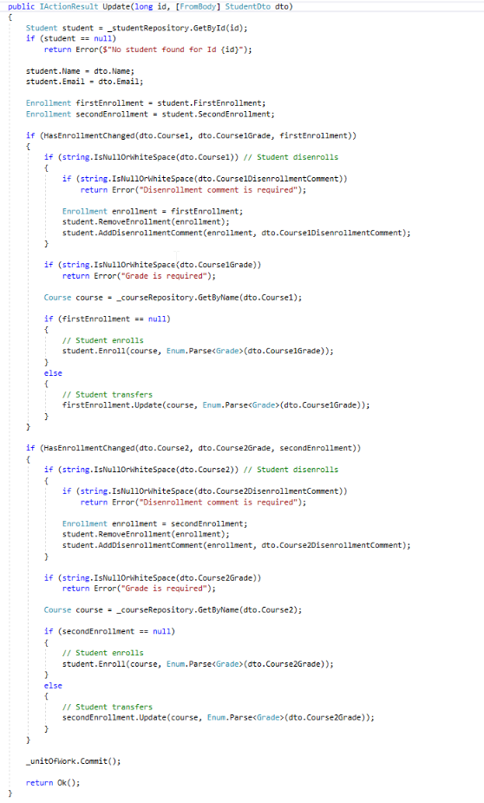

After the synchronization is done, we commit the transaction and return success to the caller. That’s it for the application functionality through the current Crud-API.

Let’s have a look to the rest of the current AS-IS code before refactoring. We already mentioned the **StudentDTO:**

|  |  |
| --- | --- |
|  |  |

The StudentDTO contains all fields required to display a student and his enrolled courses in the UI grid, and update it when posting the changes back to the Server.

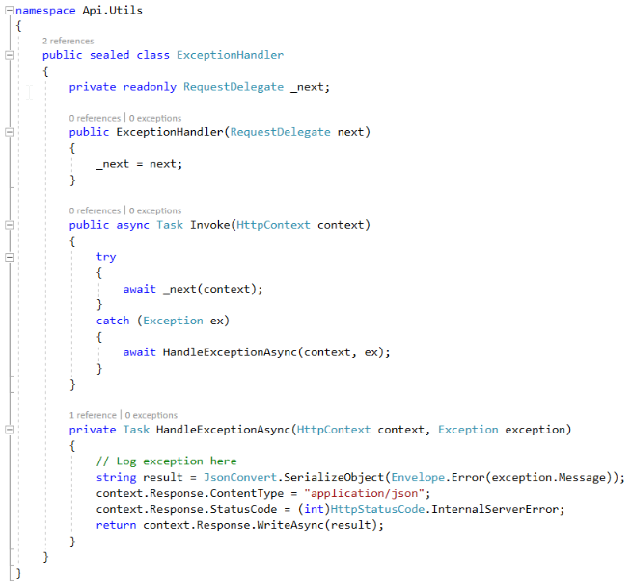

**ExceptionHandler.cs** is an infrastructure class that catches all unhandled exceptions and converts them into Http-StatusCode 500 (Internal Server Error) responses .

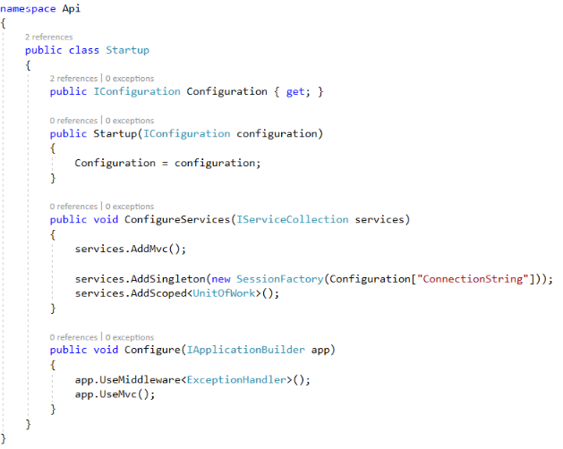

Next we have the **Startup.cs** class. Important here is the creation of the **SessionFactory** class as a singleton. SessionFactory is a class that we use to generate **NHibernate** sessions. There should be only 1 instance of such a class for the entire application, that’s why we created it as a **singleton.**

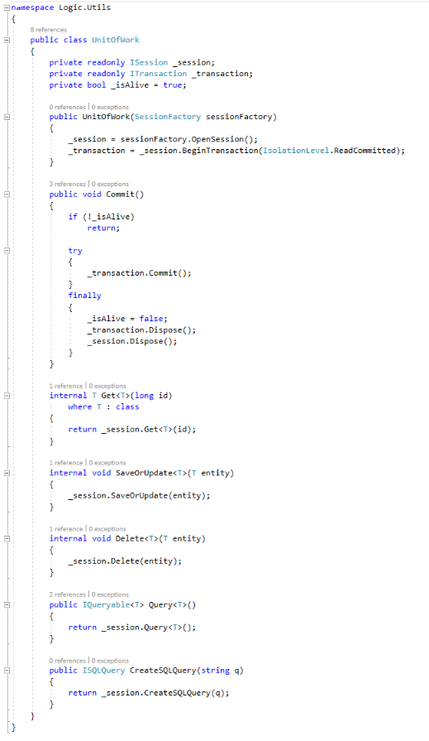

Next, **UnitOfWork** (which is part of the Logic project) is a wrapper on top of sessions themselves and should be instantiated and disposed on **each web request.** That is what the **AddScoped** method does. It will create a UnitOfWork and because the class implements the **IDisposable** interface, ASP.NET will dispose it after the request is completed.

### Database

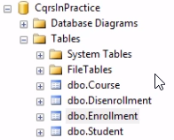

Finally we have the **underlying database.** The database pretty much “mimics” the domain model. So let’s add the connection string to a local instance of the database and run the app in the AS-IS state …

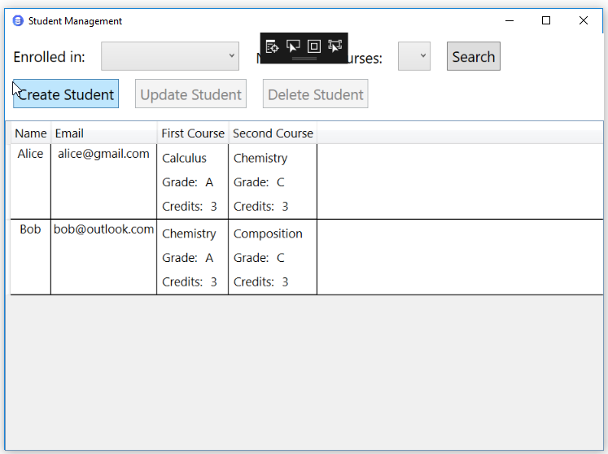

Let’s add a new student and let him enroll in some courses now …

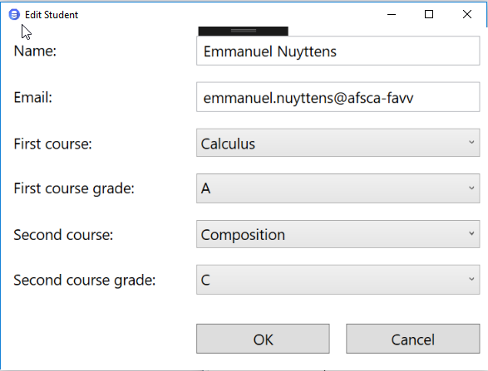

+save ...

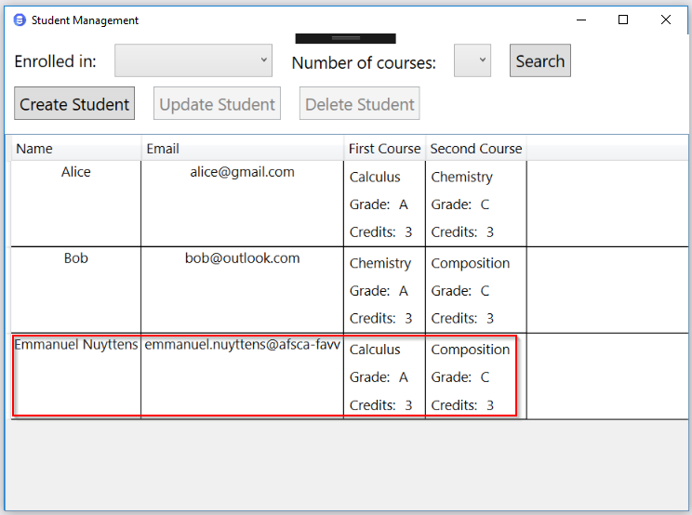

Yes, I’m added as a student, enrolled in Calculus and Composition Course and having still 3 credits left ☺. Now I can update or delete as appropriate …

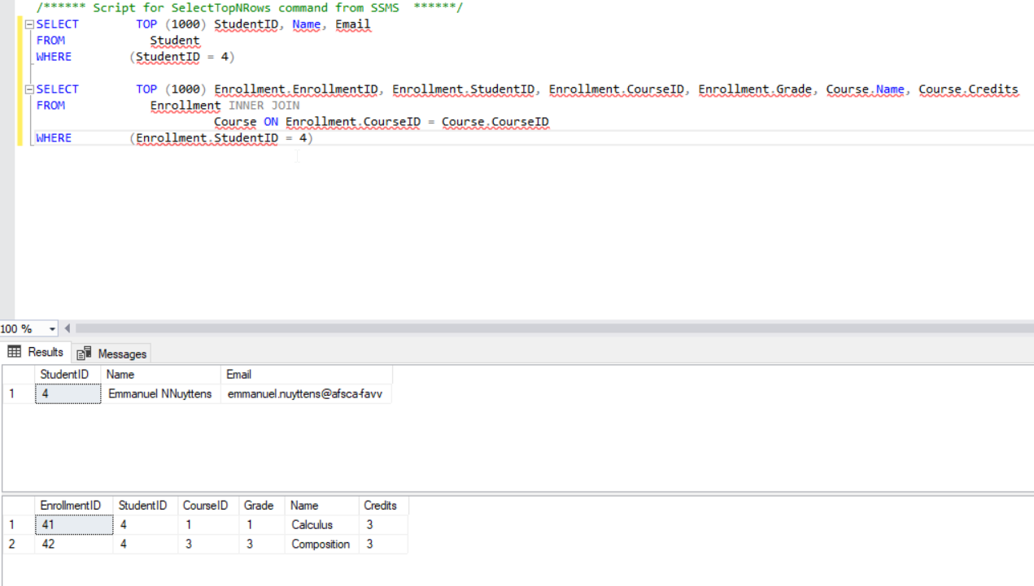

Now, when I look at the database level, I’m added and my courses are enrolled, cool ! ☺

## Application Code Drawbacks

The app as proposed in §4.4. are typical the app’s we used to write in the past. We have a UI and API-Services which connects to the backend-database and executes CRUD operations. But …

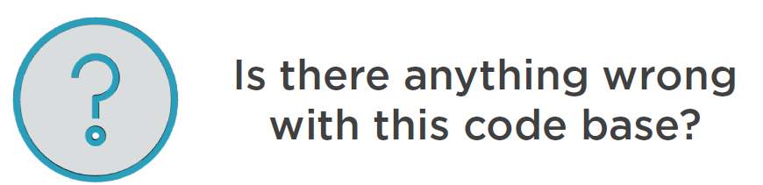

So what is wrong with this code-base as mentioned in the former § ? As we explained in the first module, CQRS brings us next 3 big benefits:

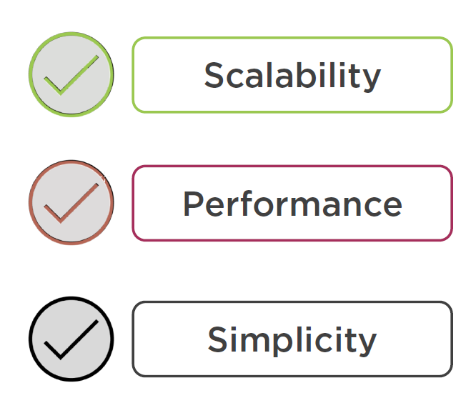

We will tackle **Scalability** in a later stage … but what about **Performance ?** Let’s open the **StudentRepository** which is part of the **Logic** project:

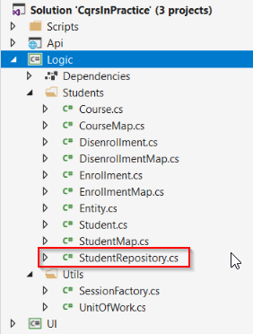

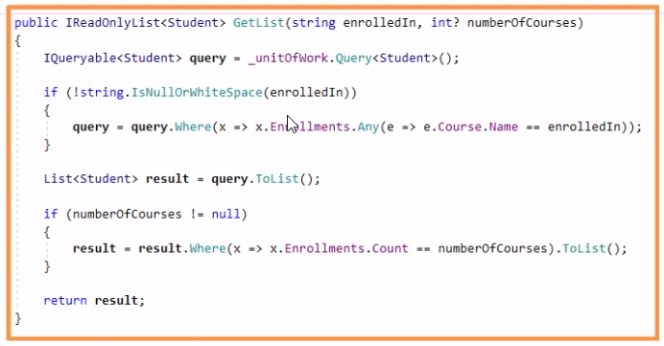

Let’s have a look at the method that filters the existing students by courses that they enrolled in and the total number of such courses. What can you tell about performance here ?

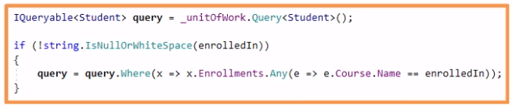

Up to this moment, this method operates upon an **IQueryable**, which is a good decision because the LINQ statement made upon an IQueryable object translate into the corresponding SQL. It means that this **Where** statement (the filter) is executed at the **database level**, and that is exactly what we want ! , because this way all processing is done on the server-side of things.

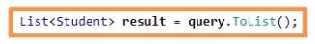

But … with the statement after the filtering we force the ORM to fetch all students with corresponding cours(es) into **memory**, and only after that we continue narrowing them down. This ultimately means that the database will send an excessive amount of data, which we then **filter manually in memory.** This is not the best solution and can hit performance quite badly !

Of course, in our demo app we won’t notice performance issues at first, because we only have a few records in our local database. But what if we’re adding thousands of them and the query as mentioned above gets excessively executed by a multitude of different clients ? …

Ideally, you should transfer only **the minimum amount of data** between the server and it’s database. But why are we doing that ? Why force the ORM to fetch all records of the database table on this step ? This is because we cannot do this “filtering” otherwise. Neither **NHibernate** nor **EntityFramework** support filtering by the number of elements in a **One-to-Many** relationship.



The only possible solution her is to finish up this “filtering” in the memory, using the in-memory LINQ provider. Another performance problem which comes up quite often is the problem called:

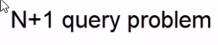

This occurs when the ORM first fetches the **Students** (the parent objects) and then for each student performs a separate call to retrieve their Zero-To-Many **Enrollements** (the child objects). And then another one per Enrollment, to get the corresponding **Course.**

So instead of a single database roundtrip, you end up with a lot of database roundtrips instead.

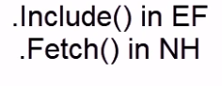

In most cases you can overcome this problem by instructing the ORM to **include the navigation properties** into the sql-script query and fetch them along with the main (parent) student object (in our case). But this is not always possible, and it is indeed very easy to overlook this issue when relying on the ORM (NHibernate, Entity Framework or other ) to query the database.

Finally, what about Complexity ? Is the code as presented in the AS-IS of §4.4. well-structured and easy to understand ? Not really … Look at the UPDATE method (PUT) in the **StudentController.cs** class:

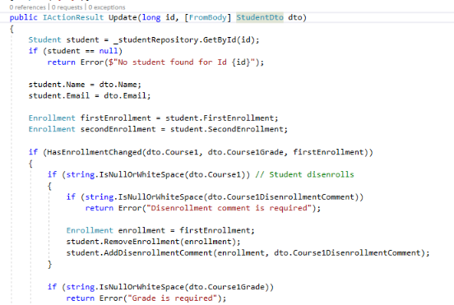

. . .

Problem with the Update method is that there is “to many logic” in the Controller method. Controller method code should be kept small instead.

We are trying to-do **to many things** in the controller action. We could certainly simplify the code of the UPDATE (PUT) method in our WebAPI-Controller by removing the **duplication validation code** to check the first and second enrolled courses, but still …

As all methods in a WebApi controller should only do 1 specific thing, the method violates the rule of SOLID-pattern, more precisely the **SRP or Single Responsibility** rule which means that a controller action should only be responsible to execute 1 specific task. But in our case the update method does several things beside the main purpose to update a student and his enrolled courses. E.g. putting the **validation logic** inside the controller is not a good idea. Validation logic should be part of the **business logic layer** and ultimately be part of a kind of **service.**

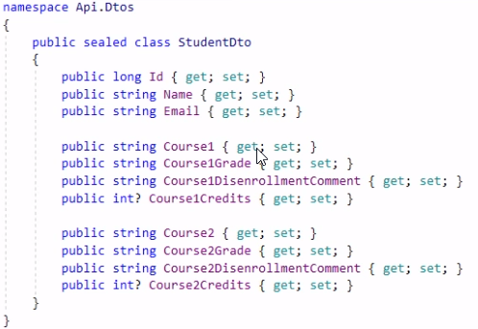

Another hint that tells us about the SRP violation is the **StudentDTO.** In current situation it is both used **for sending the data to the client**, and **receiving the data back when updating the student.** And because of that, some of the fields of the **StudentDTO may remain unused** in certain situations.

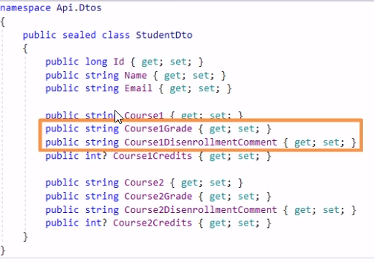

For example, when updating the student, the user needs to only specify either a **Grade** or a **Dis-Enrollement** comment, but not both … And it is also not needed to provide the **CourseXCredits** field because we just read them but don’t update them on the server, they are only used to **display information on the UI** !

This is indeed a very CRUD-based approach, and it is not the best way to organize the application code, because what we do here is to **merge all the possible modifications to the students into a single giant update method** with a **single giant update model.** Instead each of these modification types should have their own representation (projection of the model).

The approach above **may lead to a great deal of complexity and maintenance issues** when the application **“grows” and new functionality** is added.

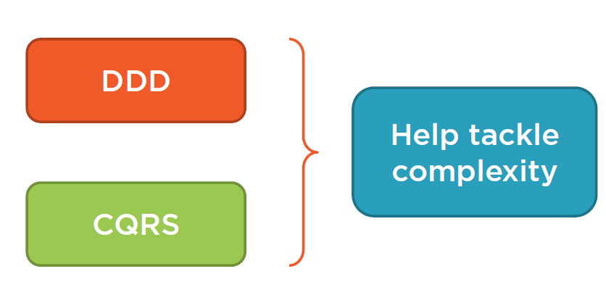

It is important not to allow such a growth of complexity, and Domain-Driven-Design in general and CQRS in particular, at very good at lowering the complexity of an application.

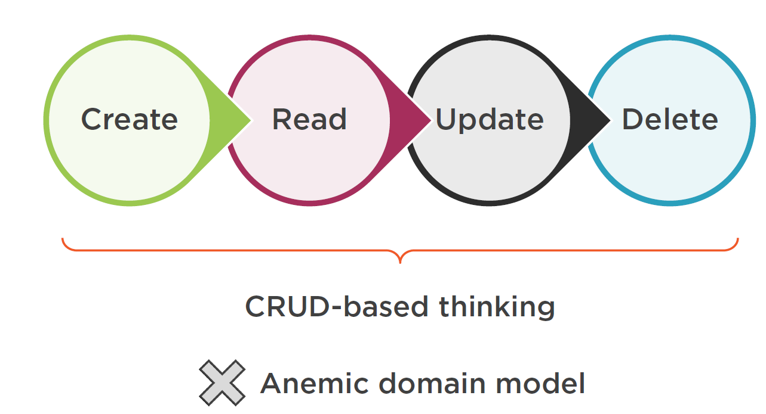

Implementing in terms of “CRUD” based operations (Create-Read-Update-Delete) is called “CRUD-based thinking” and goes often together with **Anemic Domain Model**.

An Anemic Domain Model is when you have domain classes that contain data and separate services classes that contain operations upon this data. So in case of an Anemic Domain Model, the entity domain model classes itself only contain “state”, not “behavior”.

But this is not always the case, even in our situation we have quit well-formed domain classes which contain both **state** and **behavior,** we can prove this by looking into the **Student.cs** domain class which is part of the **Logic** project.

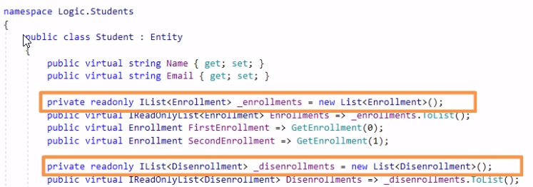

There is a good level of **encapsulation** in our **Student** entity, because for example both collection objects (to enroll or dis-enroll) are private, thus hidden for client code and only accessible through **read-only** properties (only get, no set). This means that both **enrollments** and **dis-enrollments** can only be done through a **well-defined** public interface within the **Students** domain logic class, as shown below:

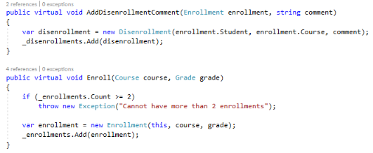

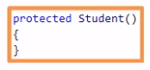

The parameter-less constructor is **protected** so also hidden for the client code.

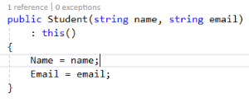

A new student can only be created through a well-defined interface.

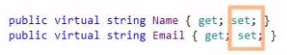

We do have public setters in the Name and Email properties of the Student class, this is because for this demo purpose no specific validation is needed for these properties, so these can be directly set by the client code if needed.

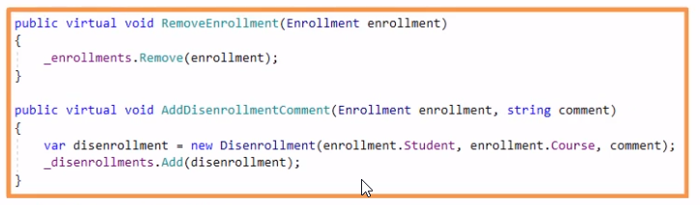

The only issue regarding to **encapsulation** is in the two methods shown above. This is because they should always be used together, because you always have to add a **disenrollement comment** when removing an enrollment. So it would make sense to “merge” those 2-methods so they stay atomic.

To conclude, our **Student.cs** domain class is surely not an anemic model but rather a rich domain model, as it should.

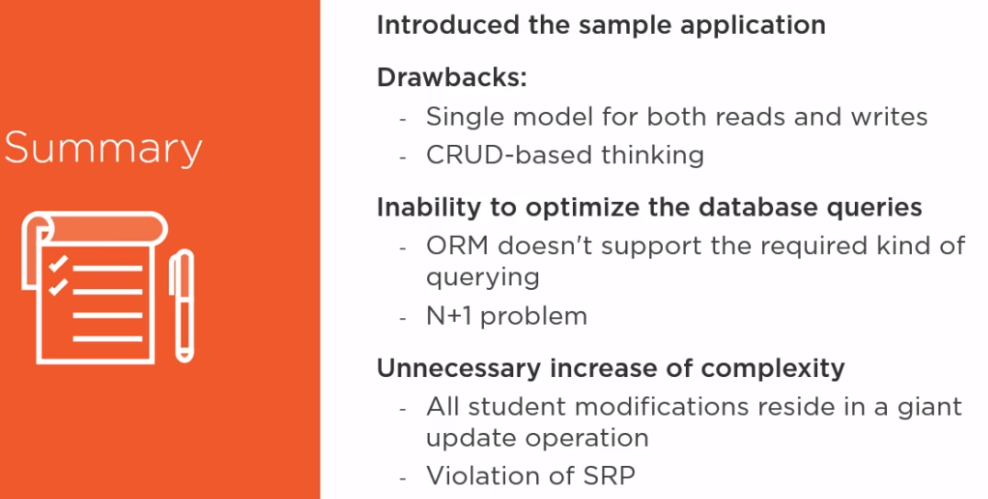

# Module-3: Refactoring Towards a Task-Based Interface

## Introduction

In this module we will explain the difference between a **Task-Based-Interface** and a **CRUD-Based-Interface.** We will transform the CRUD-based interface as implemented in Module-2 into as Task-Based Interface.

## CRUD-Based Interface

### 5.3.1. Definition

One of the most wide-spread problems in **enterprise-level** application development is the way **developers** approach **data modification.** Traditionally all **data-related** operations in an application falls into 1 of these for **“CRUD”-based** operations:

1. CREATE : To Create a new Data Object.
2. READ : To Read an existing Data Object from the underlying Data Store.
3. UPDATE : To Write modifications of a Data Object to the underlying Data Store.
4. DELETE : To Delete a previous loaded Data Object from the underlying Data Store.

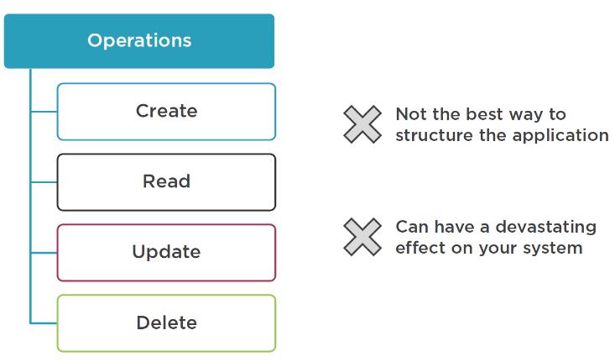

Nevertheless, it is almost never a good idea to organize your application along these lines, except for the most simplest cases.

Applying CRUD for your application can have a **devastating effect** on your system, and not only in terms of **maintainability,** to name one … This approach may damage the **user experience to.**

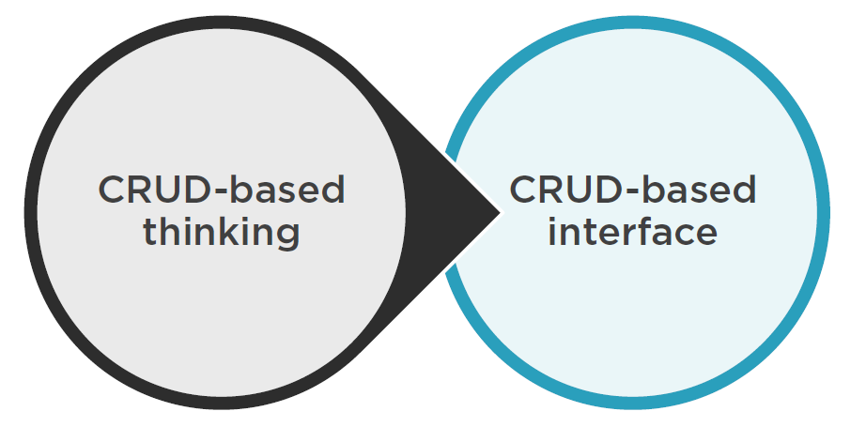

### 5.3.2. Problems with CRUD-based Interface

We will call this approach the **code-design “CRUD”-based interface,**  or in other words “CRUD-BASED-THINKING”-approach. So what is specifically the problem with this implementation approach ? There are 3 of them:

#### 5.3.2.1. Growth of Complexity

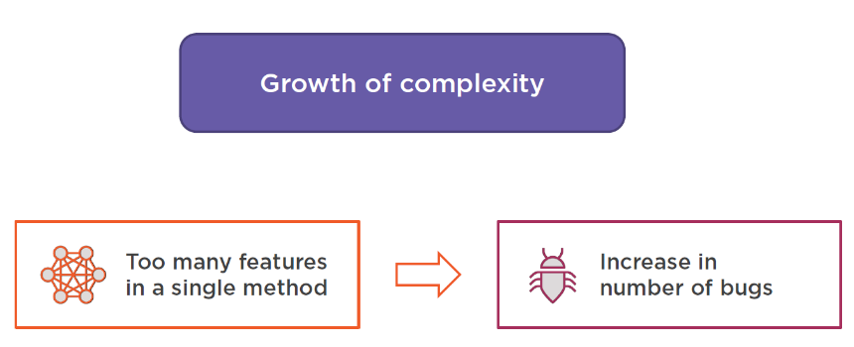

***The first problem is “uncontrolled growth of complexity”***, which means that capturing in a single method all operations that somehow mutate an object, may lead to enormous expansion of that method. We may get to many complexity within a single method, and the method may violate the SOLID-pattern design rule of SRP (Single Responsibility) too !

This may also lead to introduction of new bugs when we have to modify something in the methods.

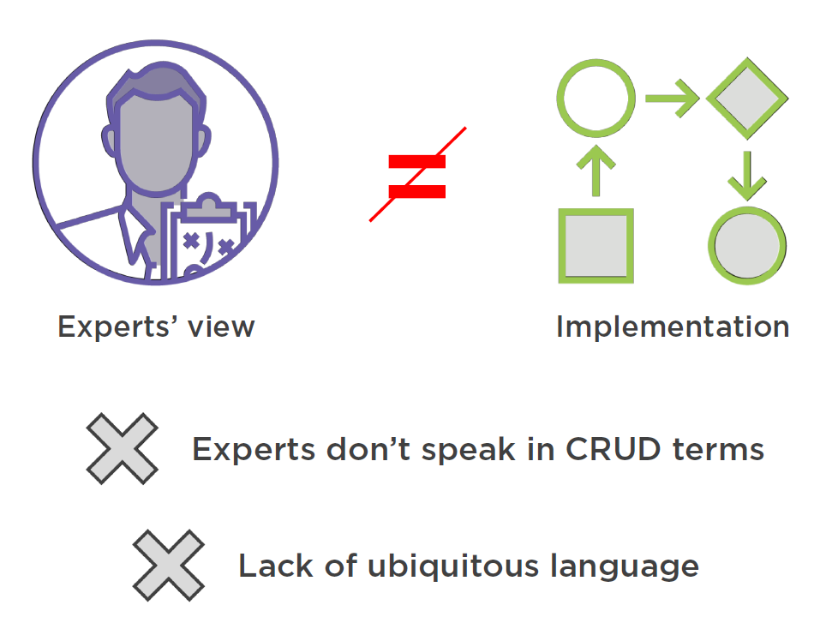

#### 5.3.2.2. Disconnect between Domain Experts and the Application Development Team

***The second problem is the disconnect between domain expert’s view and the application implementation.*** This is because domain experts don’t speak in “CRUD” based terms. Domain experts don’t talk in terms of “create student”, or “add user enrollment”, no they talk in non-technical terms like “registration of a student”, “enrollment of a user in a course” and so on … In other terms, there may be a lack of **ubiquitous language** (shared language) between de technical and the business people. UL is one of the 3 pillars[6] of **Domain-Driven-Design**.

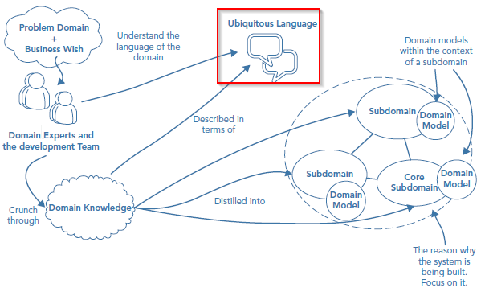

This disconnect between the business and technical people may also lead to **maintainability issues.** This because there is a lack of consistency between the application’s code and the language spoken by the domain experts. As a technical person, you have to **translate** what the experts tell you into technical artifacts. If there is no common (UL) or lack on UL, this may lead to **inaccuracies in the implementation.**

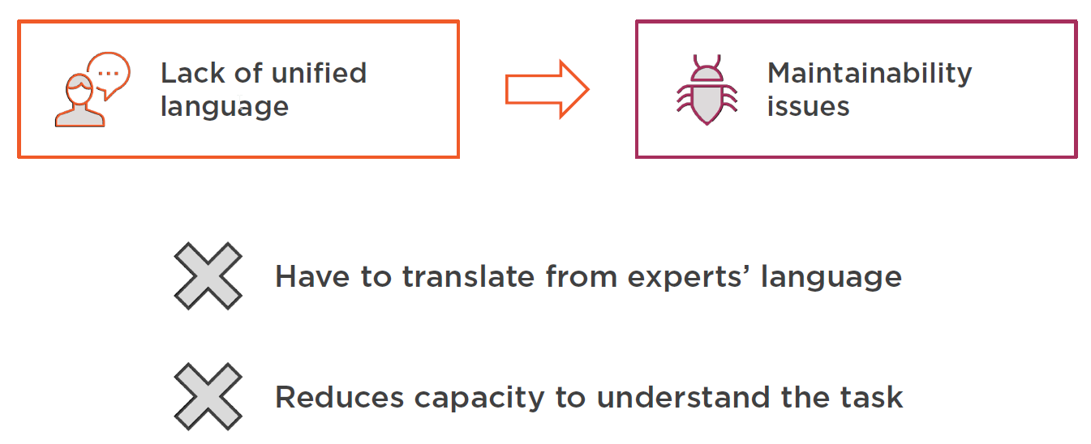

So if we can **eliminate this barriers** by introduction of the UL, this may benefit our overall performance and understanding on what the business wants and how our application should be implemented !

#### 5.3.2.3. Damaging the User Experience

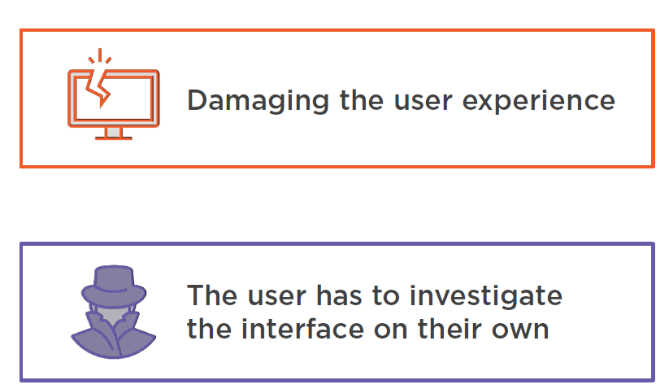

***The third problem is Damaging the User Experience.*** CRUD-based implementations also affects the way UI’s are build, and inevitably the way Users interact with the application.

Let’s have a look at our User Interface in the AS-IS state of our application (as introduced in Module-2 : Introducing a CRUD based Sample Project).

* Original Screen

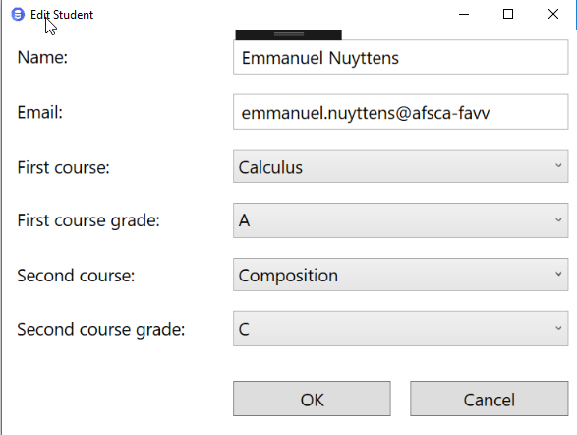

* Modify Course Enrollment

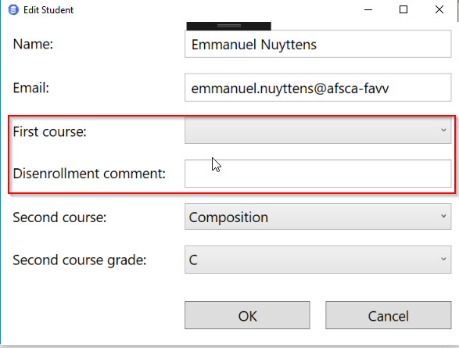

For example, the “update-screen” violates the SRP principle: If we try to “update” an existing student, does it then really make sense when you change the “course-enrollment” to any other course, then the interface stays the same (see screens above).

But as soon as you select the “empty-value” then the “Grade” field goes away I suddenly have to provide the “Disenrollment comment”, this may be very confusing for the end-user and it also violates the SRP principles.

So this screen has “to-many” features brought together on a single surface. Look at the same screen once more, how many features are in there ? At least four, let’s count …

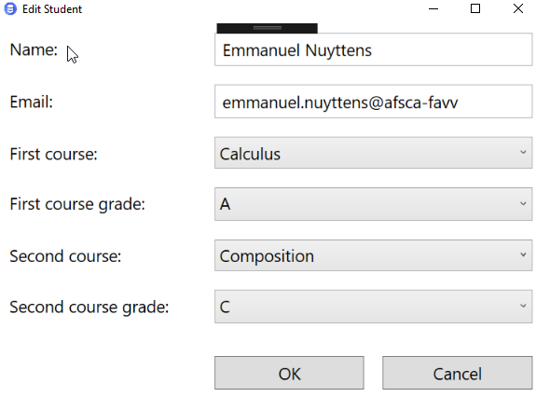

1. Editing personal information.
2. Enrolling into a new course.
3. Transferring to another course.
4. Disenrolling from a course.

From a end user perspective, this may be very confusing and it may take a while to uncover them all ! Users may never master all of these procedures in a single screen, even after working with the software for a long time !

|  |  |
| --- | --- |
|  | ***Important Note:***  All these features have to be **separated out of the single UI screen.** Ideally, the UI should guide the user through the process and not the opposite (as it is now …). The focus on user experience should form an important part of the development process, which almost never will happen if the CRUD-based thinking is in place. |

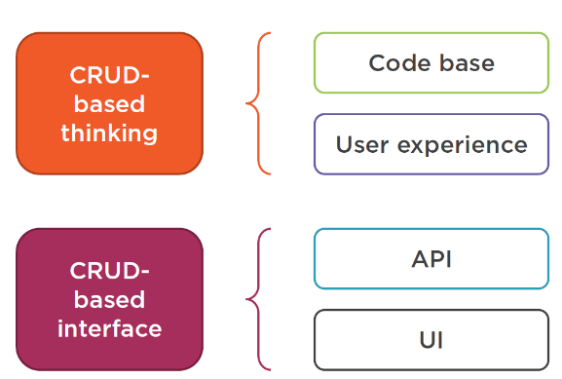

CRUD-based thinking may affect bot the **code-base** and the **user-experience** and **application programming interface (API).**

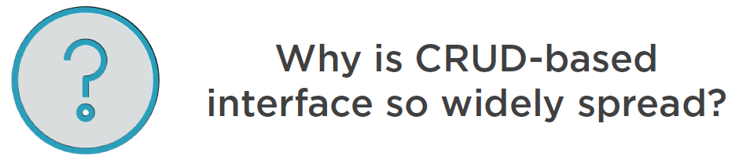

The CRUD-based interface is so widely spread because of **the developers desire to unify everything.**

## TASK-Based Interface

### Definition

So, how can we fix the issues as seen in CRUD-based application implementations ? The opposite of CRUD-based is TASK-based interface. So we should **replace our current design** with a TASK-based implementation, which means that the AS-IS CRUD-based implementation should be refactored towards a TASK-based implementation.

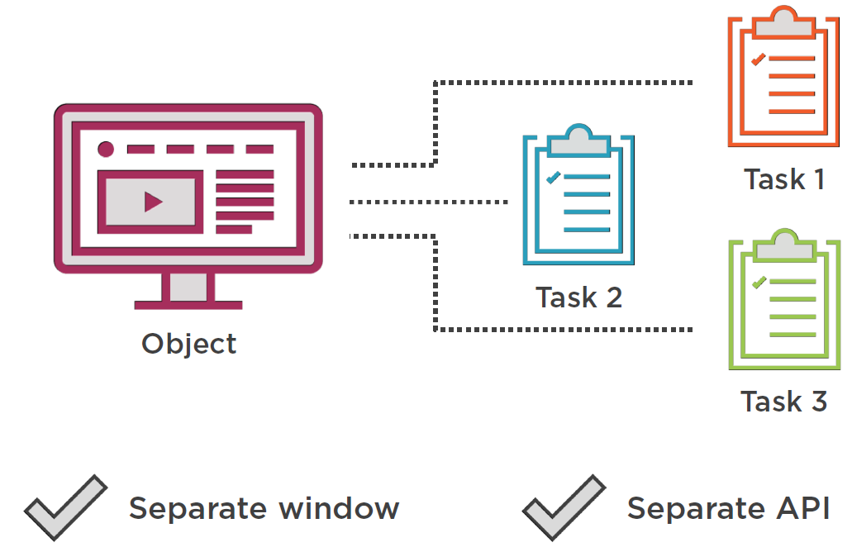

**TASK-based interface** is the result of **identifying each task** the user can accomplish with an **object** in the application. This is why its name is **task-based.**

TASK-based interface also means that for each task we should assign **a separate window (UI)** to them, and by extension also introducing a **separate API endpoint** too.

This idea takes root in the concept of **intuitive UI** where each UI Window should implement 1 (and only 1) **single distinctive operation.** We need to apply the SRP pattern. This will not only lead to **Code base simplification** but it will also bring a **great amount of domain insight,** this is because each feature linked in the UI should be linked to a feature requirement as required by the **domain experts.**

So before starting a task-based implementation, we should be in-line with the expectations and requirement of the **business.** And this business should be represented by the **domain-experts.** In other words, we should be able to bring our **codebase** closer to the **UL** of the **domain-experts !**

|  |  |
| --- | --- |
|  | ***Important Note:***  *After moving towards the* ***Single Responsibility Principle (SRP)*** *approach and the* ***TASK-Based interface****, each window on the screen will become* ***self-describing*** *and* ***intuitive.*** |

### Untangling the Update Method from the CRUD-Based implementation

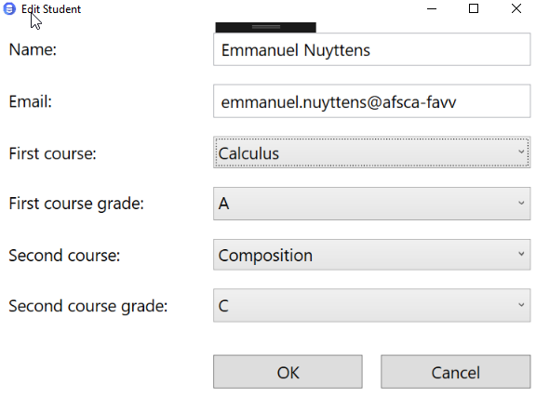

Let’s take our update-window again from the AS-IS situation (CRUD-Based interface). Currently this window is **Object-Centric**, this is because it tries to deal with the whole **student object** at once.

What we need to-do instead is **split the window** into **several task-centric** windows, each accomplishing **a specific and separate task**. As discussed before, we have 4 of such tasks:

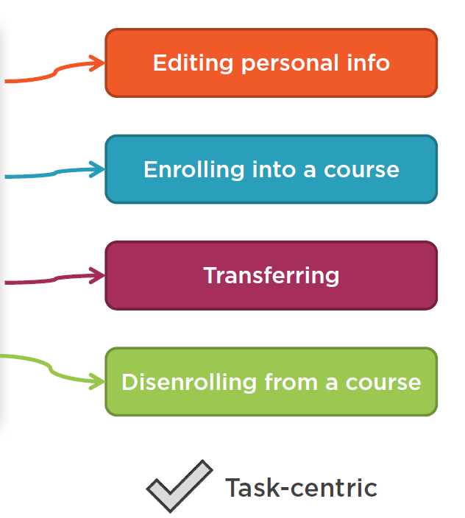

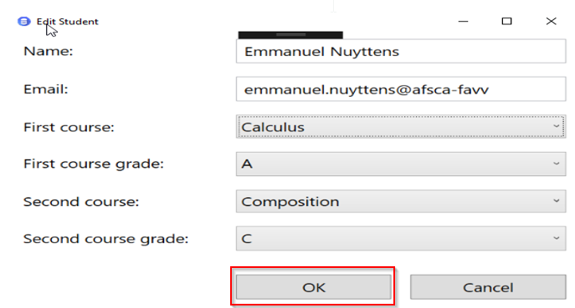

So Let’s start refactoring that (refactor from CRUD to TASK based implementation) and start from our **update window.** When the user clicks the “Ok” button, he will be redirected to the “Update” action of the **StudentController.** The StudentController is part of the Web-API Project (Api).

Before we **dive into the update method** I should explain how the **UI Project** is setup. The UI project is implemented as an MVVM[7] pattern. Check : Appendix A : Brief Introduction to MVVM Architecture Pattern

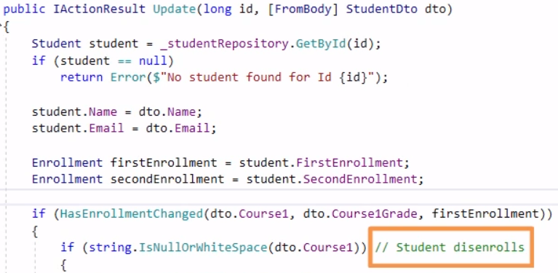

Next let’s open the **StudentController** from the **Api** project. Let’s open our **update method**. Note that these comments here are trying to translate for the reader what is going on in this method.

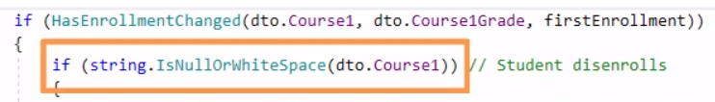

For example, if there is no incoming **course name**, this means that the student will **dis-enroll** from a former **enrolled** **course.**

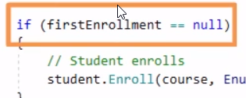

Next, if no **enrollment** currently exists, that means that the student **enrolls** in a new course, and so on …

This is already a sign that the update method does TO MANY THINGS ! We will now try to untangle the method by **extracting** all these pieces of functionality into their **own API endpoints.**

Let’s start with the **enrollment** functionality, let’s extract the specific enrollment code from this method and put it in its own method:

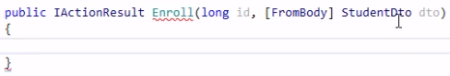

Let’s call this method **Enroll** which will takes the **StudentId** (id) and the **Student** which has been created in the corresponding create-window from the UI as input parameters.

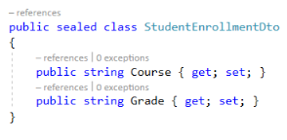

However we should also **refactor** the current implementation of the **StudentDto** class to just contain the properties necessary for the **enrollment.**

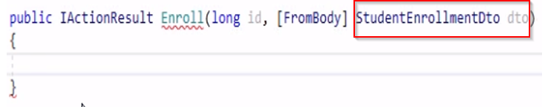

Next we have to refactor the Enroll method so it takes **StudentEnrollmentDto** as parameter.

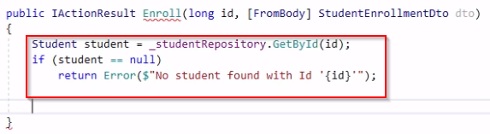

The next step is to **fetch the corresponding Student** from the **database** and return an error if such a student doesn’t exist.

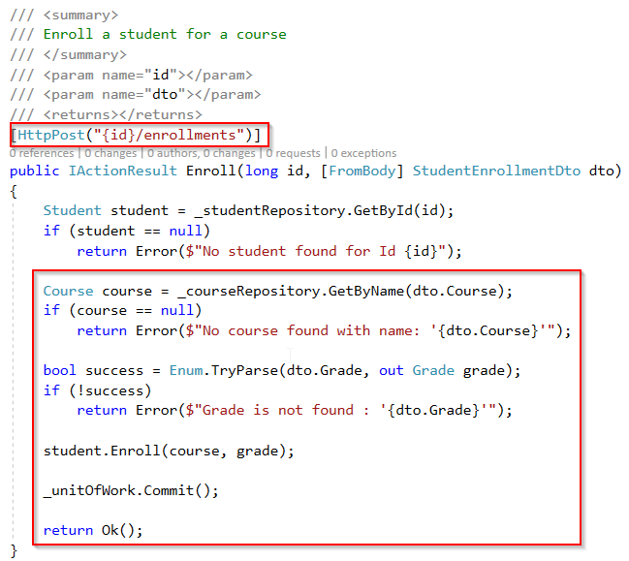

Next in order to **enroll** the student, we need to retrieve the **selected course** from the **database** and parse the **grade.** Finally we commit the save through the **unitOfWork** and return success (Ok) to the caller. We should also apply the right http-verb as attribute of the method.

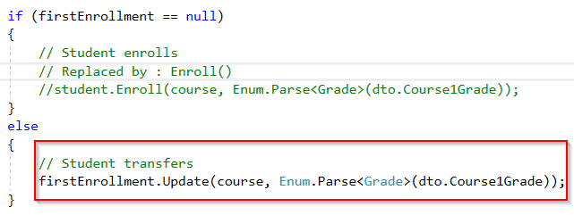

The next part of the original **Update** method that we will refactor is the **Student Transfers** course enrollment, which means that a student which already had an enrollment for a course transfers to another course.

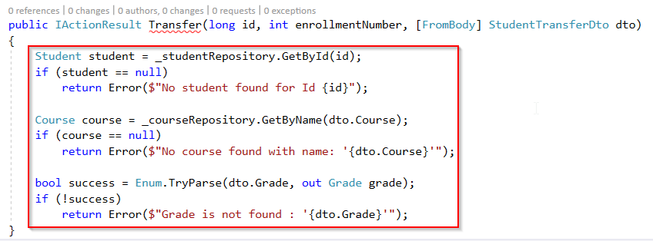

So we should create another **API-Endpoint** for the **Transfer** of a course. So let’s call the method **Transfer().** The method will take the student-id (id) as its first parameter. We also have to specify the enrollment number (because one of the business rules states that we can max add 2 enrollments for a course per student), so we have to specify which course for the student should be modified. We will also need the same **validations** as from the **enrollment method**.

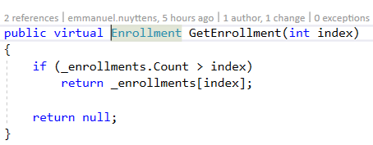

Next we need to get the **enrollment** itself from the student somehow, and currently we only have the **FirstEnrollment** and **SecondEnrollment** properties from the **Student.cs** domain class.

This class also already contains a method to get a specific enrollment, so let’s use that (first change private to public for the method modifier). And because we use NHibernate as underlying ORM mapper, we also should make this method **virtual.**

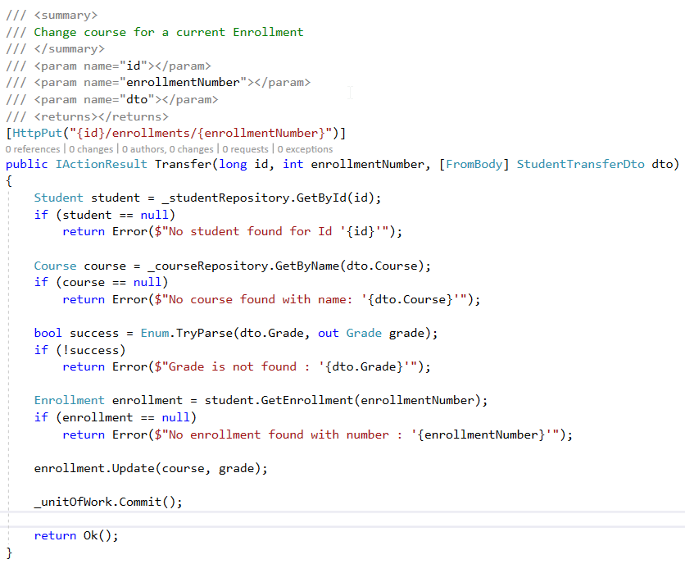

Next we can use the **GetEnrollment()** method from the **Student.cs** domain logic class into our **StudentController.Transfer()** method to get the appropriate **enrollment.** Finally we commit the changes and we also provide the appropriate PUT http verb as an attribute to the class method header.

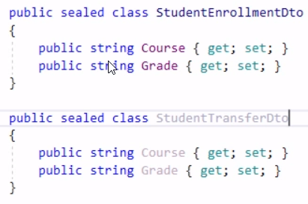

We also have to create a class to hold values of our transfer, we will call this **StudentTransferDto.**

|  |  |
| --- | --- |
|  | ***Important Note:***  *You will note that the classes StudentEnrollmentDto and StudentTransferDto are identically the same, and so in theory we could use the same DTO for both endpoints. However, this is generally a bad practice, because it introduces a tight coupling between the 2 endpoints. And if for some reason one of the 2 DTO’s has to change due to business requirements, this would mean that at some point in time some properties are not specific any more for a specific object, that is what we want to avoid. So we better create 2 separate objects, one for the enrollment and one for the transfer, even if they contain same behavior at this time.* |

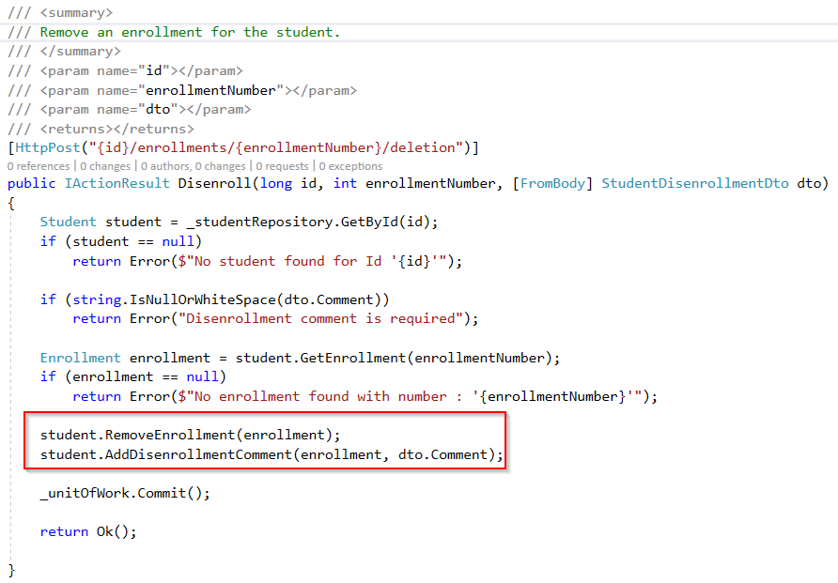

The next piece of code that we have to **refactor** from the StudentControlleris **“student disenrollment”.** So we will start by adding a **Disenroll()** method to our StudentController class.

Next we also need to retrieve the appropriate student object and check that a dis-enrollment comment has been added.

Finally we have to take 2 actions : one to remove the enrollment and another to add a dis-enrollment comment. Finally we commit.

|  |  |
| --- | --- |
|  | ***Important Note:***  *We use 2 methods from the student domain model to accomplish a single task (RemoveEnrollment & AddDisenrollment). This can be seen as a* ***code smell.*** *It is a sign that the* ***domain model*** *is not properly* ***encapsulated*** *and is* ***leaking internal implementation details.*** *Neither of the 2 operations make sense without the other one, this means that both should be transactionally commited or rollback to be in a consistent state. So we have to fix this !* |

*So we cannot “remove” an “enrollment” without adding a “disenrollment comment” and we cannot add a “disenrollment comment” without removing an “enrollment”.*

To fix the **code smell** as explained above, we must first open the **Student.cs** domain class which is part of the **Logic** project:

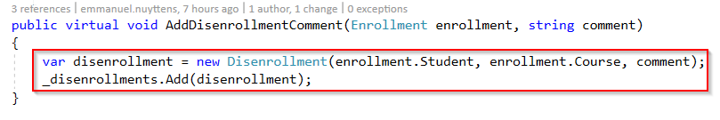

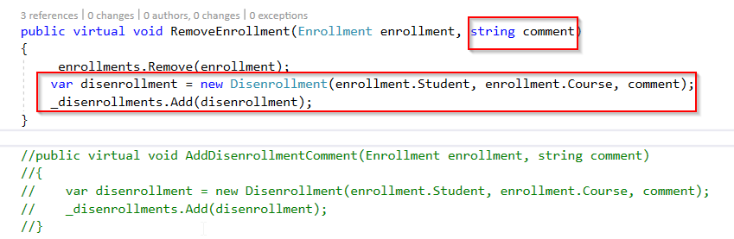

Next move the code from the **AddDisenrollmentComment**() method to the end of the **RemoveEnrollment()** method. We should also add the **comment** parameter.

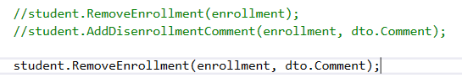

Also adapt the **Disenroll()** method of the **StudentController** class.

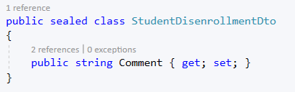

This method will also accept the studentid (id) and the enrollmentNumber and we also have to create a separate DTO, called: **StudentDisenrollmentDto**.

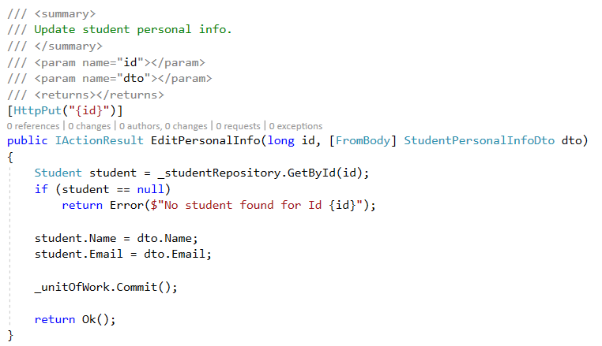

The last piece of functionality that we have to refactor is the **editing of the students personal information.** We will introduce a new method for this in the **StudentController** class.

We also need a new DTO containing the student properties that we can modify:

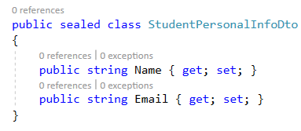

### Recap: Untangling the Update Method

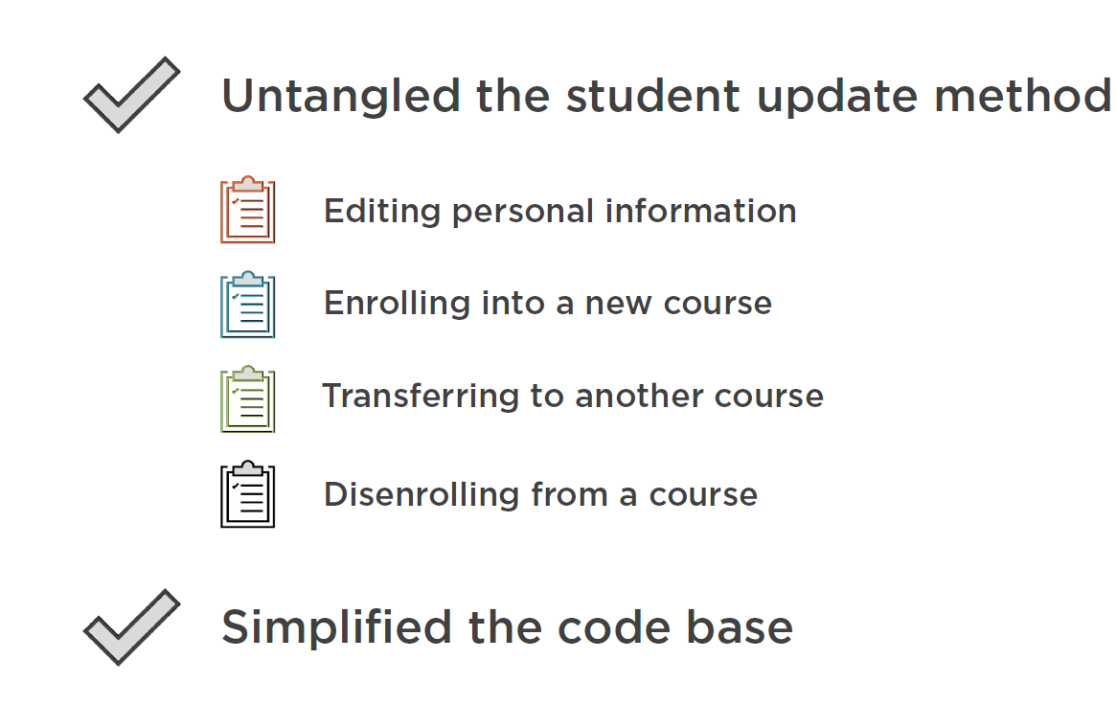

We refactored the CRUD-based API interface into a TASK-based API interface by creating smaller pieces of functionality with respect to the SRP approach. So each method is now responsible for **1 task and only 1 task !**

### Refactor to TASK-based User Interface

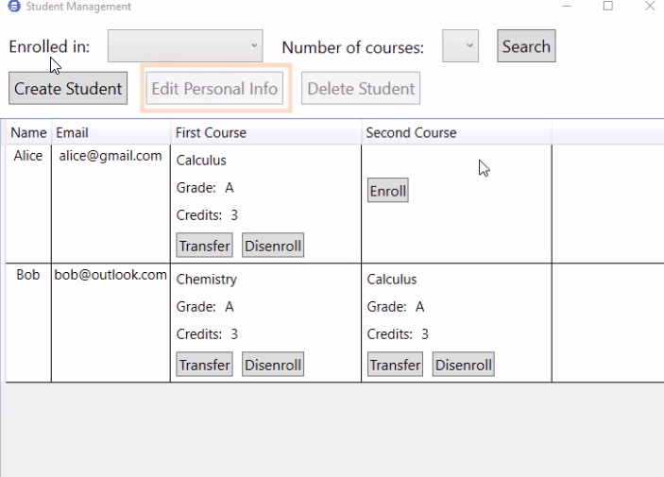

You can see that our UI has been changed to be compliant to our TASK-based backend API.

First we have the **Edit Personal Info** button (this was Update Student before).

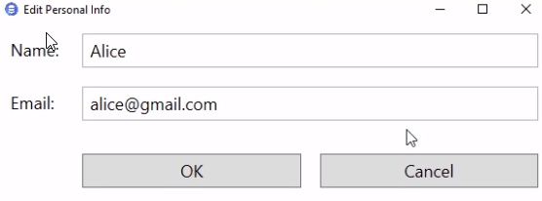

And if we “click” it , then it shows a much simpler and more intuitive window. The rest of the functionality is now represented as context-dependent buttons. E.g. “Alice” is not enrolled in her second course and now you can use the “Enroll-Button” to let Alice enroll into a new course:

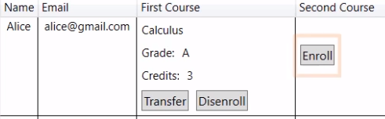

* Enroll View:

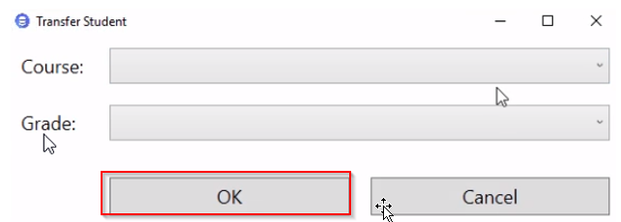

Window used to enroll a student in a new course. All fields are dedicated to accomplishing this specific task. Let’s have a look at the code behind the “OK” button:



* Enroll ViewModel:

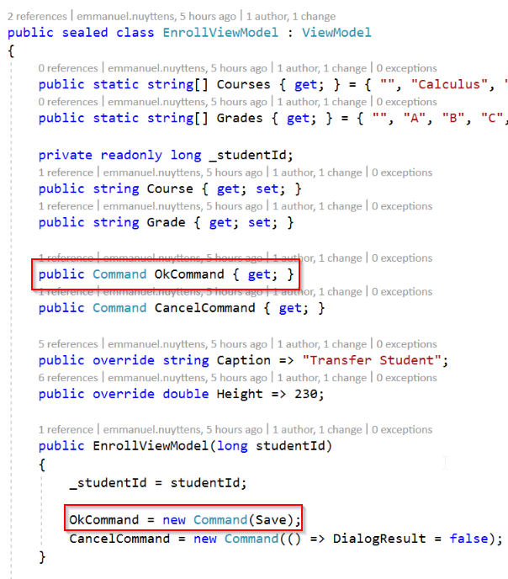

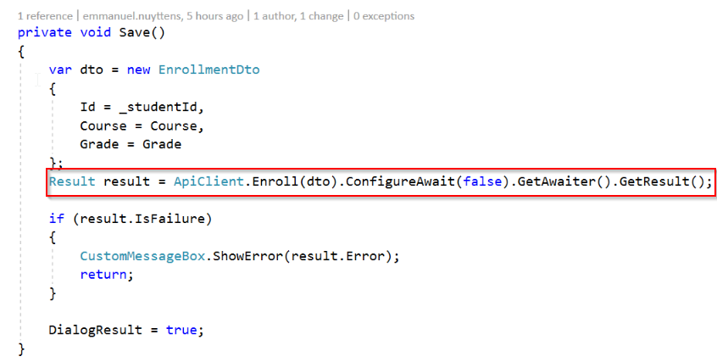

* UI.ApiClient (Proxy)

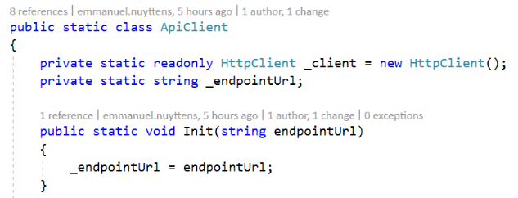

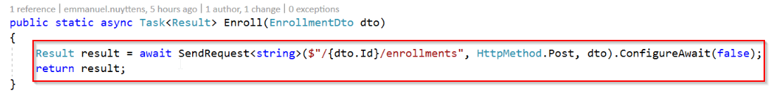

* Api.StudentController (API):

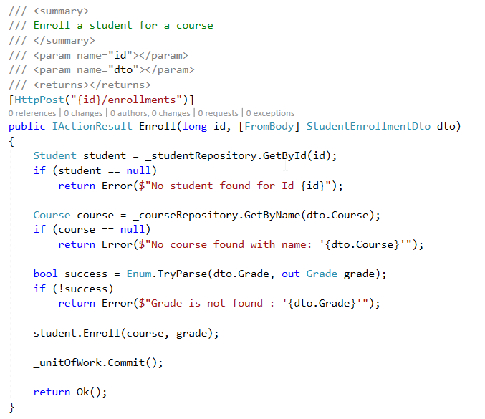

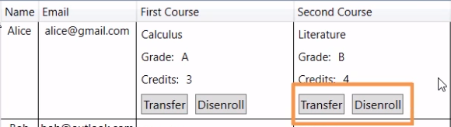

After we added an “enrollment” to a course, only the remaining actions show up when they are applicable. In our case, after adding a first course for Alice, we can only transfer to another course or dis-enroll from the course. Transfer and Disenroll will again have their specific “commands” in the linked view model which will execute the appropriate actions on the underlying Api, just the same way as we did for the **enrollment !**

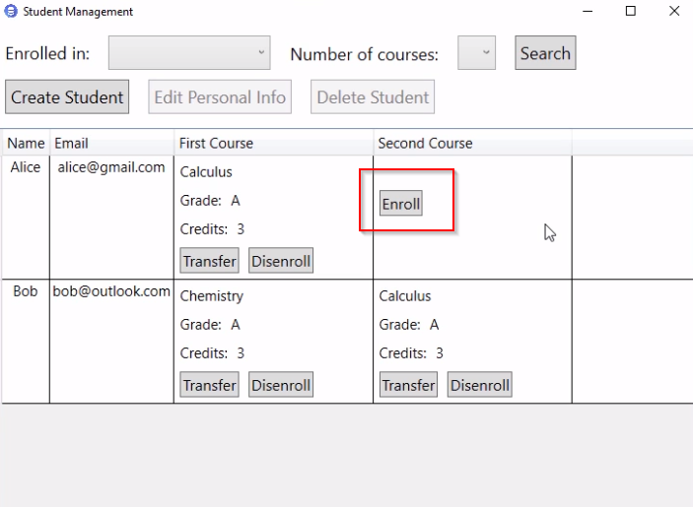

And finally, if we disenroll the course for Alice, we will get the “Enroll” action again, so this makes sense, and this way users are better guided throughout the use of the application.

### Dealing with Create and Delete Methods



What about the “create” and the “delete” endpoints in the StudentController class which are being executed from the “Create” and “Delete” commands in the ViewModel ?

Let’s first have a look at the delete method in our API Controller class:

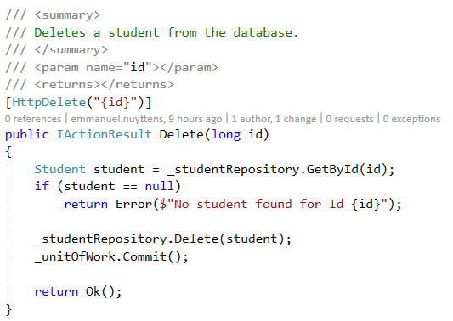

The delete method is “small” and does 1 thing, so it doesn’t violate SRP.

Next let’s have a look at the create method in our API Controller class:

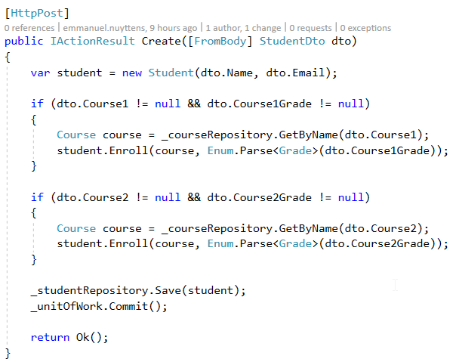

It might look like the create method does to many things, because it both creates a student and enrolls the student into courses. But actually this does not violate the SRP principle because these 2 actions are atomic and form a single-transaction.

There are still problems with these 2 methods. 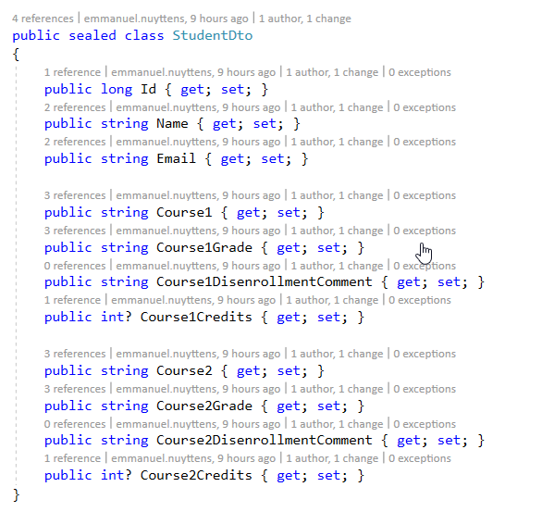

First the **Create** endpoint still uses the **StudentDto** to accept data from the calling clients. This is also the same DTO that the UI uses to display the students in the grid, and it has a lot of fields that we don’t need when creating a student ! So we need to come up with a separate DTO that would contain only the fields required for the create task !

The second problem is the names of these methods. Ask yourself the question: “Does it make sense from the domain’s perspective to create or delete a student ? How do the domain experts describe these operations ?

Remember: Any API endpoint that is named after one of the CRUD operations is a red flag, and each time you see such an endpoint, ask yourself: “Is this operation really just that, a delete or a create, or maybe there is a deeper meaning behind it ?

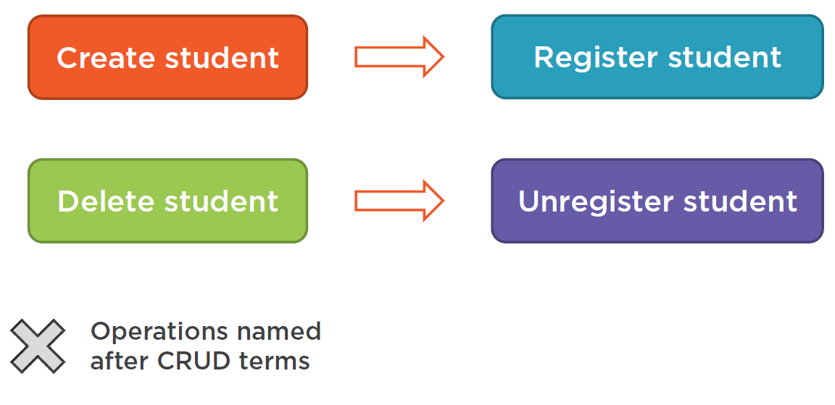

This habit alone can give you a great amount of insight into the problem domain that you are working on. So, what do these methods actually mean ? The only way to find this out is to ask the domain experts. They may say “register” instead of “create” and “unregister” when they mean to “delete” a student. So it makes sense to incorporate this piece of UL into our code as well !

So let’s start to-do the necessary refactorings !

First we create the Dto to “register” (aka: create) a new student:

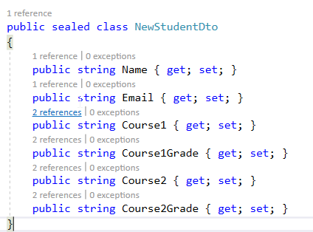

And refactor the “Create” method:

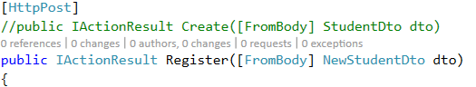

And refactor the “Delete” method:

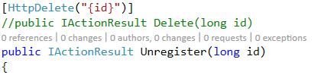

|  |  |
| --- | --- |
|  | ***Important Note:***  *The full blown “StudentDto” class will now only be used for displaying students in the datagrid of the UI. And so we can get rid of the fields that were only used for modifying the student. In particular we don’t need the disenrollment comments anymore.* |

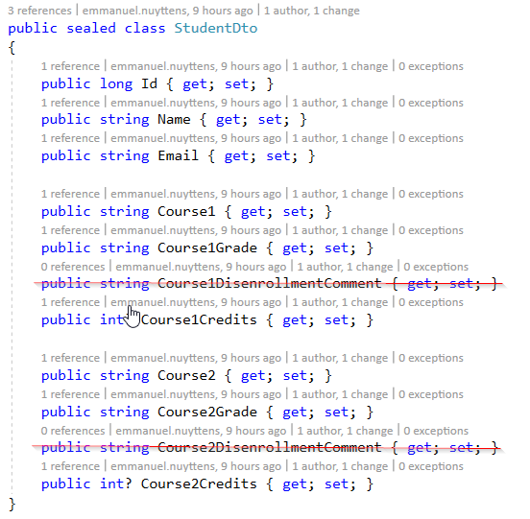

### Recap

We have now refactored the CRUD-based app towards a TASK-based app which gives us a lot of benefits in terms of **performance,** **scalability,** **simplicity** and **user experience.**

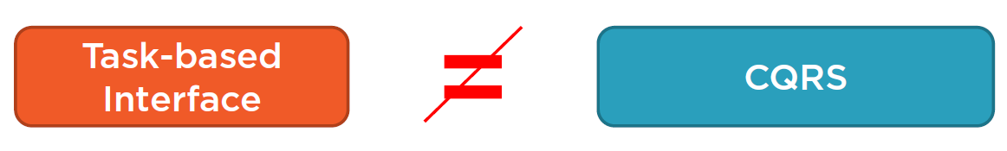

But although we favor TASK-based implementations, it is **not** a pre-requisite for **CQRS !**

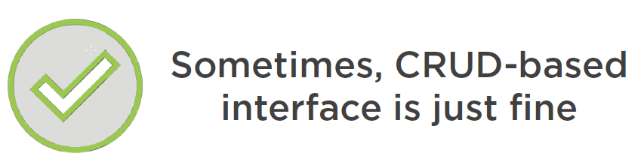

And sometimes CRUD-based interface may be just fine too ! ☺

# Module-4: Segregating Commands and Queries

## Introduction

In the previous module we refactored our application towards the **TASK-based interface**. All the operations that can be performed on a **Student** domain object are now clearly defined wand have their **own API endpoints.**

Our next goal on the path to refactor the application towards **a CQRS based** implementation would be to **explicitly split between “Commands” and “Queries”** and this for each of those **API endpoints.**

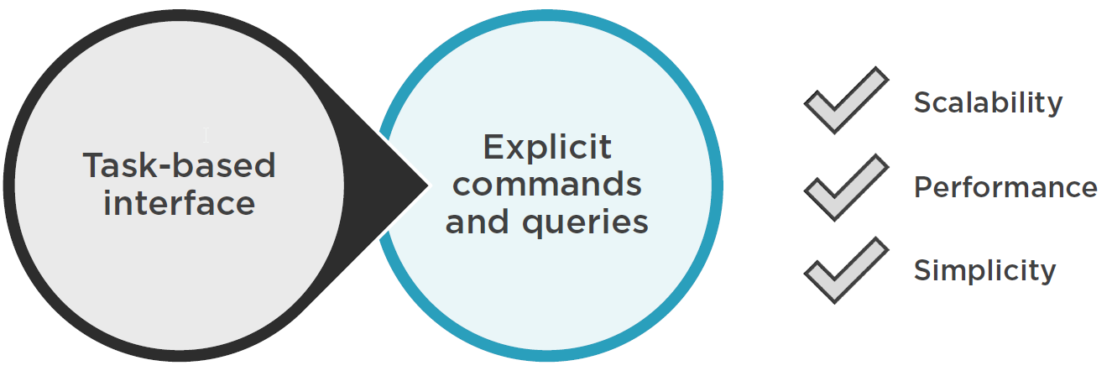

This refactoring towards **Commands and Queries** will bring the real **benefits** that we discussed in the first module, more specific benefits towards:

* Scalability.
* Performance.
* Simplicity.
* User Experience.

## Introducing a First Command

Ok, let’s start to open our **StudentController API** as hosted in the **Api** project:

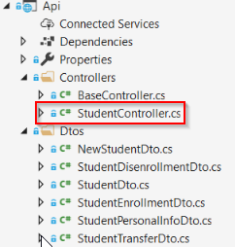

Let’s first outline which of the API controller endpoints here represent **commands** and which represents **queries.**

As we already discussed in module 1 :

*“Every operation can be either a command or a query. A query doesn’t mutate the external state, such as that of the underlying database, but it will return something to the caller. On the other hand, a command is the opposite of that. It does mutate the external state but doesn’t return anything to the calling client”.*

### Inspecting the GetList endpoint

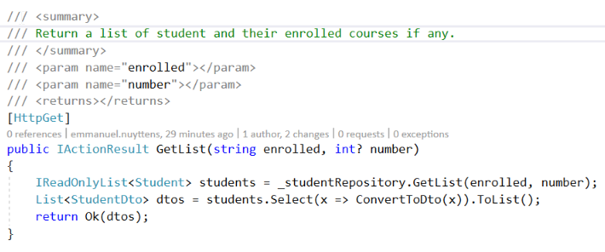

The GetList method is clearly **a query** which **returns a list of students which are enrolled in some course(s).** The method **doesn’t mutate** any of the underlying data.

### Inspecting the Register endpoint

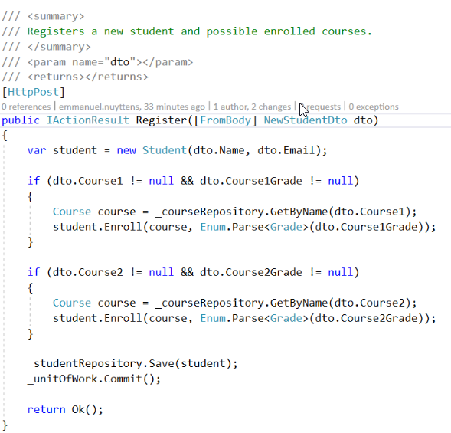

The register endpoint is clearly a **command**. It does **mutate the database** as it inserts a new student into it and it **doesn’t return anything** to the caller other than the acknowledgment of the operation success.

### 6.2.3. Inspecting the remaining endpoints

Next endpoints are also commands:

* Enrollments
* Transfers
* Disenrollment
* Editpersonal information

### General rule for REST

* PUT and POST 🡪 Commands
* GET 🡪 Queries

### Separate classes for Commands and Queries

To continue down the CQRS path, we need to introduce separate classes for each command and query in our application, and we’ll start with the **EditPersonalInfo** method.

In project **Logic** folder **Students/Commands** we create a new class for that and call it **EditPersonalInfoCommand.**

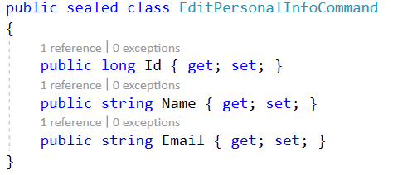

So in our case we will create a Command to notify that the properties for a student have been modified by some action in a client application, so we have to include those properties in the **EditPersonalInfoCommand** class. We also have to add the unique identifier of the Students, which is the Id.

#### The Command Class

What we can do now in our **StudentController** action is create a command and execute it. This would be the most obvious choice. However this is not the best design decision because we would have 2 different concerns here:

* Command itself should represent what needs to be done. It should be a “declaration of intent”.
* The execution itself is a different matter. The execution will often refer to the “outside” world, such as the database and you don’t want to delegate that responsibility directly to the commands. This is an important point ! So we don’t want the command to execute itself, it should be a separate class that where execution is delegated to. This is the task of the **CommandHandlers,** and in our case we would create a **EditPersonalInfoCommandHandler** class for that purpose.

#### The CommandHandler Class

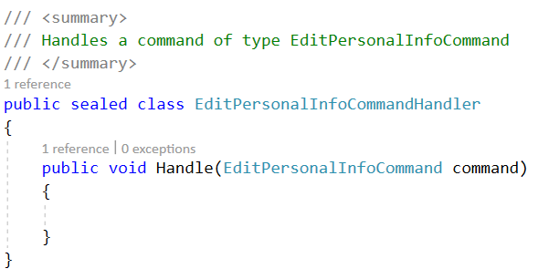

A CommandHandler should at least contain a single public method called **Handle().** This method is responsible for receiving the incoming command and handle it appropriately.

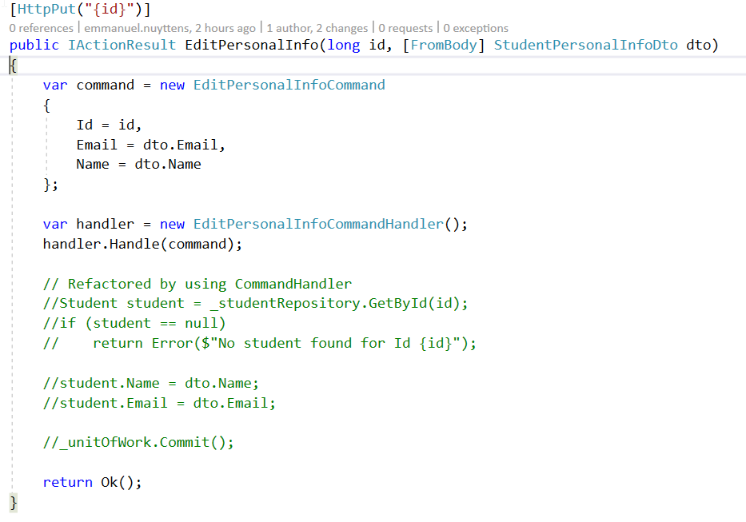

Next we can create an instance of the command handler class and pass the command to in in the controller instead of creating and executing the command directly.

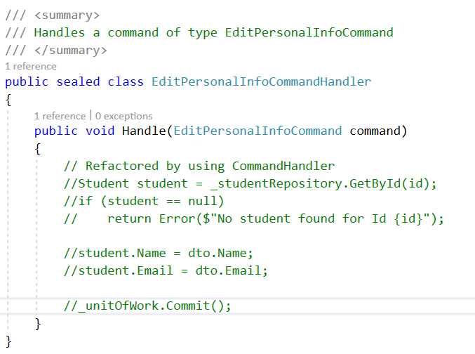

The rest of the code (the business-logic) can then be removed from the controller and be part of the appropriate CommandHandler class (EditPersonalInfoCommandHandler in our case).

|  |  |
| --- | --- |
|  | ***Info:***  *The problem with the design as mentioned above is that we need to instantiate the command-handlers manually in each controller methods, and this would be very repetitive. Or we would have to inject them into the controller’s constructor. But having to inject each handler into the constructor of the controller is not a good idea too. This would certainly damage the maintainability of the code !* |

What we can do instead is **leverage the ASP.NET Core dependency injection infrastructure,** and we will do that in a moment …

Another problem with this approach is that each handler class will have their own public API. There would be no common interface between them, and so we won’t be able to extend them with new functionality. We will handle this by adding **decorators** on top of the **command handlers** so that we could enrich those handlers and introduce cross-cutting concerns to our application.

#### Introducing the ICommand Class

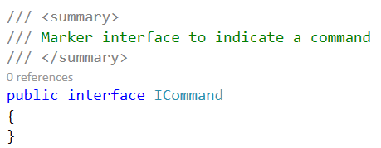

And so we need **a common interface** between all our **commands and command handlers**. For that we need to introduces **a couple of new types.** The first is the **ICommand.** Its ‘a so-called **marker interface**, which means that its to mark the commands in our code base. So let’s add this in our **Logic** project in folder **Students/Command.**

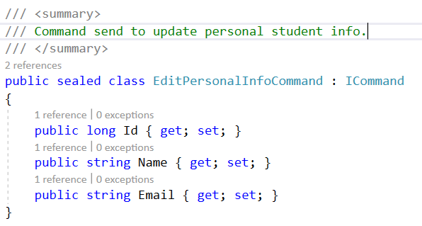

Next we can make our command implement this interface.

#### Introducing the ICommandHandler Class

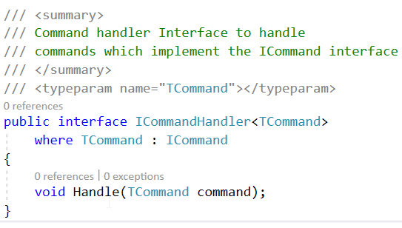

The second interface class that should be added Is the **ICommandHandler** interface class. It’s the interface that works with a **particular type of commands,** and this type is specified as a type <T> where T = ICommand implementation. The interface itself will just have a single method called **Handle.** The Handle method will then accept a command of type TCommand.

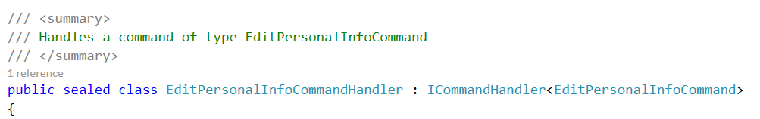

Now we can inherit our **EditPersonalInfoCommandHandler** from the **ICommandHandler** interface.

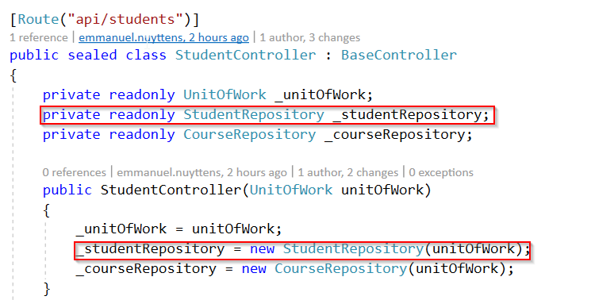

The handler needs a **Student Repository.** Before, in the controller we created the repository in the constructor by instantiating manually. For that we use an instance of **UnitOfWork** that ASP.NET Core injects into the Constructor.

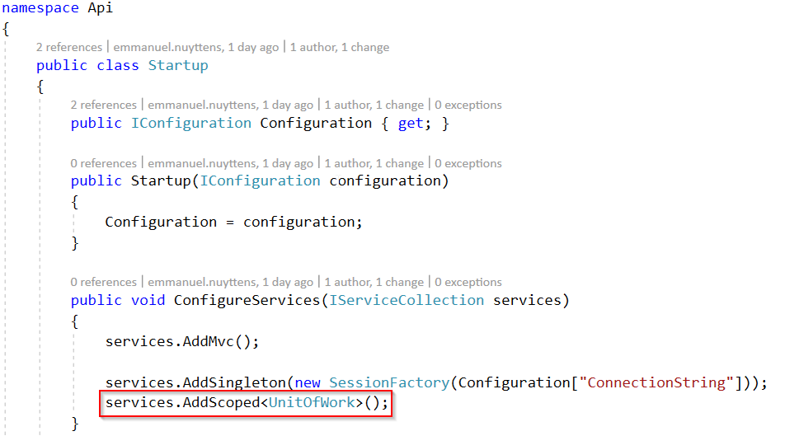

This injection initialization is done in the Startup.cs class of the API-project as shown above.

So we can repeat the same principle for the CommandHandler.

Next we can add the handling code of the handler.

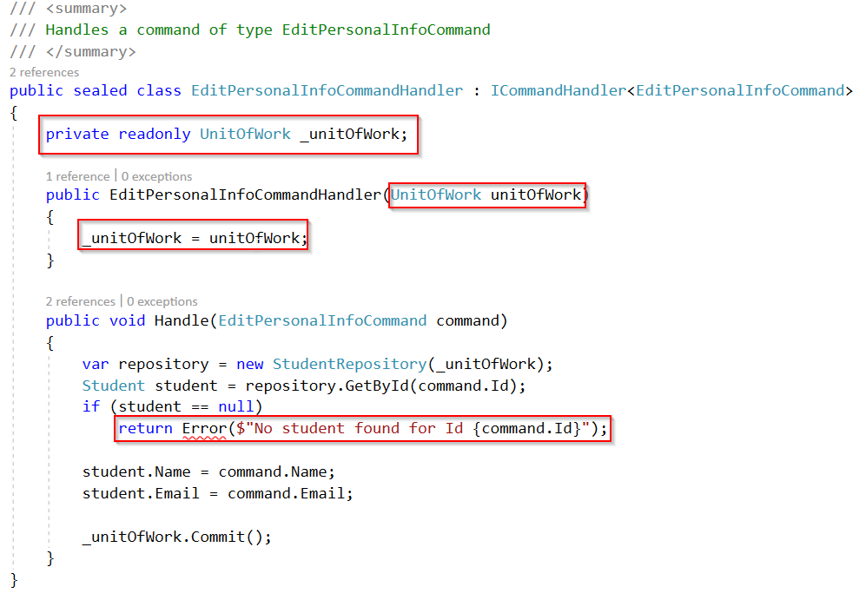

The only issue we have is the **“Error”** type, so what can we do about it ? If we look back in the controller (StudentController in our case) and open the definition of the **Error** method then you can see it is defined in our **BaseController** class:

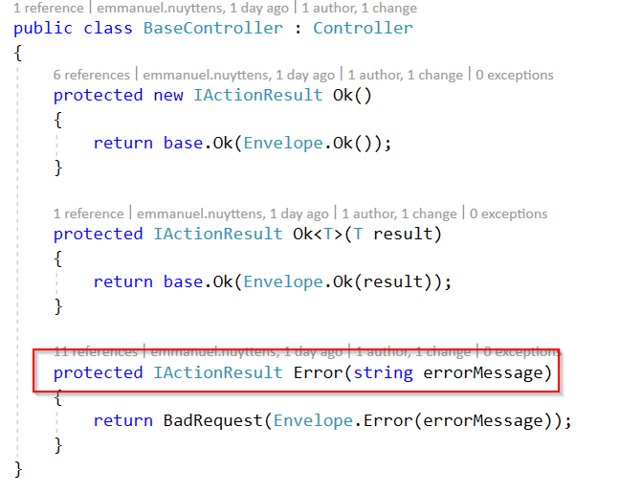

It is basically a wrapper on top of the built-in **BadRequest** action result and we pass an **Envelope** with the error to it. We could make our command handler an instance of **IActionResult** too but that is not the best design decision we can make !

It’s better to leave the specific **ASP.NET concerns to the Controller** and keep the command handler free of such concerns. But how can we return an error from the command handler then ? One way would be to throw an exception, which is also not the best way to deal with this issue. Exceptions used for controlling the program flow and more specific for validation, tend to complicate the code base, and it’s better to use an **explicit return value** instead.

So in our case we will use the special **Result**  class : this is a simple class which either represents a **success** or a **failure.** It is part of a NuGet package:

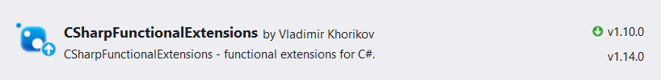

The refactored code for both the **command handler and controller endpoint** is next:

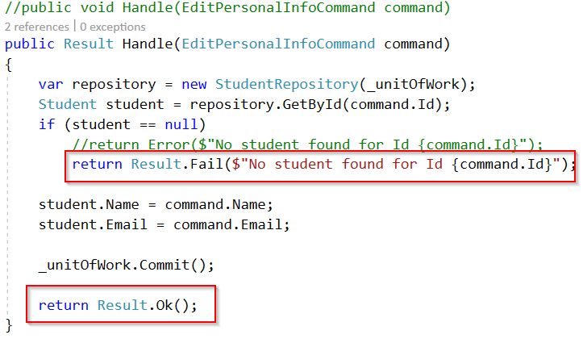

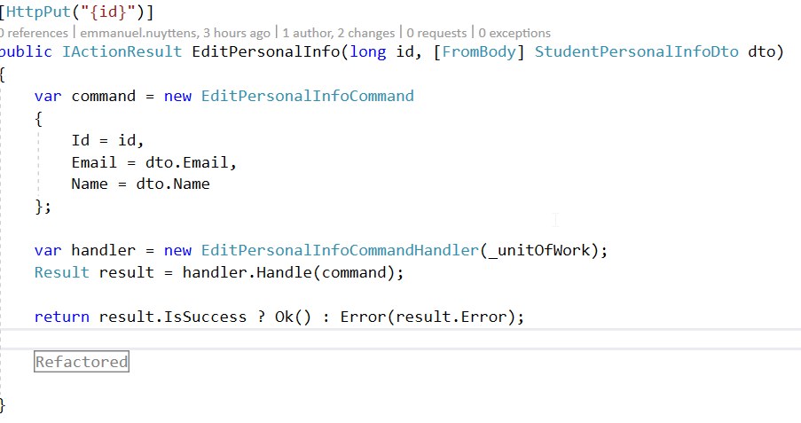

## Command in CQS vs. Command in CQRS

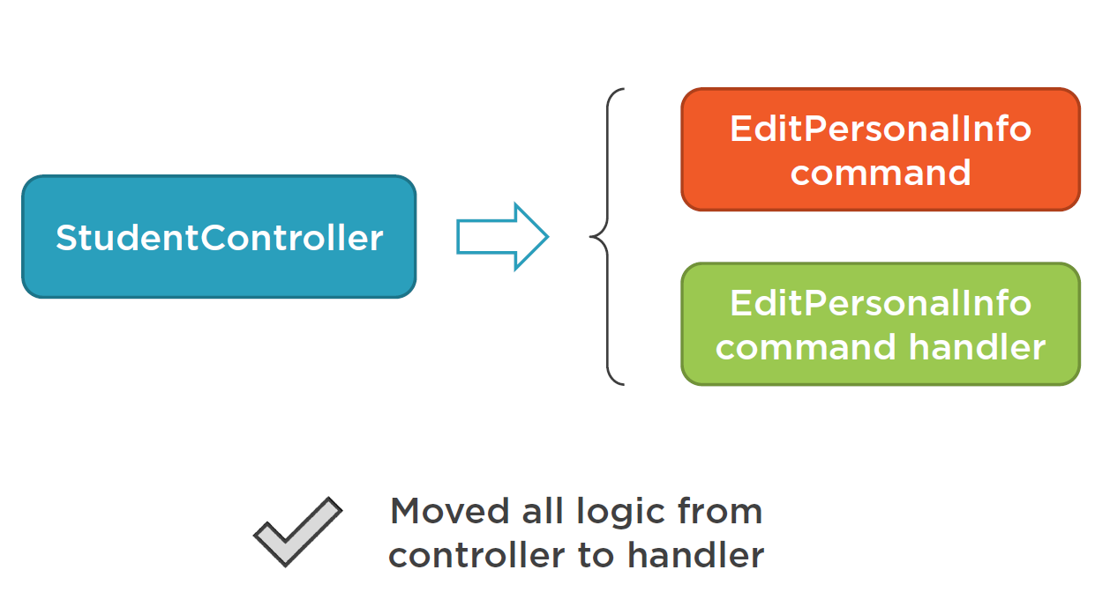

We introduced our first command called **EditPersonalInfoCommand** and it’s command handler **EditPersonalInfoCommandHandler** and we moved all the code from the corresponding **API-Controller** method to that handler. Now all that the controller method does is creating an instance of the command and the command handler and passes the created command to the command handler, get’s a result back from the handler and sends the result back to the calling **client.**

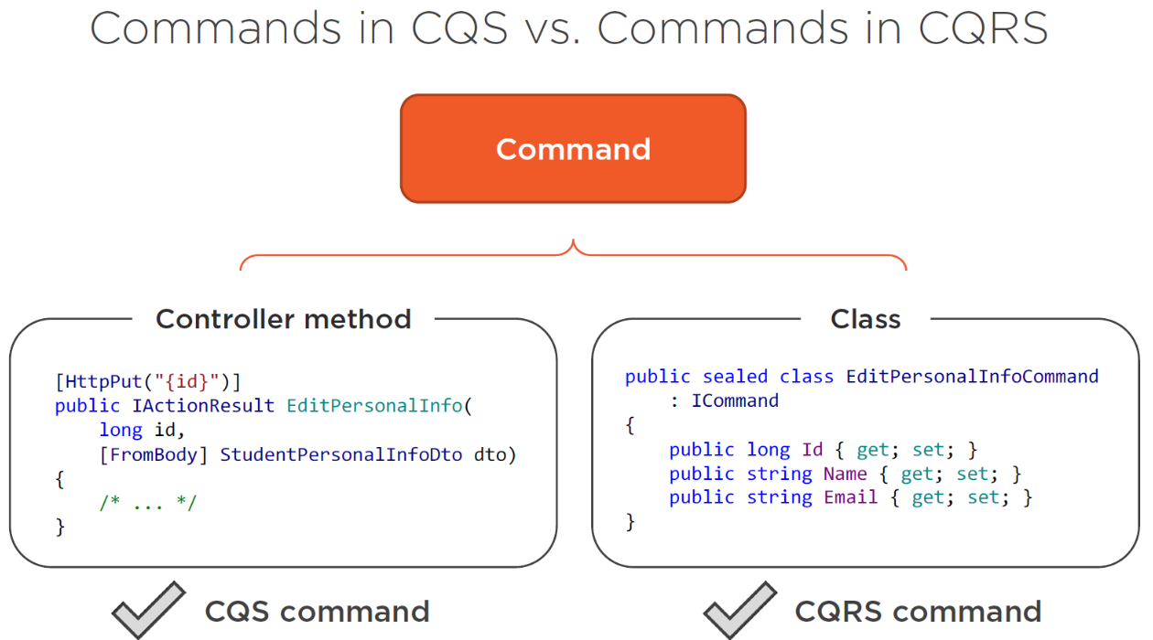

Currently we’ve been using the term **command** into 2 different ways 🡪 the controller method and the command class.

A command is a serializable method call. Is there an analogy for a command handler ? Yes, because you can think of command handlers as being **regular ASP.NET controllers** with just a single method and that single method is also a command in the CQS sense, because it **mutates state and returns void** (or a confirmation that the method is well executed or not).

## Commands and Queries in CQRS

All messages in an application can be divided into **three categories:**

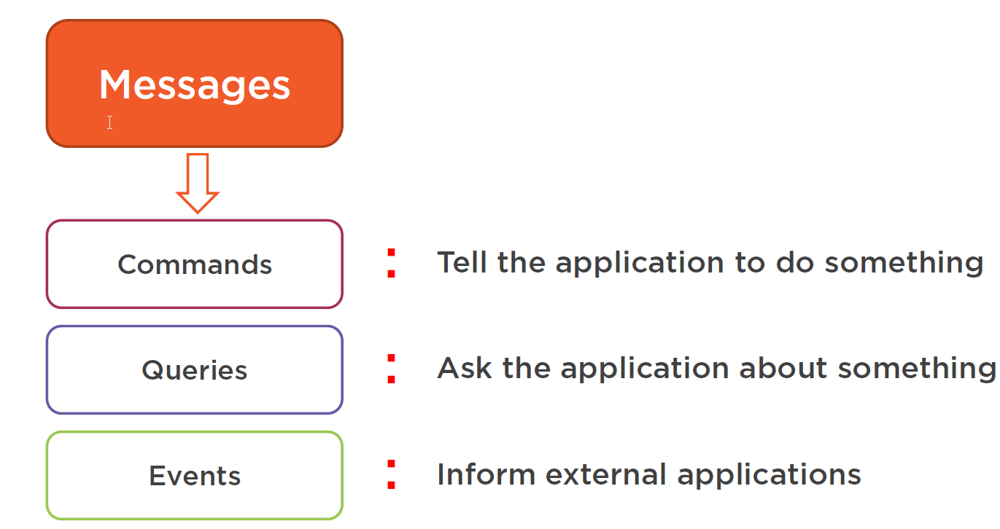

Our application can create an event to **inform external applications** about some **change.**

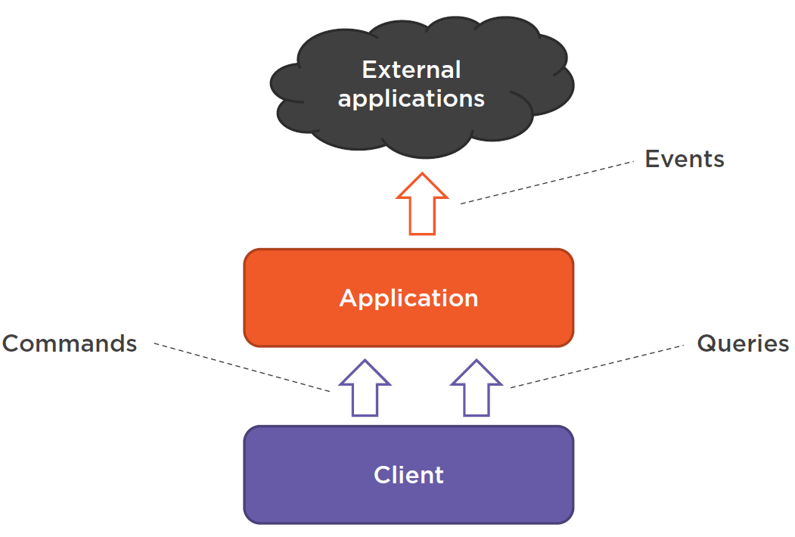

In the image above, we see all 3 types of message together in a single diagram.

1. The **Client** sends **commands** or **queries** to our **Application** in order to tell to either do something (command) or ask about something (query).
2. Next our **Application** communicates with **External Applications** via **Events.** It informs them about **changes** within the **Application.**

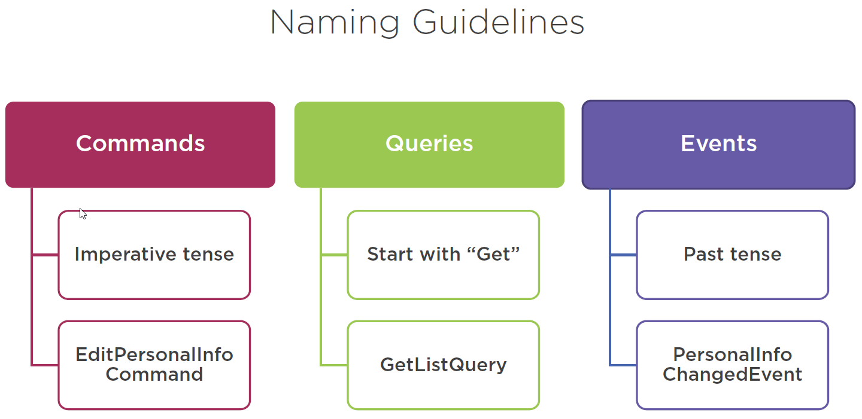

There are naming guidelines associated with these 3 kind of messages:

First of all, **commands** should always be in **imperative tense**. That’s because they are telling the application to do something, e.g. **EditPersonalInfoCommand** is a good example here.

Next **queries** will usually start with the word **Get**, like **GetListQuery**. That’s because queries will ask the **application** to provide some **data,** and the word Get is the most natural way to define this.

Finally, **events** should always be in the **past tense.** That’s because they state a fact that **already happened in the past.** E.g. **PersonalInfoChangedEvent.**

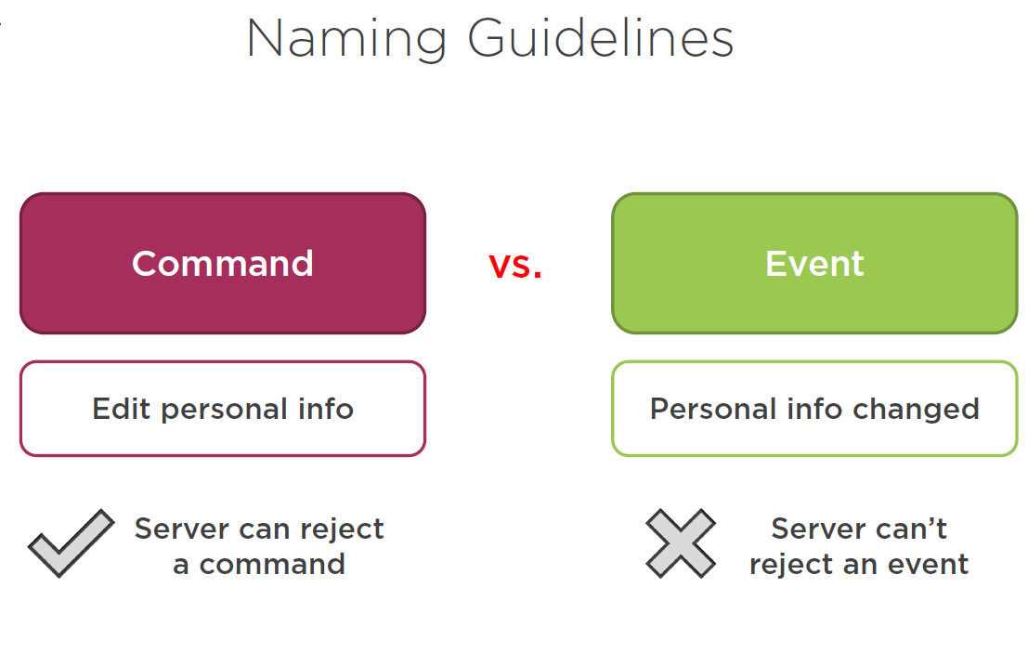

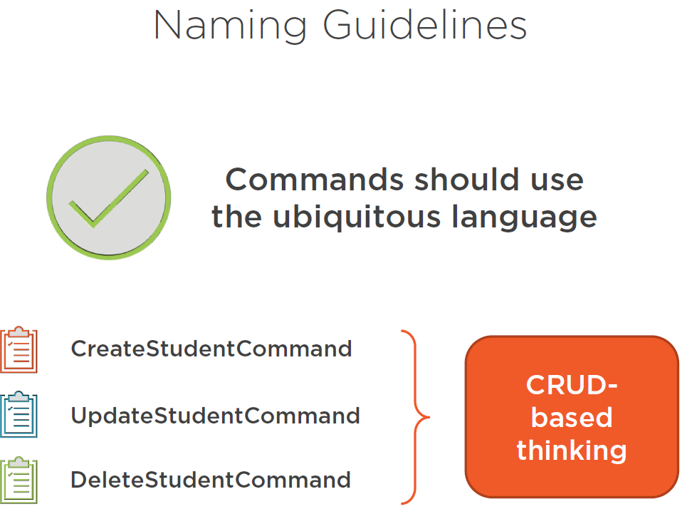

## Commands and Queries in the Onion Architecture

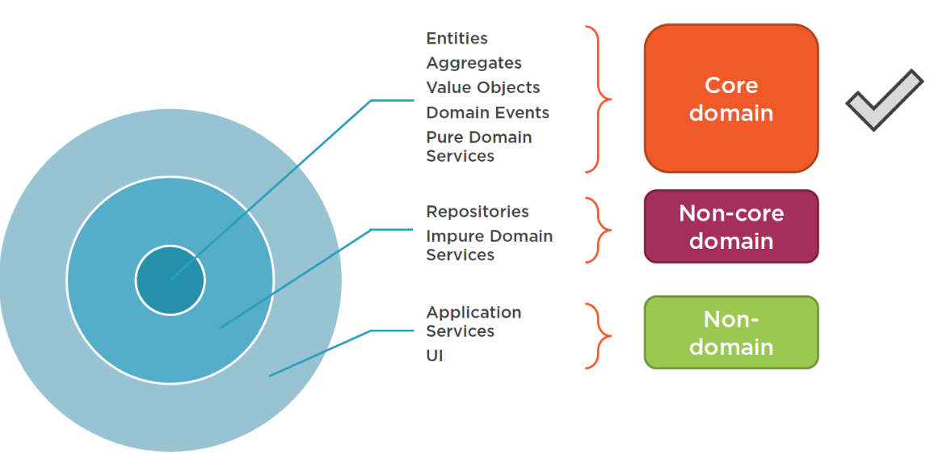

Above is a typical architectural design picture to define the different layers in a domain-driven-design enabled application, also called the onion-architecture.

The inner layer represents the “Core domain” containing domain entities represented as Aggregates and Value Objects, domain events and the pure Domain Services.

The layer above represents the so-called “Non-Core Domain”, these are the artifacts which represent the external world, like the database, file system and non-domain related Services.

Finally we have the specific Application Services and the UI, which don’t belong to the domain-model.

Such a layering helps us to show the relationships between the different parts of the application. E.g. the domain-layer (inner-circle) should be isolated from the external world.

Now, where do commands and queries belong into this picture ? Events are already presented at the “core-layer” of the onion and commands and queries also belong to the core-layer, just like the domain-events.

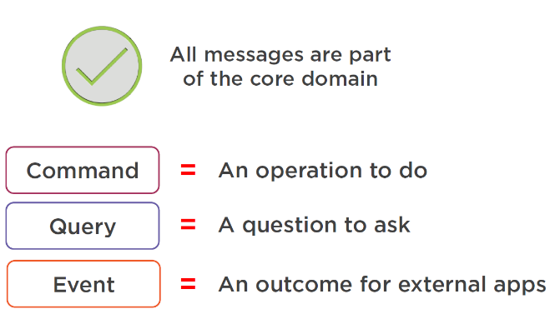

All messages in the application are part of the “core-domain-model”. They explicitly represent what the “clients” can do with the application, that would be represented by the “commands”, and all the questions that the client could ask would be by intermediate of the queries. And what the outcome is for the external applications, that’s the events, summarized:

* Client “instructs” the domain to do something 🡪 “Commands”.
* Client “requests” data from the domain 🡪 “Queries”.
* Client should “act” upon some executed action in the domain 🡪 “Events”.

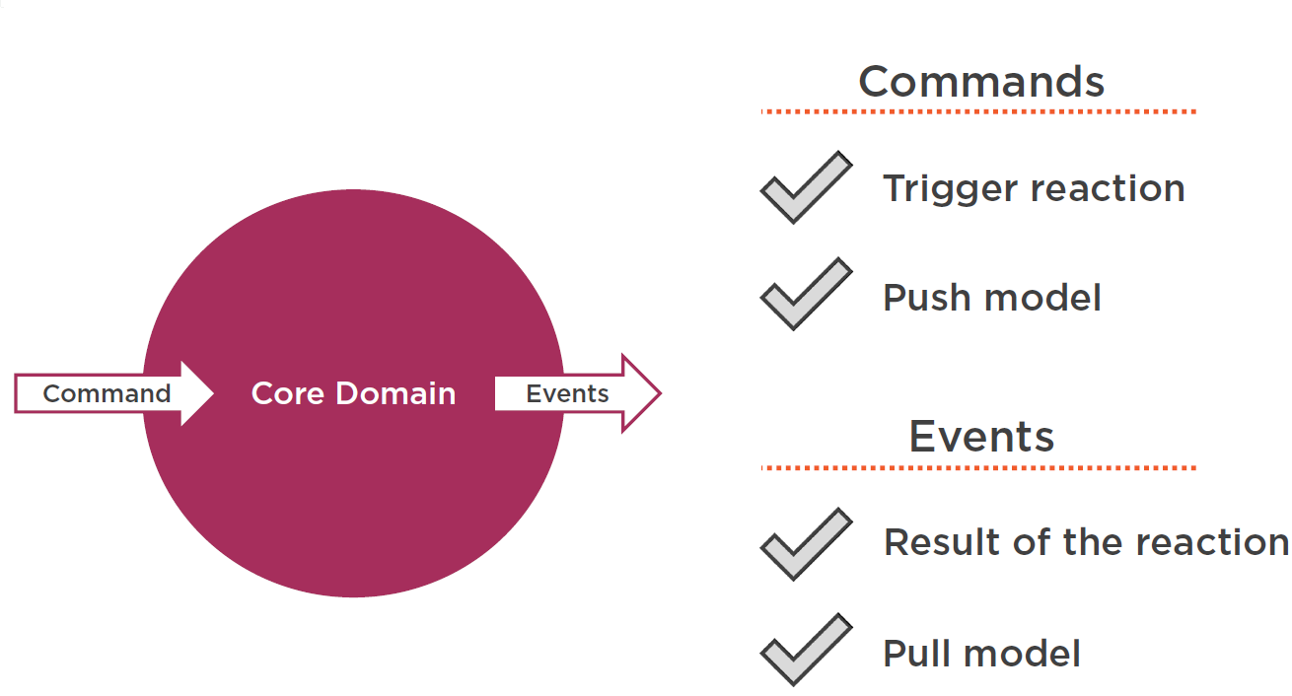

## Commands vs. DTOs

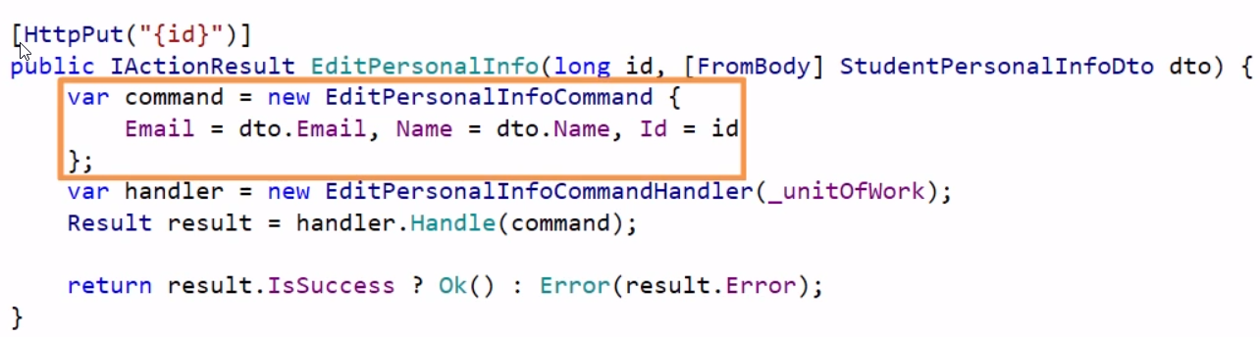

A DTO[8] is a data contract made for the client and it’s structure should map as close as possible to the representations needed in the **user interface.** If we look for example to our **EditPersonalInfo** API method, it receives a **StudentPersonalInfoDto** from the client and transforms it to a **EditPersonalInfoCommand** which will be handled by the appropriate **CommandHandler.** This is a good practice as shown above.

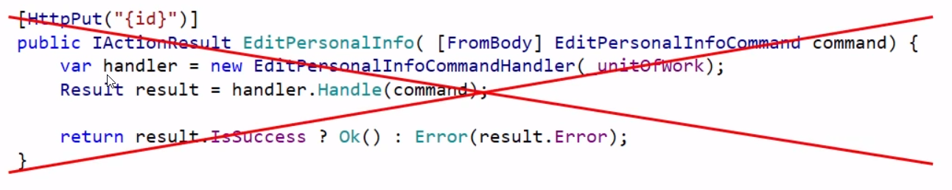

We could be “tempted” to “leak” the command structure into the outside world (client in our case), and let the client create the command and omit the mapping to the corresponding DTO, but it is not a good practice to-do so. Commands and DTOs are different things.

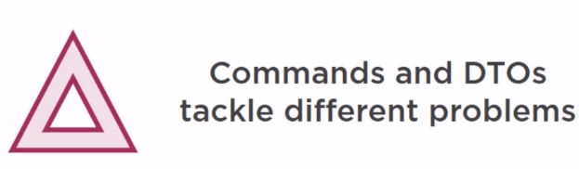

**Commands** are serializable method calls on the methods in the domain model, whereas **DTOs** are the DataContracts between the Backend-API and the Presentation Layer of the calling Client.

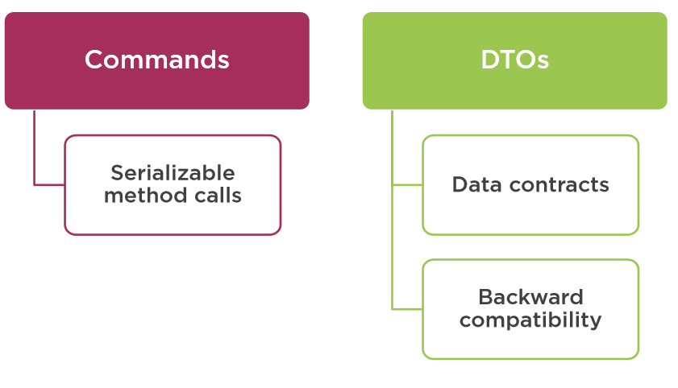

The main reason that we create this separate layer with data contracts is to provide **backward compatibility for the Clients of** our Backend-API. Without the DTOs, our API could introduce **breaking changes** with every **change of the domain model.**

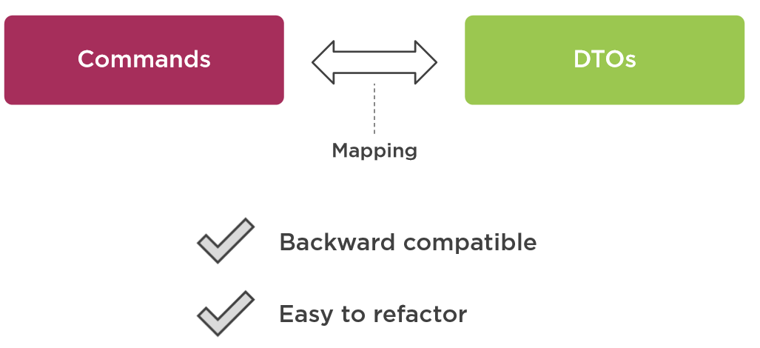

So the main purpose of mapping between the DTOs and Commands is for backward compatibility and easy refactoring of both domain model and the required contract for the client. E.g. we do not want that changes in the domain model which does not affect the user interface are leaked into the user interface, and which may lead to re-deployment of both backend and frontend when something in the domain model changes !

## Leveraging ASP.NET Core Dependency Injection to Resolve Handlers

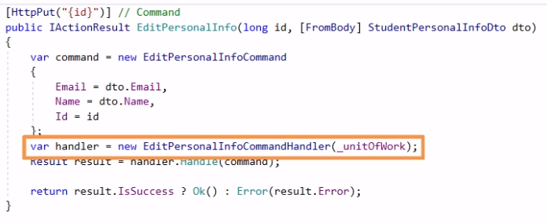

As it is not convenient to create command handlers in each and every controller action manually. For example, in the **EditPersonalInfo** action, we are instantiating and executing the command handler within the controller action method, as you can see above.

What we can do instead is that we can **leverage** the **ASP.NET Core dependency injection** mechanism to resolve the command handler for us.

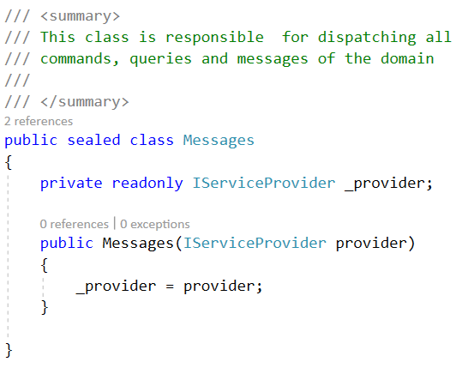

We can do that by creating a **helper class** first called **Messages** in our **Logic** project**,** we can add this in the **Logic** project under the **Utils** folder. This class will be responsible for dispatching all the **messages, events** and **commands** within the domain.

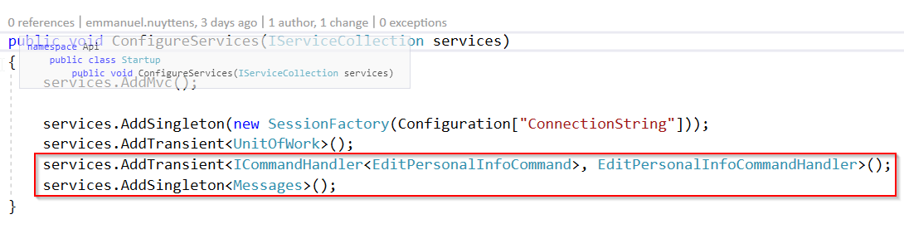

We inject an instance of the **IServiceProvider** instance in the constructor of the class. This interface is part of the .NET Core framework (Component(Model) and implements the **Service Locator Pattern** and it gets from the **dependency injection container** a service of a given type. These possible types are registered in the **Startup.cs** classof the **Api** project. We should also tell the dependency resolver how to resolve our CommandHandler.

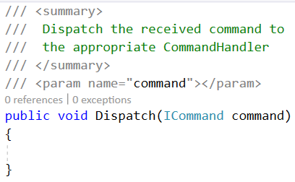

Let’s return to our **Messages** class. Next we add a **Dispatch** method. This method will an implementation of an **ICommand** class as a parameters and “Dispatch” the command to the appropriate **CommandHandler** class as defined by the **ASP.NET Core Dependency Injection Container** as registered in the **Startup.cs** class of the **Api** project.

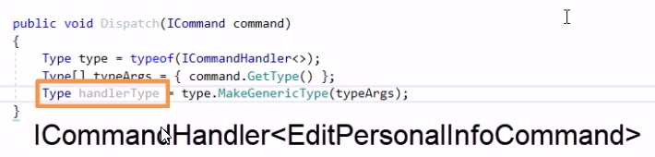

Within the **Dispatch** method we have to find the right CommandHandler for the given Command instance. We have already the **provider** instance which knows how to **resolve a handler for a particular ICommandHandler interface.**

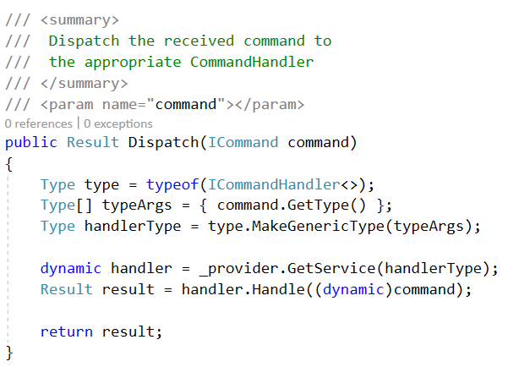

Next we can make use of the **dynamic** type to create the handler from the provided type information and execute **Handle** on the handler class.

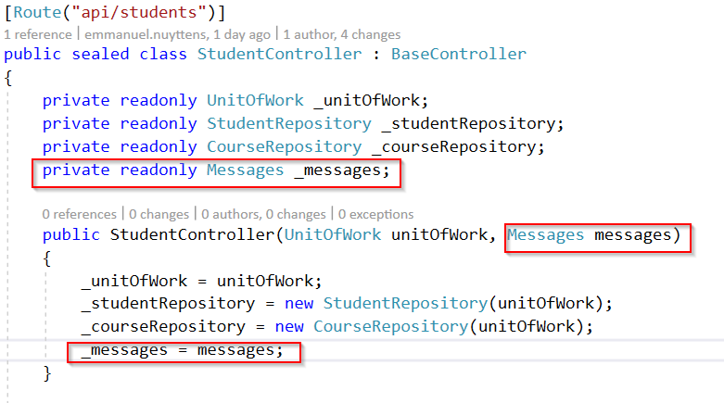

Next we go to the **constructor** of the **StudentController** class and pass in an instance of the **Messages** class.

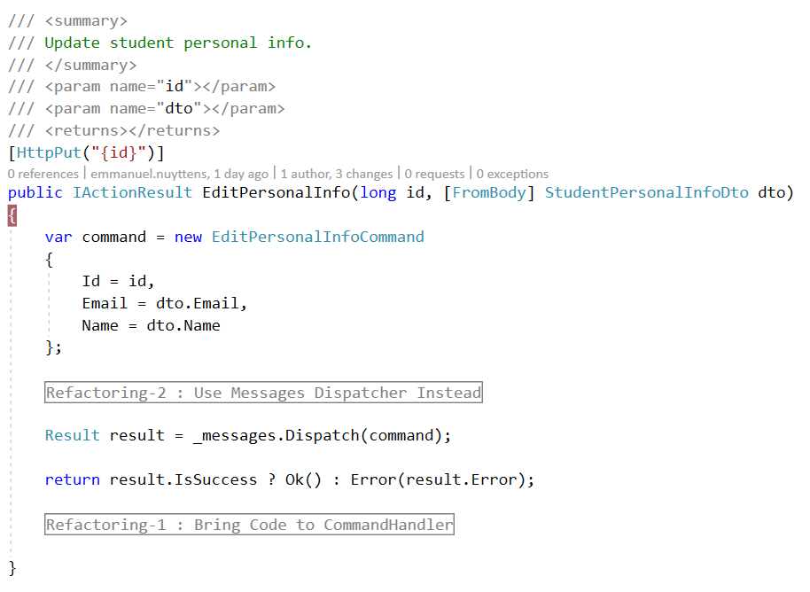

And finally in the **EditPersonalInfo** method (endpoint) we can use our **messages** instance to dispatch the command to the right command handler.

## Introducing a Query

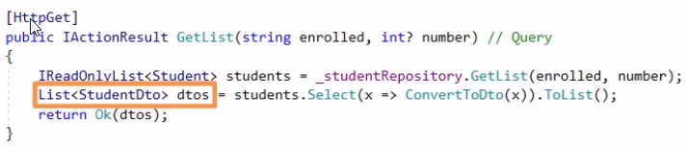

Let’s now introduce a query, this represents the **read** side of our application. There is currently only 1 method that is a query in the CQS sense, and that is **GetList** in our **StudentController** which returns a list of **StudentDto**.

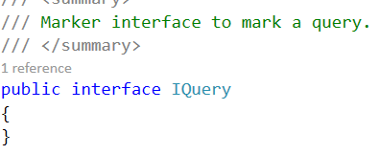

Similar as **ICommand,** we have to create an **IQuery** interface to in our **Logic** project.

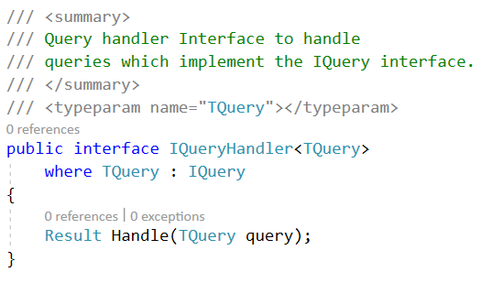

Similar as **ICommandHandler,** we have to create an **IQueryHandler** interface to in our **Logic** project.

Instead to the CommandHandler, which normally doesn’t return any **data** besides the Ok() or Error() as a Result. But the query has to return some **data.** How to fix this ?

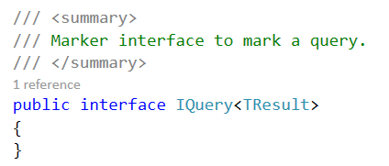

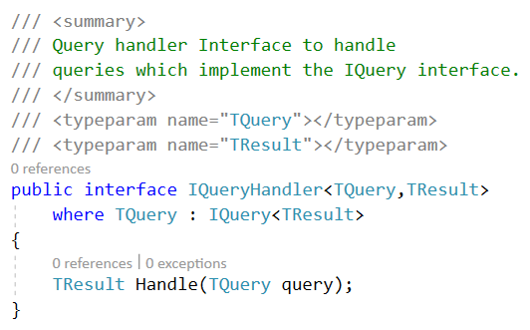

We can fix this by introducing a new type parameter **TResult** and we should also add this parameter to the **IQuery** interface.

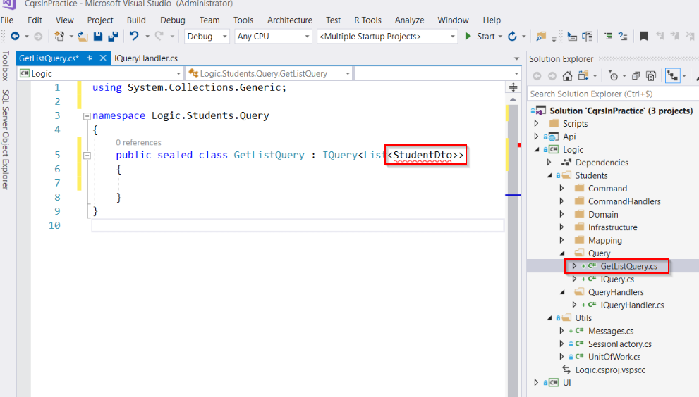

Next we proceed with the query itself. We will name the query **GetListQuery** which should return a list of **StudentDto** objects. But currently the **StudentDto** is only known by the UI project, not by the Logic project.

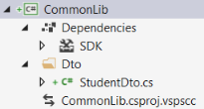

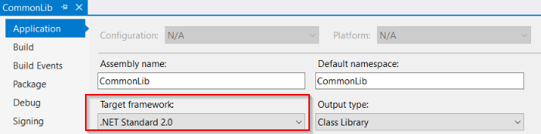

|  |  |
| --- | --- |
|  | ***Important:***  *For DTO objects which should be known in both the UI project as the domain logic project, it’s best practice to create a “shared” DTO library.* ***Create the CommonLib project as a .NET Standard*** *library, so it will be compatible with both .NET Core for the Logica and Api and full .NET Framework for the UI. Reference this library in both Api and UI and Logic project.* |

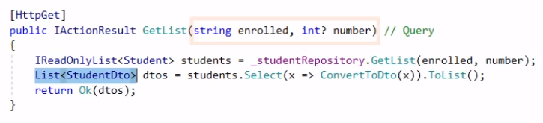

As we can see from the controller endpoint method, the query has 2 parameters, enrolled and number. These should be added to the Query too !

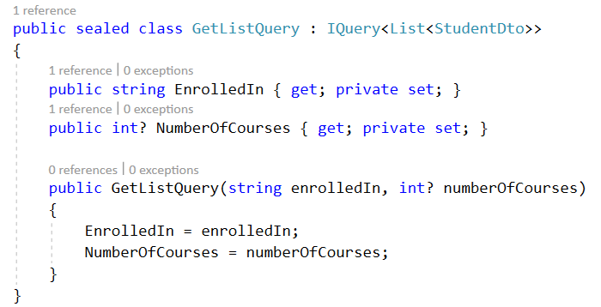

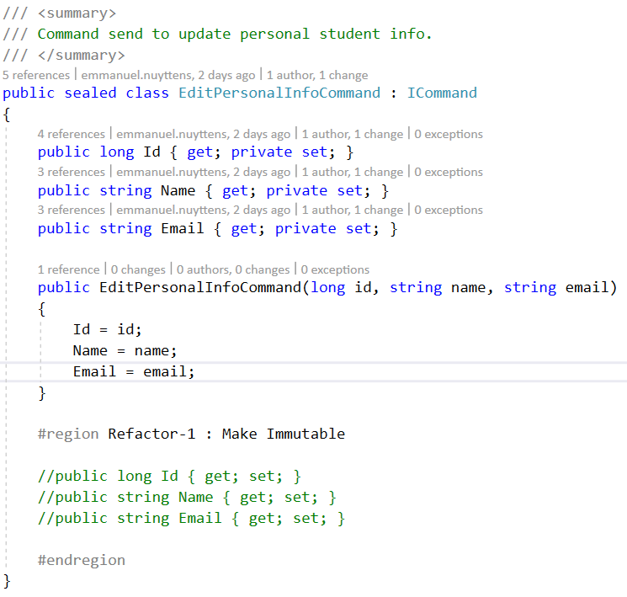

Let’s refactor also the Command that we created, so it becomes Immutable (as properties can not be set from outside the class).

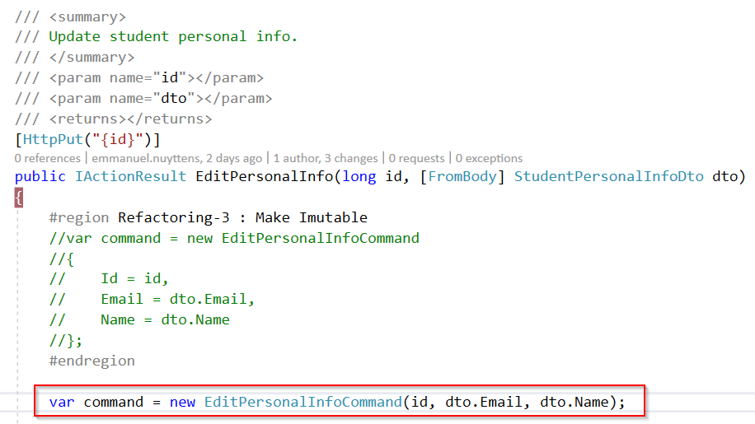

Of course, we must also change the created instances for the command in the corresponding controller action.

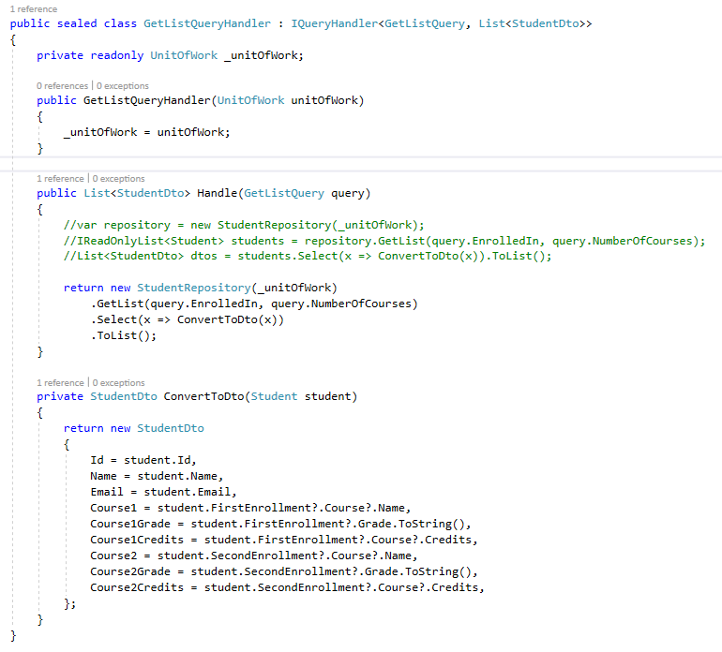

And here is our corresponding QueryHandler for the GetList.

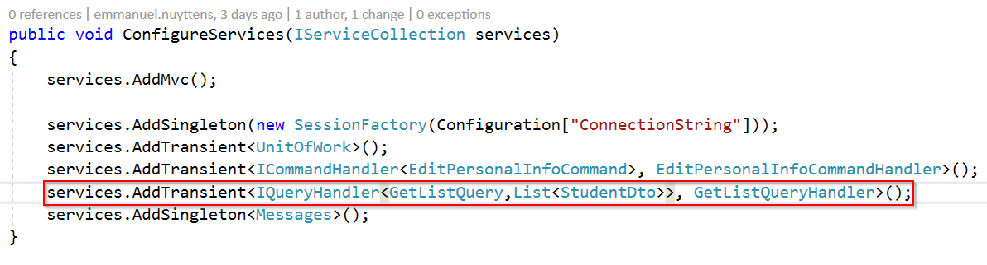

In order to use our QueryHandler in the controller we have to set it up in the **Startup.cs** class.

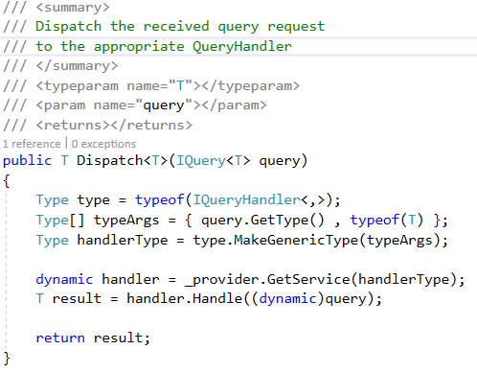

We also need to add another **Dispatch** method to the **Messages** class.

## Finish up the Refactoring

We have refactored 2 methods towards command or query handling implementation, the other methods still have to be refactored, let’s have a look at the current situation and how the other /endpoints of our Student API Controller should be refactored towards a command- or query handler implementation.

|  |  |  |  |  |
| --- | --- | --- | --- | --- |
| Method | Http  Verb | Uri  BaseUri {/api/students} | C = Command  Q = Query | Done? |
| GetList | GET | "{}" | Q | Yes |
| Register | POST | "{}" | C | No |
| Unregister | DELETE | "{id}" | C | No |
| Enroll | POST | "{id}/enrollments" | C | No |
| Transfer | PUT | "{id}/enrollments/{enrollmentNumber}" | C | No |
| Disenroll | POST | "{id}/enrollments/{enrollmentNumber}/deletion" | C | No |
| EditPersonalInfo | PUT | "{id}" | C | Yes |

### Register

#### Current implementation

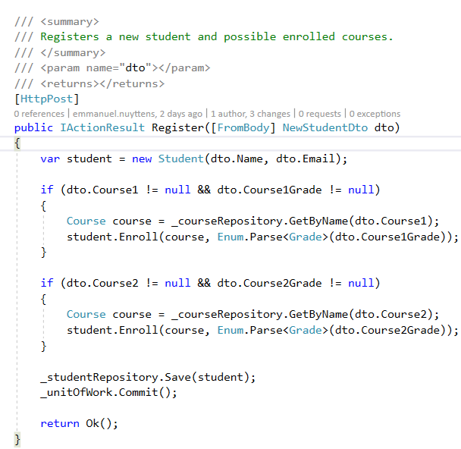

The image above shows the current implementation for the **/register** endpoint. With this endpoint we first create a student and next enroll them in their (possible) selected courses. So let’s move the code from the controller to the appropriate command handler next.

#### Create the Registration Command

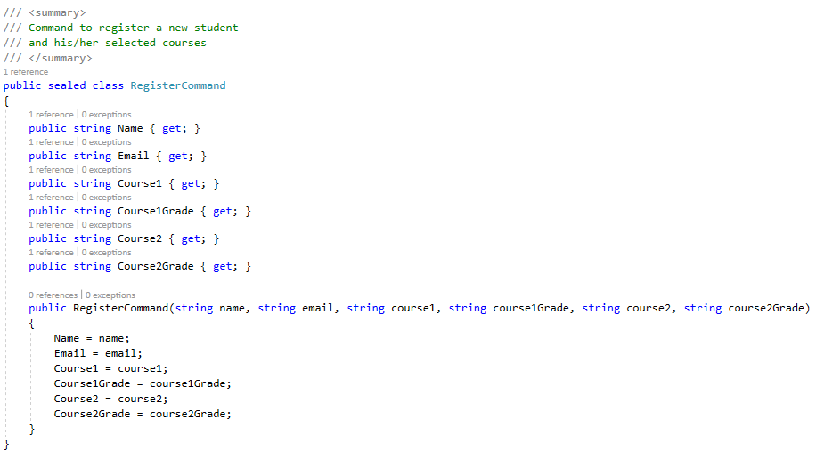

#### Create the Registration Command Handler

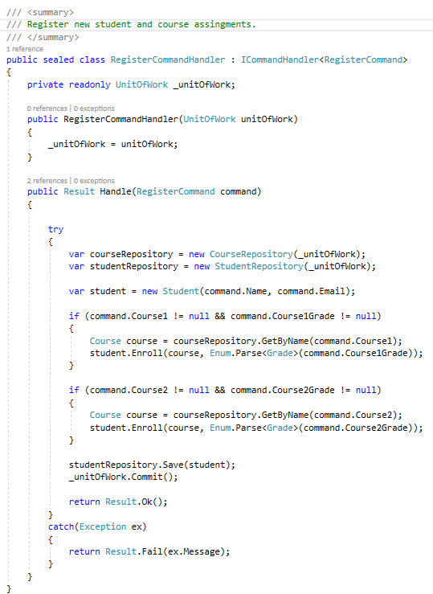

#### Refactor the Register Endpoint

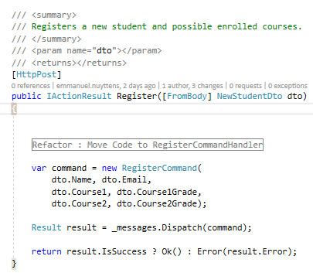

#### Add to the DI-Container in Configure Services

services.AddTransient<ICommandHandler<RegisterCommand>, RegisterCommandHandler>();

### UnRegister

#### 6.9.2.1. Current Implementation

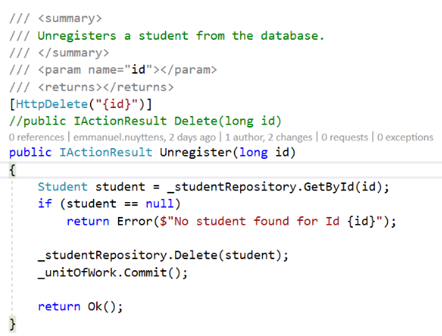

#### 6.9.2.2. Create the Unregister Command

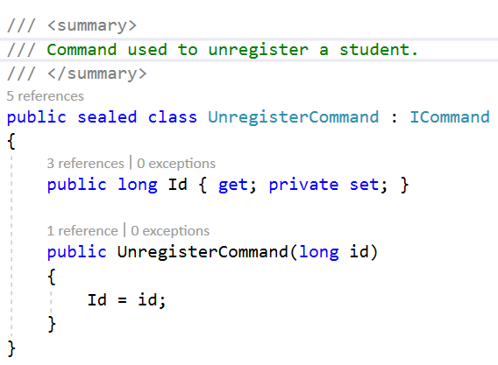

#### 6.9.2.3. Create the Unregister CommandHandler

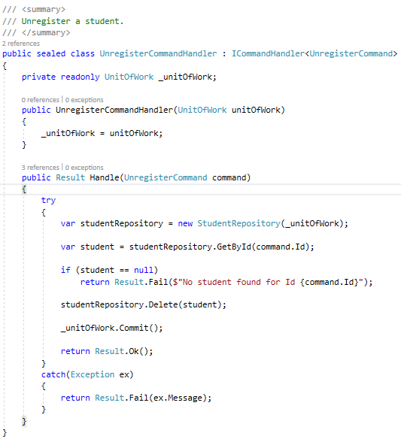

#### 6.9.2.4. Refactor the Unregister Endpoint

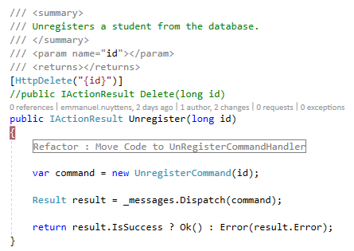

#### 6.9.2.5. Add to the DI-Container in Configure Services

services.AddTransient<ICommandHandler<UnregisterCommand>, UnregisterCommandHandler>();

### Enroll

#### Current Implementation

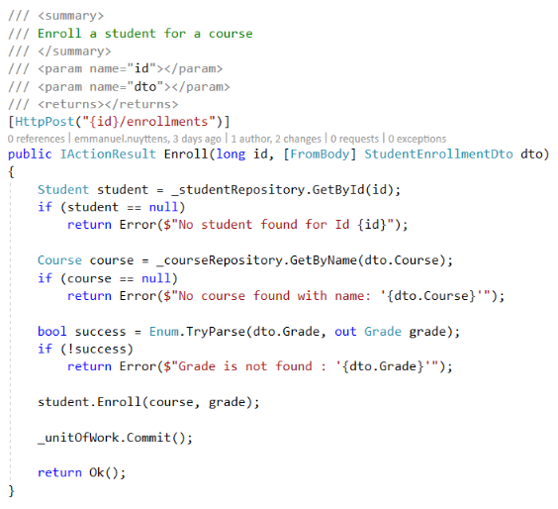

#### Create the Enroll Command

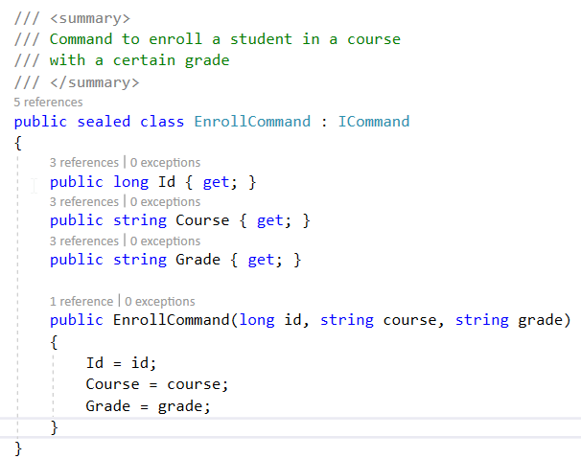

#### Create the Enroll CommandHandler

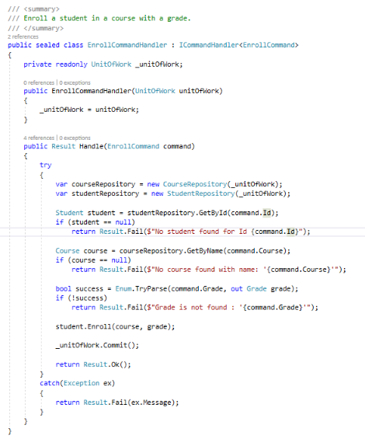

#### Refactor the Enroll Endpoint

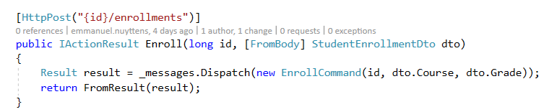

#### Add to the DI-Container in Configure Services

services.AddTransient<ICommandHandler<EnrollCommand>, EnrollCommandHandler>();

### Transfer

#### Current Implementation

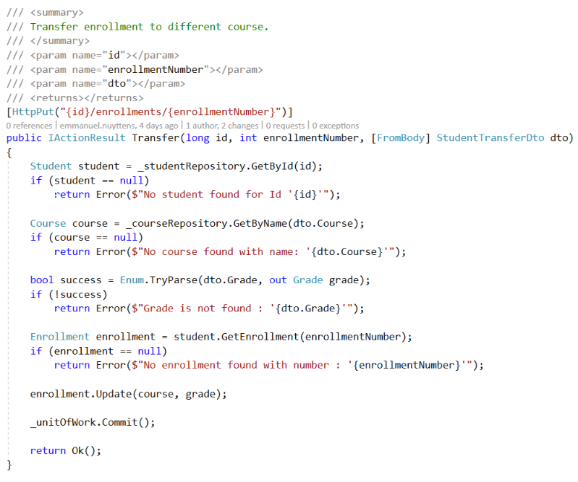

#### Create the Transfer Command

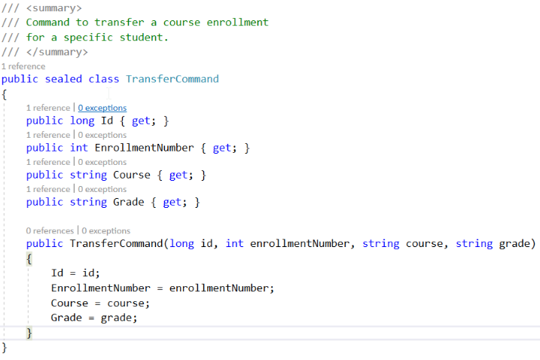

#### Create the Transfer CommandHandler

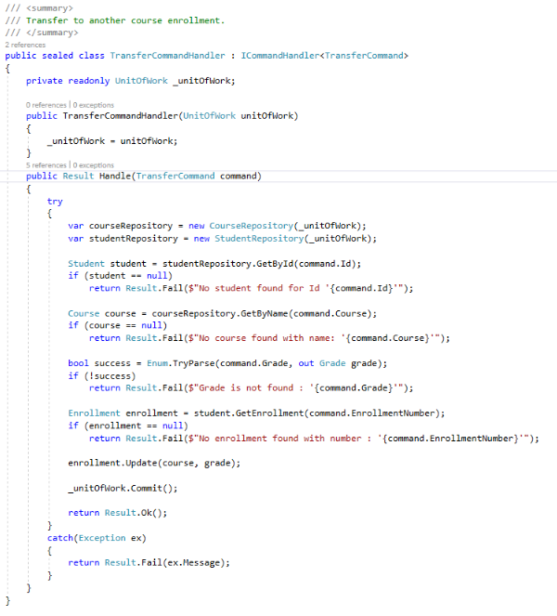

#### Refactor the Transfer Endpoint

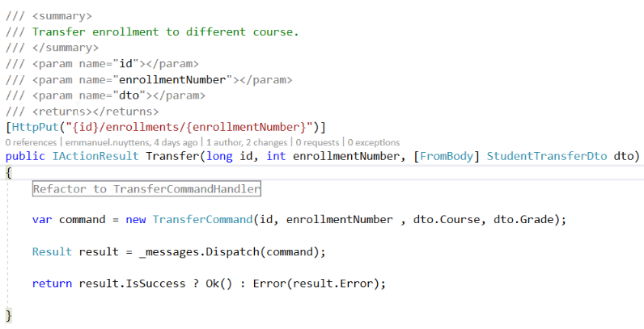

#### Add to the DI-Container in Configure Services

services.AddTransient<ICommandHandler<TransferCommand>, TransferCommandHandler>();

### Disenroll

#### Current Implementation

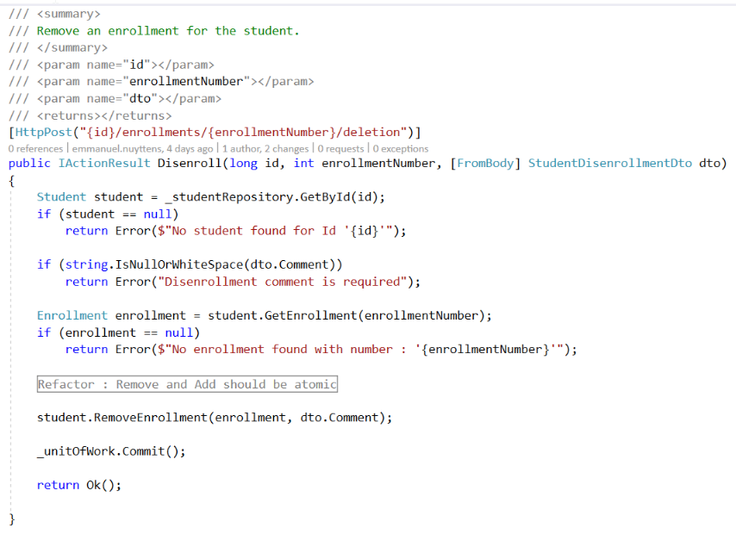

#### Create the Disenroll Command

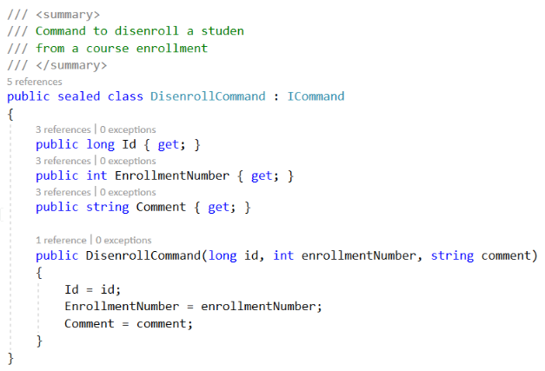

#### Create the Disenroll CommandHandler

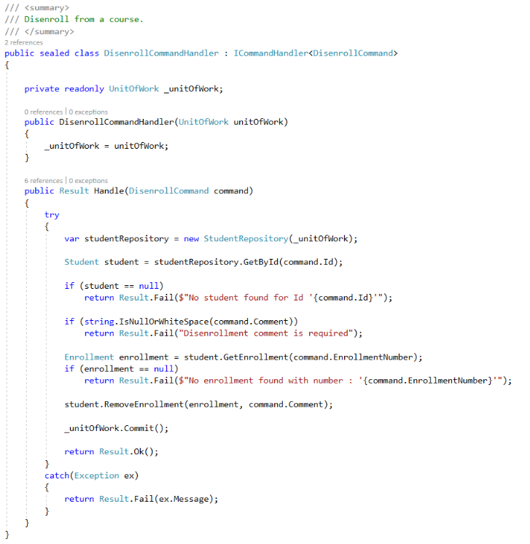

#### Refactor the Disenroll Endpoint

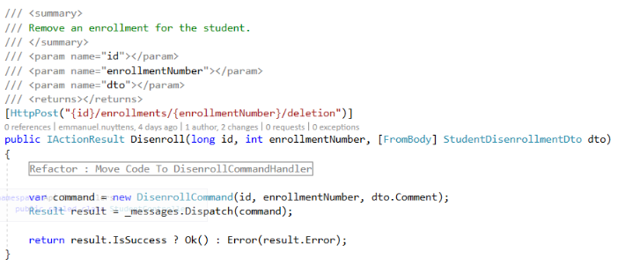

#### Add to the Di-Container in Configure Services

services.AddTransient<ICommandHandler<DisenrollCommand>, DisenrollCommandHandler>();

### Some final Refactorings

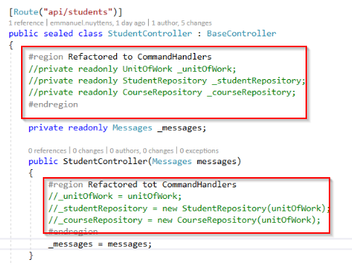

We don’t need the repositories and unit of work anymore in the StudentController, because these are part of the different commandhandlers now.

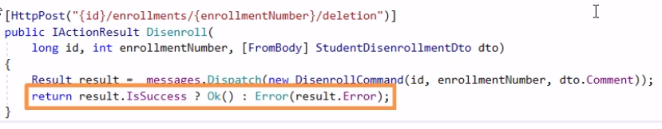

Finally, we can also refactor the repetitive transformations of the result instances into Http responses.

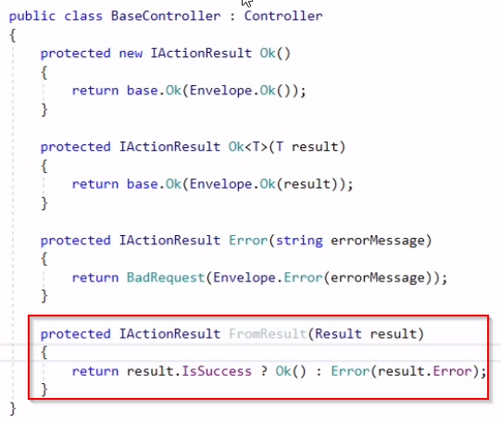

We can move this method to the **BaseController**.

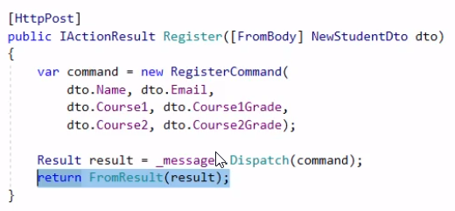

And finally refactor each endpoint method in the StudentController.

## Recap: Introducing Commands and Queries

We refactored the StudentController so that it uses “Explicit Commands” and “Query Objects” now. The controller itself has now become a “thin wrapper” on top of these commands and queries.

In theory you could even remove this controller because it only creates commands now and dispatches them to the command handlers.

|  |  |
| --- | --- |
|  | ***Important Note:***  *In practice, there is* ***to much of internal ASP.NET wiring*** *that is tied to the controller. For example, the HTTP GET or POST method and URL routing. So it is impossible to get rid of controllers entirely, but you won’t be using them for anything other then this ASP.NET wiring stuff because all the real application logic should go to the command handlers.* |

# Module-5: Implementing Decorators up Command and Query Handlers

## Introduction

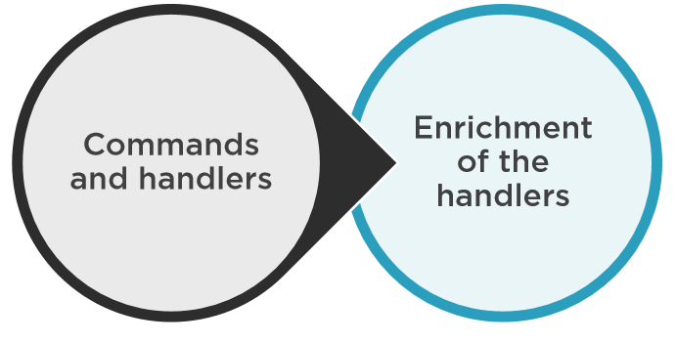

In this module we will see how we can easily **enrich** the **command & query handlers** that we created in the former modules by applying the **decorator pattern** for **cross-cutting** concerns (like logging) in our application.

## Cross-Cutting concern requirement : Resilience

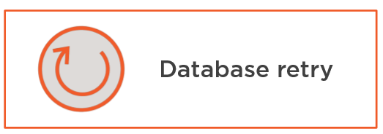

Let’s say that we want to add **resilience** to our application by adding **replies** in case of **transient errors** (temporary outages).

Let’s state that our **connection** between our **database** and **application** goes down sometimes (unstable). And so we have to introduce a **retry** mechanism to deal with this issue.

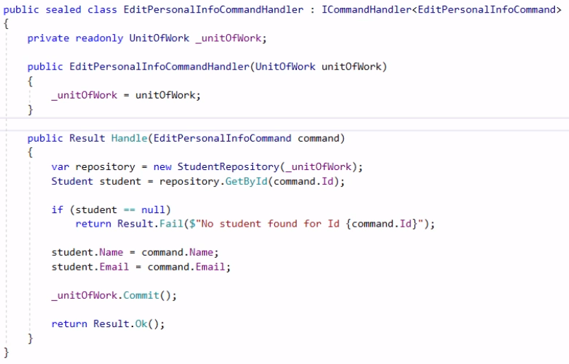

Here is our **EditPersonalInfoCommandHandler.** We could for example **“hard-code”** a number of retries of the **commit method** in the **Handle** method, as shown below:

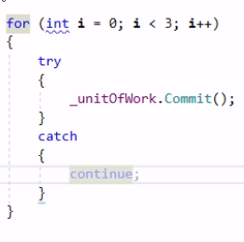

This solution sounds feasible at first but unfortunately, it wouldn’t work, because when a database  **connection** breaks, the connection becomes unusable, so the **­_commit** method won’t work anymore from within the for(;;) loop.

Even when the database goes online again within the border of the loop, ADO.NET will throw an exception saying that the current connection is broken and cannot be recovered from.

So you have to create a new database connection on each attempt to make this work. And another issue is that the **Commit** method is not the only one which reaches out to the database. We also have the code which retrieves the student by Id for example.

If for some reason within one of the attempts to commit the student is no more in the database you should not retry the attempt to commit but give feedback to the user that the student is no longer available in the database.

So the only way to make a retry work is to **retry the whole commandhandler handle method**  instead.

Instead of implementing this behavior in each and one command handler we can make this part of the **ICommandHandler interface class instead**, so it can be re-used within each CommandHandler. We can do this by introduction of the **Decorator Pattern.**

## Introducing a Database Retry Decorator

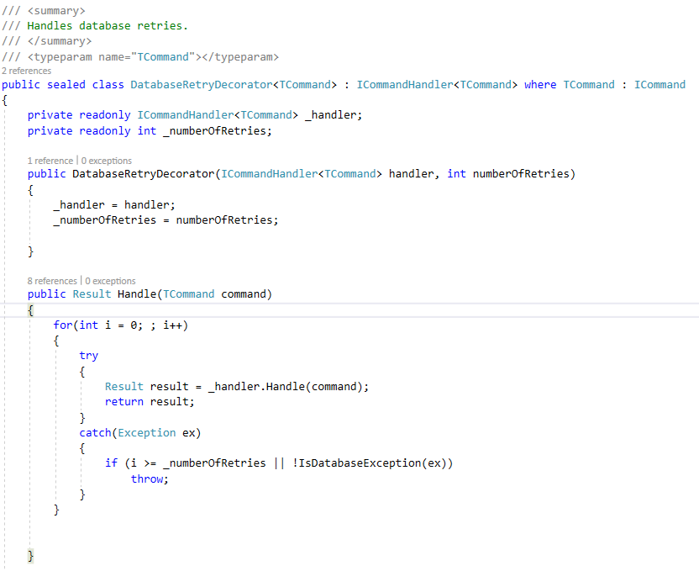

In our **Logic**  project, let’s first add a new folder called **Decorators**. Next we add a new class called **DatabaseRetryDecorator.**

Next, inside the **Handle** method we will introduce a **for loop** which will retry the action for a number of times.

But how to-do the actual **retry** ? We need a reference to the **handler** which the **decorator** decorates ! 🡪 inject into constructor !



Next, in the startup class of the **Api** project, we need to register our decorator.

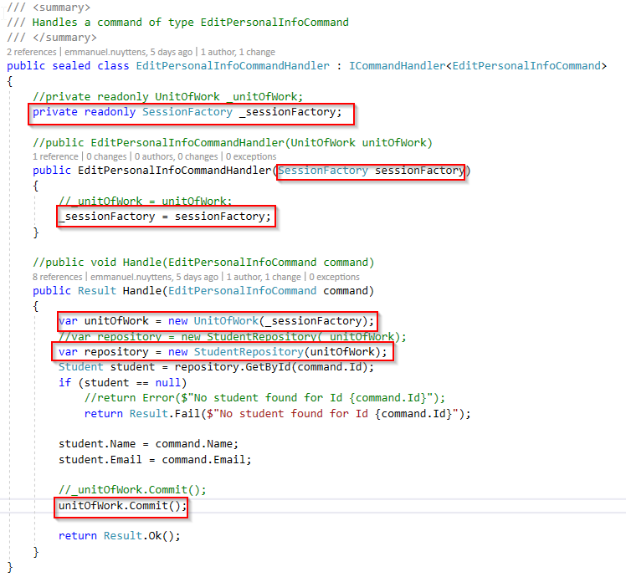

Our **EditPersonalInfoCommandHandler** has changes too. We need to inject the **SessionFactory** (instead of the UnitOfWork). This is because when the database comes unavailable, we cannot reuse the existing connection.

## Introducing an Audit Logging Decorator

This is another decorator that we will be adding to the **EditPersonalInfoCommandHandler.** We will log all the changes made to the personal info of a student and this will be on top of the **Retry-Decorator** that we already added before.

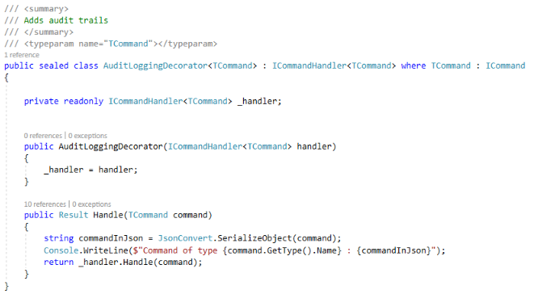

The implementation of the **AuditLoggingDecorator** is quite similar to the database retry decorator and to keep things simple we just log to the console window, but in production environment we should rely on a logging framework of course.

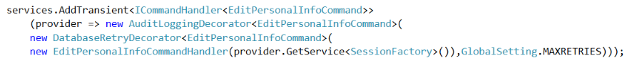

Finally, we also have to adapt the **Startup.cs** class from our **Api** project so that the **AuditLoggingDecorator** is added.

|  |  |
| --- | --- |
|  | ***Important Note:***  *The order in which the* ***Decorators*** *are added is very important ! In Our case we will first execute the* ***AuditLogginDecorator*** *Handle method, next the* ***DatabaseRetryDecorator*** *Handle method and finally the* ***EditPersonalInfoCommandHandler*** *Handle method.* |

## Streamlining the Decorator Configuration

### Drawback of Current Implementation

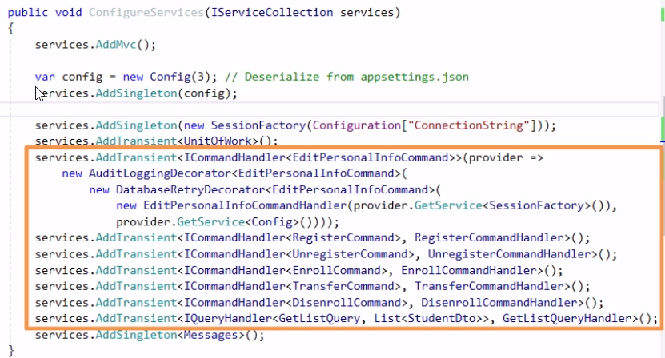

The **decorator pattern** along with the **command and query handlers** is a powerful mechanism. But there is one drawback to this implementation, as we can see from the **Startups.cs** class as shown in the image above, the configuration becomes quit **extensive,** and if we continue to register handlers and decorators in this way, the code will come **to verbose**.

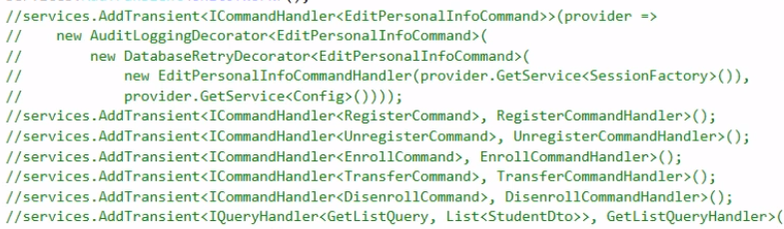

A better approach would be to define the **decorators** with **attributes** on the **command and query handler** classes instead.This will allow us to get rid-off all the configuration code as shown above and use a **declarative** approach to enrich our handlers with **cross-cutting** functionality, as shown below:

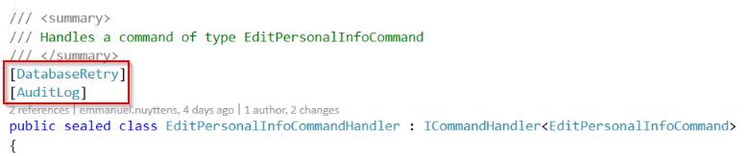

But how can we achieve this ? First we have to define the **Attribute** classes for each decorator. We will create them in a folder called **Attributes** in the **Logic** project.

### Create a Handler Registration Class

We need a handler registration class to **map** the **attributes** to the **corresponding decorators,** or more specific properly **registering our handlers** taking into account the **decoration attributes.**

To do this, we will create a new class in the **Utils** folder of the **Api** project called **HandlerRegistration.cs**

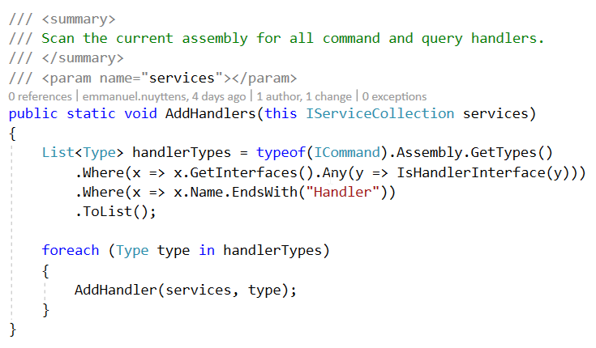

The only public method that this class implements is the **AddHandlers** method which is an **extension method** on top of **IServiceCollection.**

|  |  |
| --- | --- |
|  | ***Note:***  *It is a good convention to always define methods that register ASP.NET services as extension methods.* |

First we will scan the assembly which contains the domain model for all **command, query** and **event** handlers.

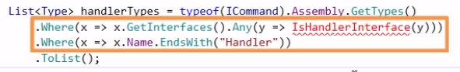

We are getting al the types from the assembly that end with “Handler” and implement the “IsHandlerInterface”.

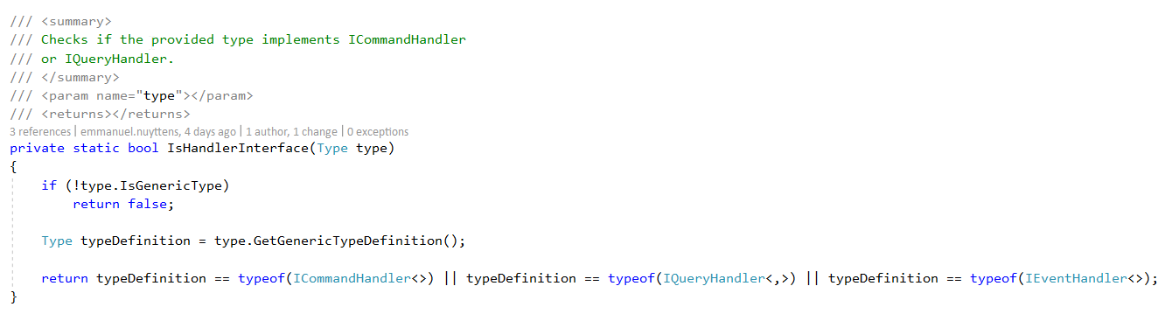

Next the private “IsHandlerInterface” method checks if the type is either a CommandHandler, QueryHandler or EventHandler interface type.

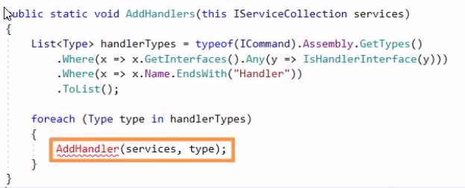

Next, for each type (Command,Query or Event Handler) returned by the IsHandlerInterface() method we call the **AddHandler** method.

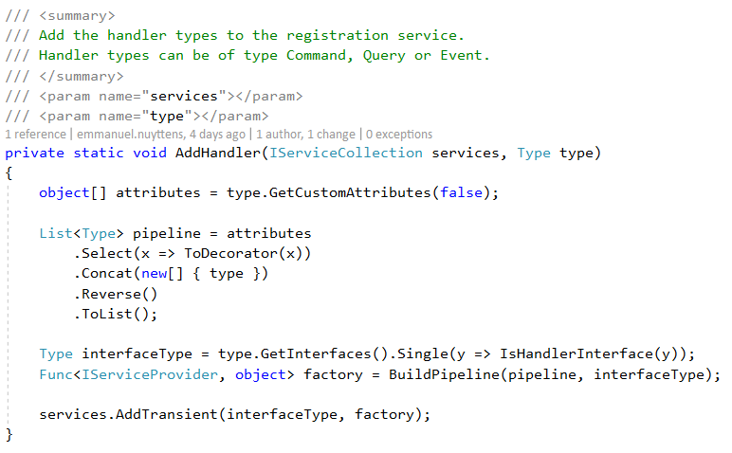

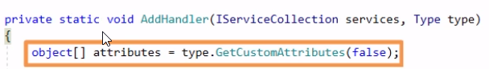

The AddHandler method retrieves all **attributes** attached to the type,

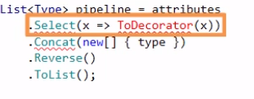

and converts them to **decorator types**

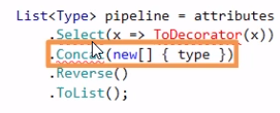

and adds the type of the handler itself and create a list out of that.

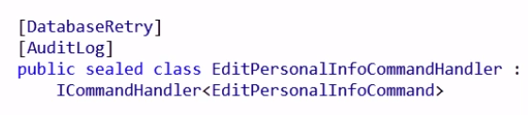

So for our **EditPersonalInfoCommandHandler** (as shown above), the list would look like this:

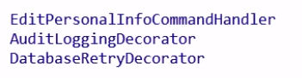

The “Handler” is created first, and on top of our handler the code will create the AuditLoggingDecorator and on top of that the DatabaseRetryDecorator. Below is how the Decorator method looks like:

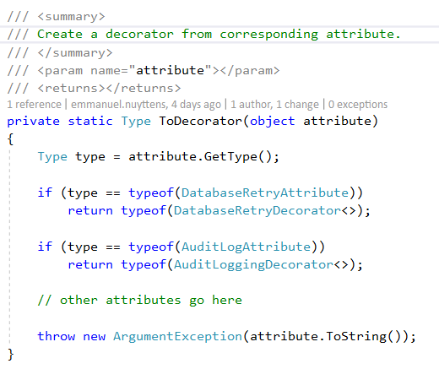

|  |  |
| --- | --- |
|  | ***Note:***  *When we create a new decorator, we will have to add the appropriate code here.* |

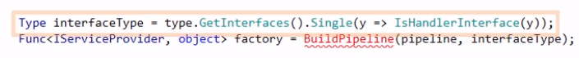

Next, still in the AddHandler() method, for each handler the **interfaceType** variable will contain the interface that the handler implements.

So for the type **EditPersonalInfoCommandHandler** the interface would be **ICommandHandler<EditPersonalInfoCommand>**



Finally this method will create a factory method out of all the **decorators** and **associated handlers** that we found and register them in the service collection, as shown below:



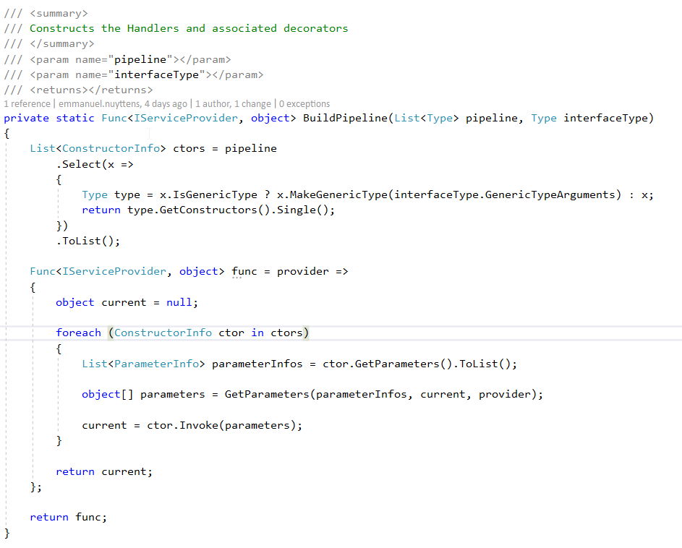

The **BuildPipeline** method will create the handler and appropriate **decorators** which were set as **attribute** on top of the **method signature** of the handler method.

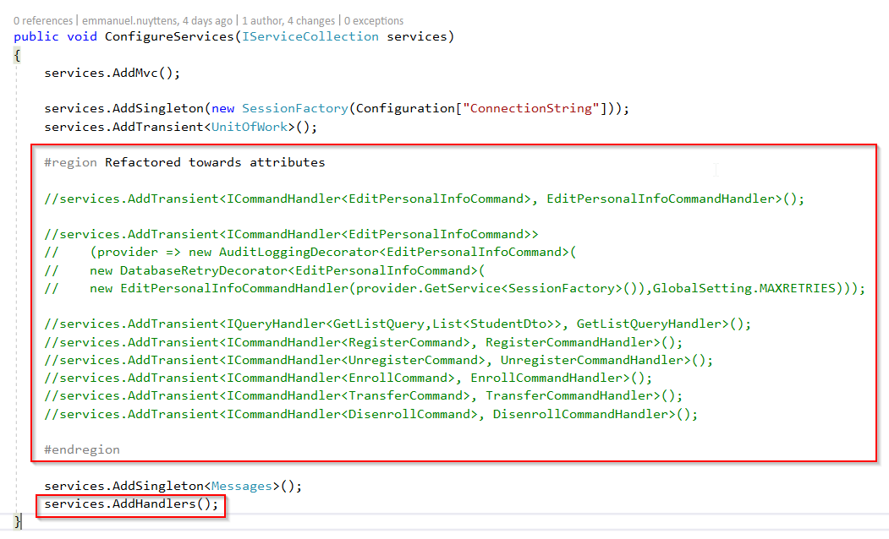

Finally, the **Startup.cs** class of our **Api** project becomes much simpler, as we can remove all handler registrations and replace with a single **services.AddHandler()** method.

### The AuditLog and DatabaseRetry Attribute classes

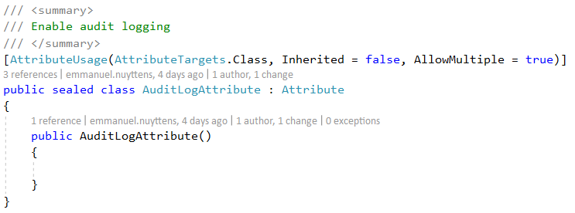

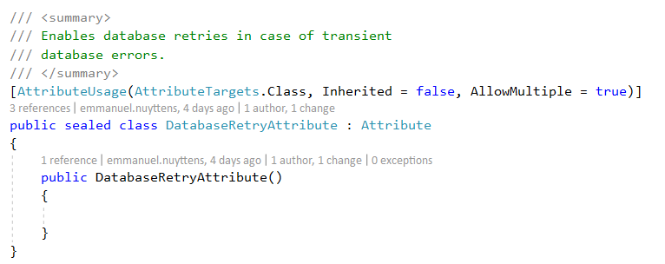

The attribute classes are simple **Marker** classes which make it possible to add the corresponding attribute on the handler methods and hook-up the corresponding **decorator.**

### Replace of UnitOfWork

In order to the database retry logic to work, we need to replace the **UnitOfWork** with the **SessionFactory** implementation because we cannot **reuse the same UnitOfWork** while “re-running” the handler !

The first one is in the **GetListQueryHandler:**

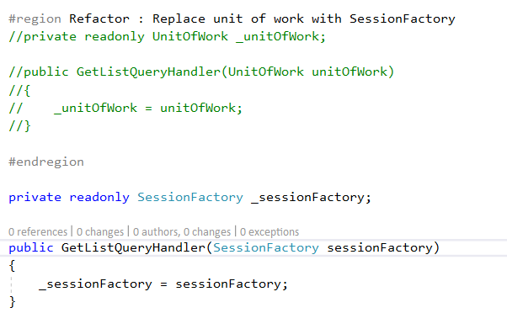

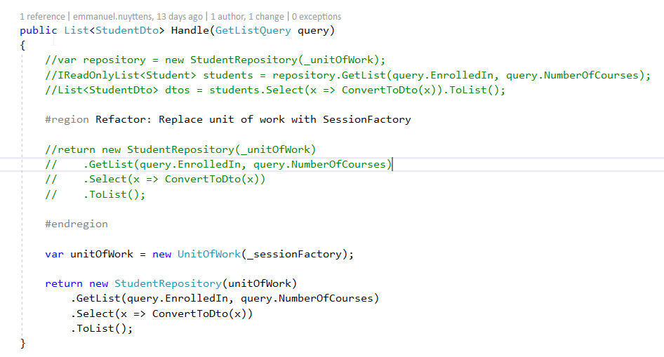

Do the same for:

* RegisterCommandHandler
* UnRegisterCommandHandler
* EnrollCommandHandler
* DisenrollCommandHandler
* TransferCommandHandler

### Test Decorator Attributes

Finally to test, we can for example add the **AuditLog** attribute on the **RegisterCommandHandler** and check if it’s working:

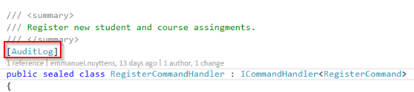

Let’s create a new registration …

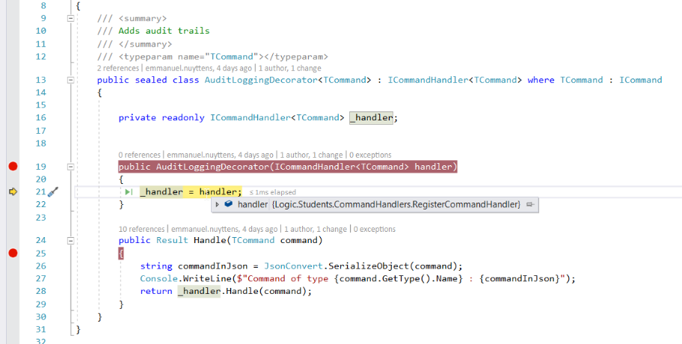

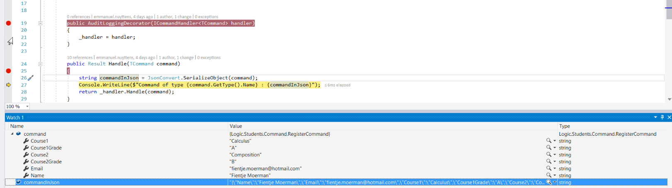

Decorator get’s hit …



Info get’s logged …

## Dependency Injection Framework Alternative



Instead of using the custom made **HandlerRegistration** class, we could use an existing DI library too, an example is **Simple Injector.**

## Decorators vs. ASP.NET Middleware

At this point, our command and query handlers and the decorators on top of them are very similar to **ASP.NET middleware** infrastructure.

If we look at the **ASP.NET middleware class** we currently have in our project, the **ExceptionHandler** and compare it to one of our custom **decorator**, then they look very similar.

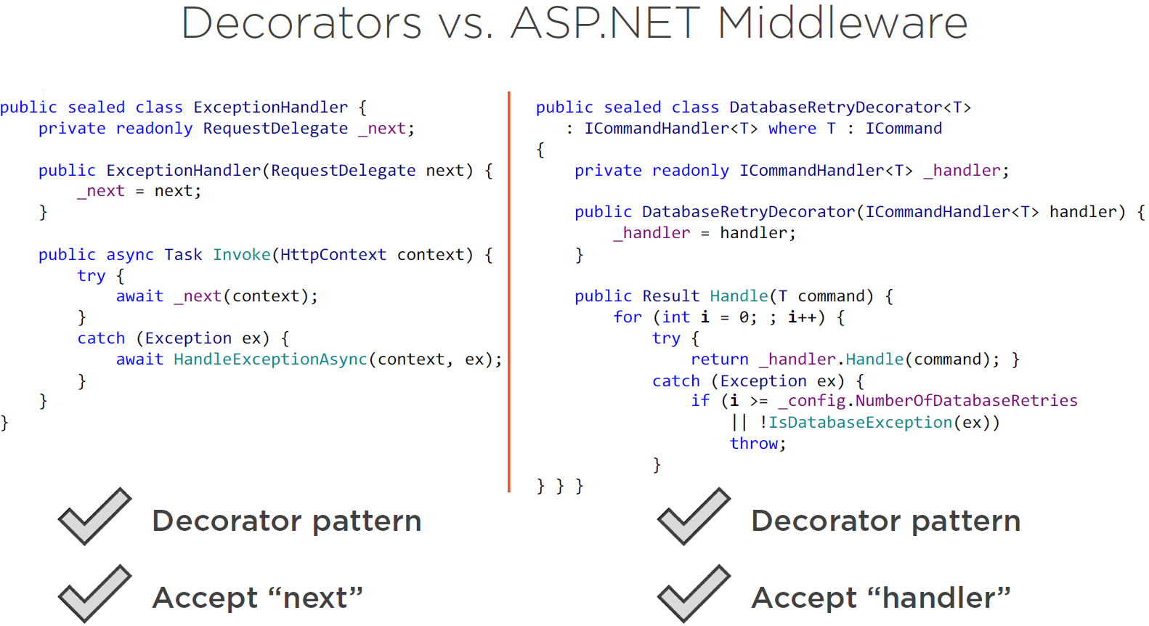

In fact they both implement the **decorator pattern.** The only difference is that the **ASP.NET middleware** doesn’t rely on **explicit interfaces** like our **ICommandHandler,** this is because ASP.NET uses **reflection** to find a corresponding method to call in the **middleware classes**, and that is the **Invoke()** method as shown above.

What is similar is that they accept the next **item in the pipeline** as an **input parameter**, and both of them put their own logic on top of it.

# Module-6: Simplifying the Read Model

## Introduction

In this module we will see how we can adapt the “Read-Model” to increase application performance.

## The State of the Read Model

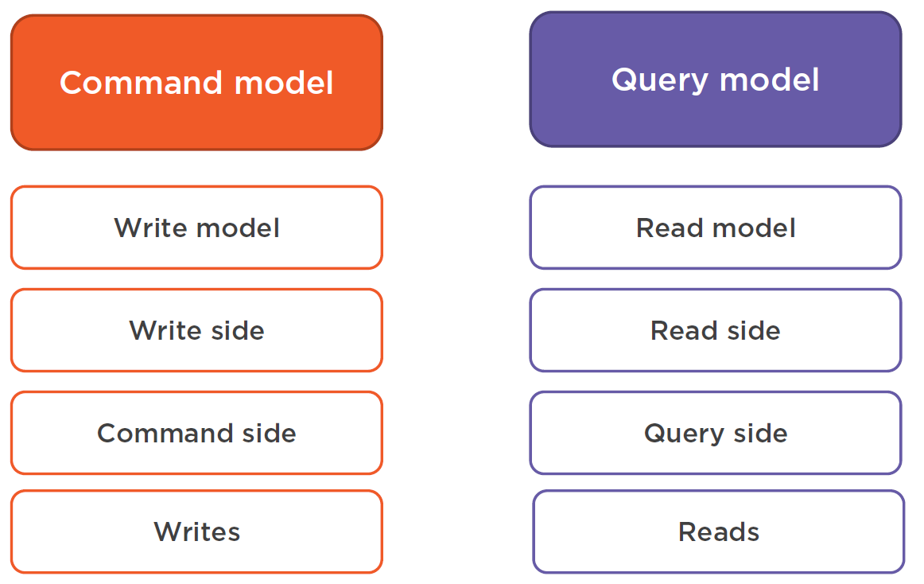

As we already know, the **CQRS pattern** is all about the **creation** and **maintenance** of 2 different models:

* One for Commands 🡪 aka **The Write Model.**
* One for Queries 🡪 aka **The Read Model.**

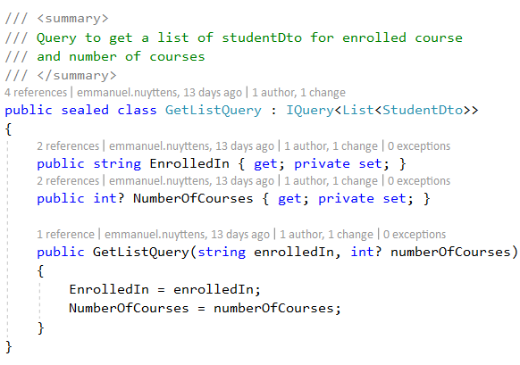

Let’s next have a look to the **current state** of our “Read-Model” (query-model). It currently only consists of only one query, called **GetListQuery** which implements **IQuery<,>** and returns a **List of StudentDto** to it’s caller (list of registered students in the system).

The query also allows some **filtering** (filtering by a particular course or a particular number of courses).

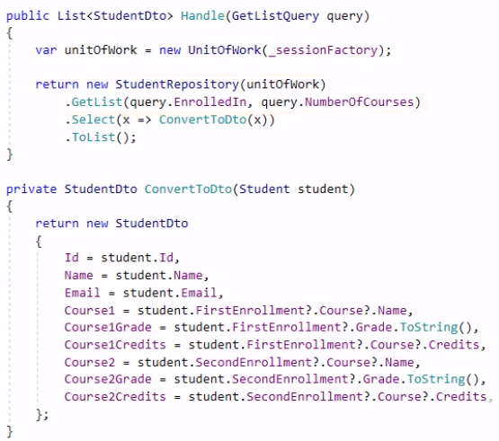

What the **query-handler** does is that it calls the **StudentRepository** to get a list of registered **Student** entities out of it taking into account the supplied filtering parameters and converts them to corresponding list of **Dto** objects for the client.

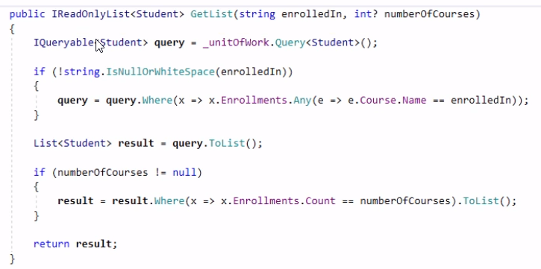

Finally, let’s have a look at the **StudentRepository**. We use the **GetList(…)** method here and the method first creates an IQueryable of Student entities.

This **IQueryable is a special interface in .NET that enables data-querying**. .NET provides **extension methods** on top of IQueryable.

The implementation of **IQueryable** is very different from the implementation of **IEnumerable** for example.

The **extension methods** on top of **IEnumerable** work with **Collections** in the **local memory.** But **IQueryable** is more complex. It has 2 properties, a **Query Provider** and an **Expression.** An expression is a type that contains **metadata** about the request, and the Query Provider has access to the underlying database and it also knows how to query it given the supplied expression.

When you work with **IQueryable, it doesn’t get executed** until you call a method that **transforms** the IQueryable into an in-memory collection (ToList, Single, First …).

As you can see from the query above (to filter students on course name and number of courses), there are some limitations.

For example, you cannot use it to filter an object by the number of elements in one of it’s collections (Enrollements in our case). In our case LINQ does not know how to filter on the number of enrollments and do that in a single query (because of this we need 2 queries).

As an example let’s say that we want to filter for course “Calculus” and the student must have 2 enrollements.

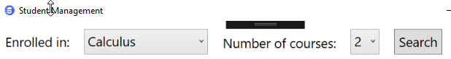

The first will retrieve the students with the enrollements for the supplied course, the second limit by number of enrollments e.g. in sql-profiler this will be:

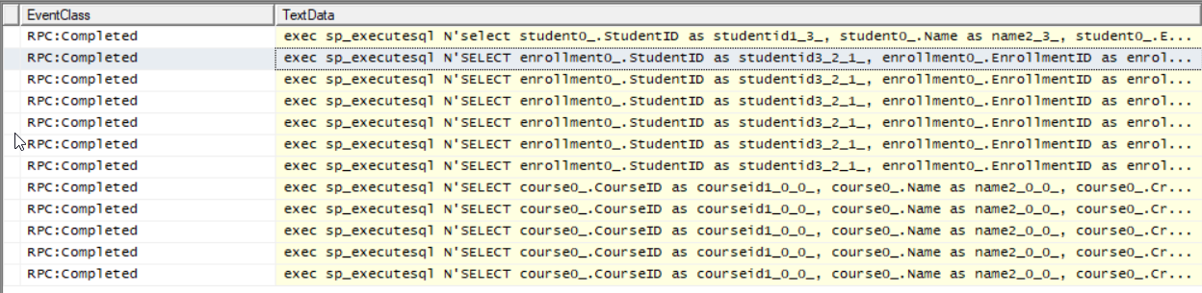

This will result in multiple query-executions in SQL-Profiler which is a huge performance hit when having many of registrations and enrollments !

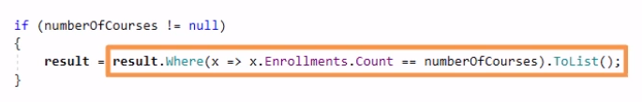

The second problem is the so-called **N + 1** issue. In order to complete the filtration in the memory, the ORM needs the rest of the student data, more particularly the **Enrollments** collection of each **Student** and because these collection is not “eager-loaded” as part of the S**tudent** collection set, they are loaded “lazily” (lazy-loading), 1 by 1 ! This is done when LINQ iterates through the in-memory collection.

## Separation of the Domain Model

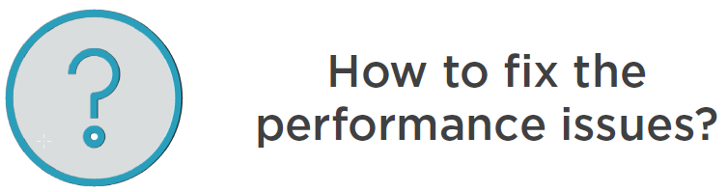

So our current “Read-Model” for the GetList() query may have **performance issues.** But how can we fix this ?

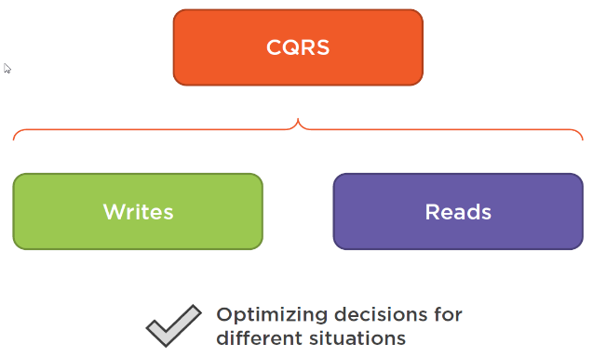

Well, that what CQRS is all about ! Remember that the CORE principle of CQRS is to have **2 models**, one for “Writes 🡪 Commands” and one for “Reads 🡪 Queries”.

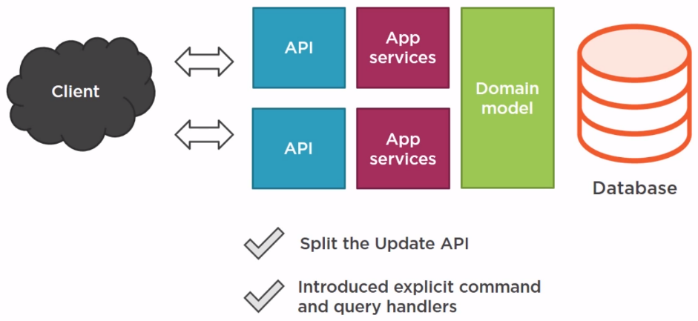

We already introduces some segregation at the API and App Services level (e.g. for API we segregated the big “update” method into several smaller methods like Transfer, Enroll, Disenroll and EditPersonalInfo. We also already segregated the App Services by creating specific commands and handlers, e.g. TransferCommandHandler, EnrollCommandHandler, DisenrollCommandHandler and EditPersonalInfoCommandHandler.

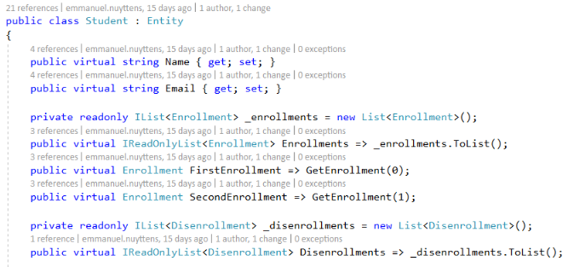

Look at the repository once again. The GetList() method uses the same **Domain Model** as the linked CommandHandlers. It uses the same **Student Entity** (as shown above) and this put’s a restriction on what we can do with this method ! We should instead create a specific **Read-Model** which is better structured to read from the database with single performant queries.

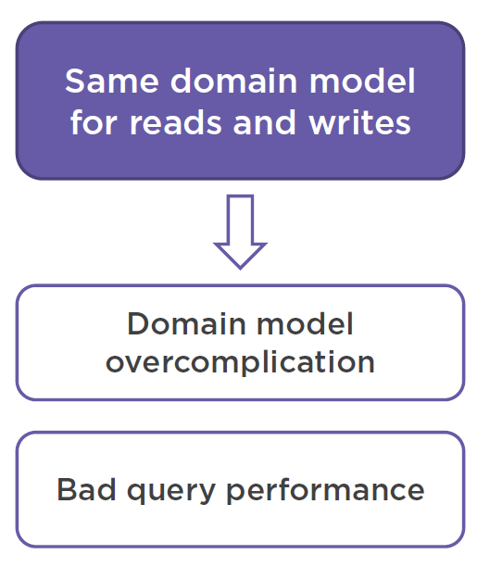

The fact that we are using the same **domain model** for both **command** and **query** sides of our application leads to two things :

1. It overcomplicates the domain model : the domain model becomes then it should be.
2. It hinders our ability to fully utilize our database.

We cannot utilize optimized database queries in such an environment.

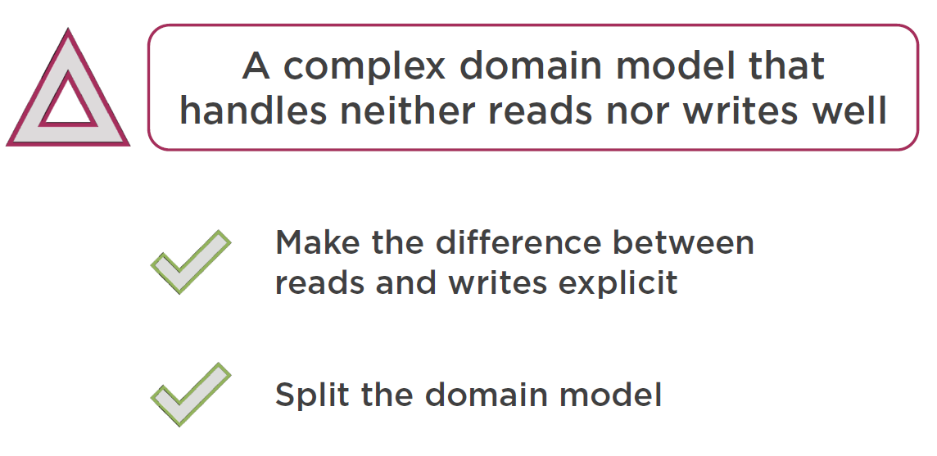

Having a single model for both “reads” and “writes” will mostly end up in an implementation that neither handles reads or writes in the most effective way !

So we will need to “split” our domain model !

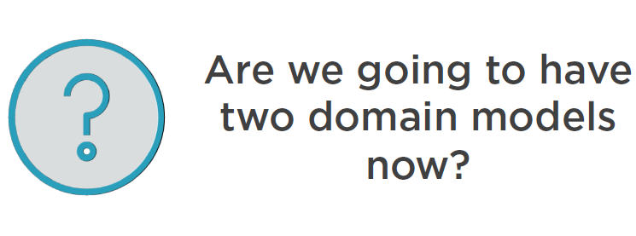

No, we will actually not have 2 specific domain models as we will “take out” the domain model from the **read side** completely.

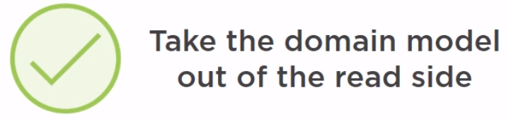

So the **read-side** will **lack any knowledge of domain model** objects !

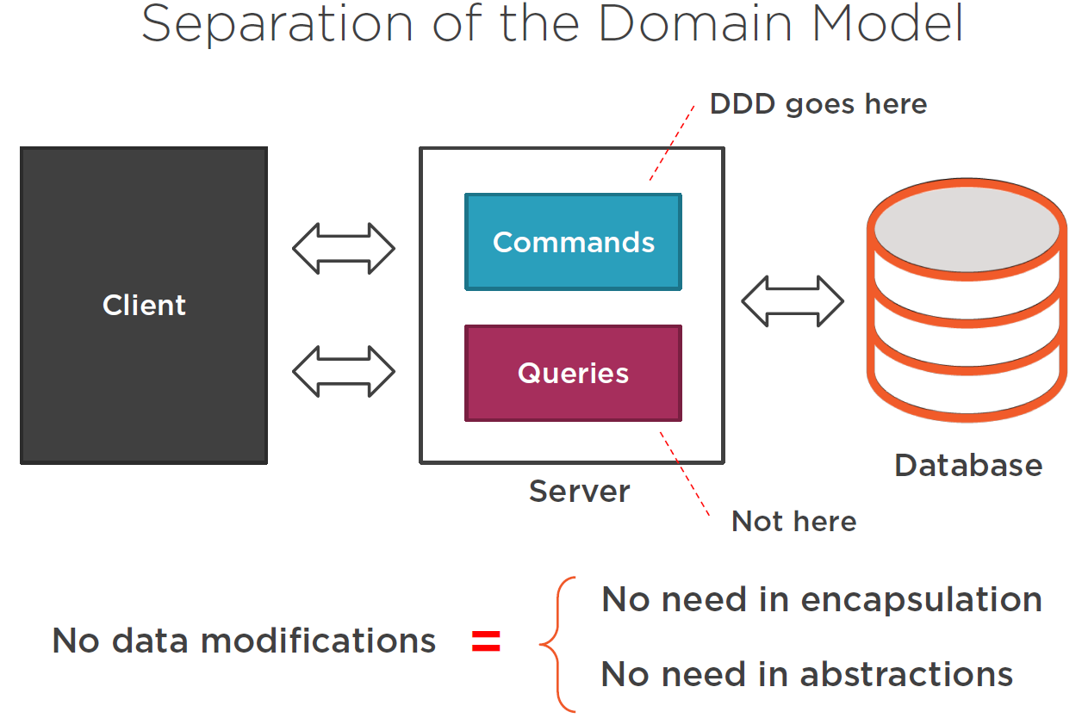

In fact, there is **no-need** for a **domain-model** on the **read-side** of the application, because the **domain-model** is only required for **commands**, and commands are on the **write-side** of the **domain-model.**

|  |  |
| --- | --- |
|  | ***Important note:***  *One of the ultimate goals of* ***domain modeling*** *is how to represent data in the most performant way to the client ! And so, we can just “drop” the* ***domain-model*** *from the* ***query-handlers*** *entirely ! So ultimately, we WONT NEED AN ORM for the query part either ! So it’s better to create all the database code queries manually here ! And this will be beneficial in many cases because you would be able to use* ***database-specific*** *optimization technics which would not be able to achieve with an ORM such as NHibernate or Entity Framework !* |

## Simplifying the Read Model

### Define the ConnectionString Settings Class

We are going to get rid-of the domain model entirely in the **read-side** of our application. So we will no longer used the current Repository method from the **StudentRepository**.

Instead we will need a **direct connection to the underlying database** for running our **SQL queries** against.

So we need a **connection string** to be stored, we will create a new class for that in the **CommonLib** project:

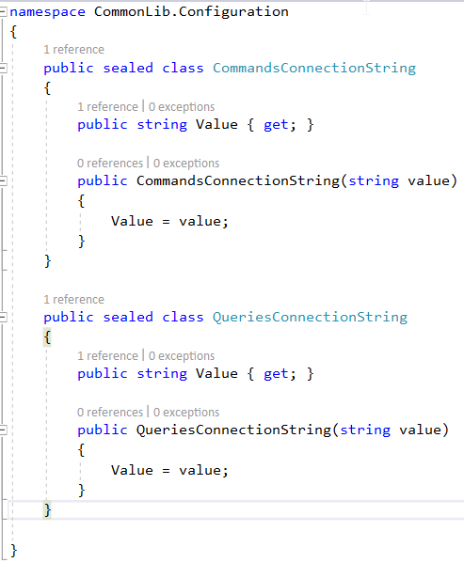

Here we will both define a connection string for the “read-side” (QueriesConnectionString) and for the “write-side” (CommandsConnectionString), at this moment they will point to the same database but we will change this later …

### Refactor the Startup.cs ConfigureServices Method

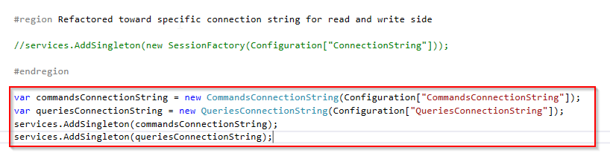

### Update the appSettings.json file

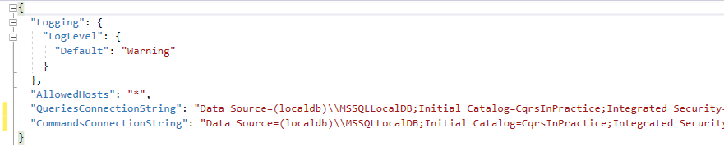

At this moment we have the same database for “read” and “write” side, but this will change later …

### Refactor the SessionFactory class

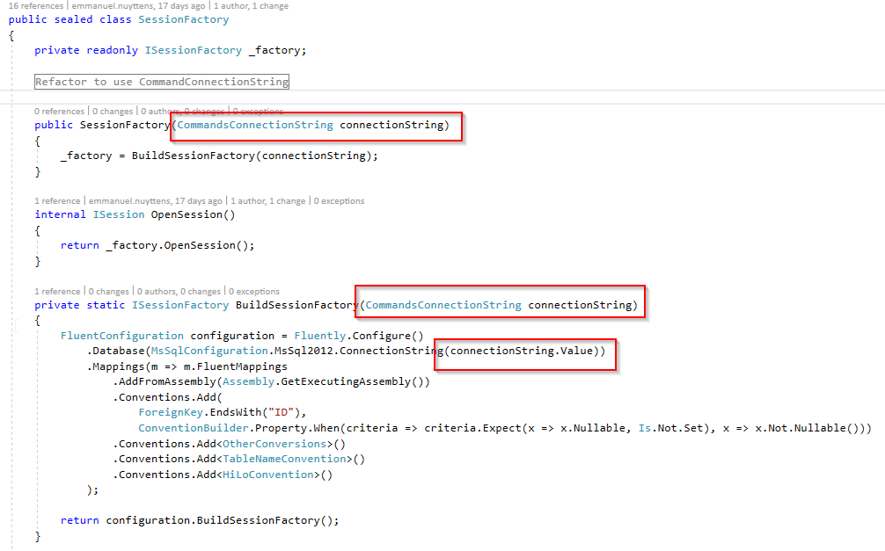

We will next refactor the SessionFactory class (write-side) to use the CommandsConnectionString so it is in analogy with the read-side.

### Refactor the GetListQueryHandler

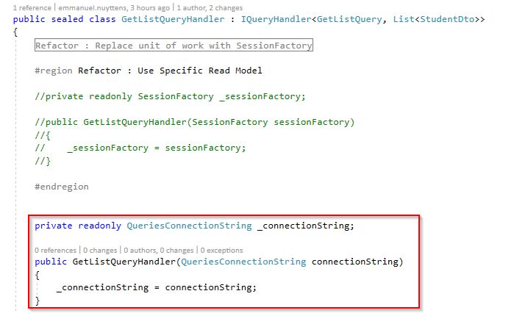

We first have to refactor the **constructor** to take a **QueriesConnectionString** object as parameter instead of the **SessionFactory.**

Next we have to refactor the query, but first we will add a reference to **Dapper**, which is a lightweight ORM that is perfect for scenarios where you write your custom SQL-Queries. Dapper will map the result of the custom SQL-Queries to your custom types.

The handle method has also changed, because we will no longer use the ORM and StudentsRepository any more, because we need multiple queries to achieve our goal.

What we want to do is to “get” the data with 1 single request to the database server and then map to a Dto structure which maps to the UI requirements, so our handle method will be as next:

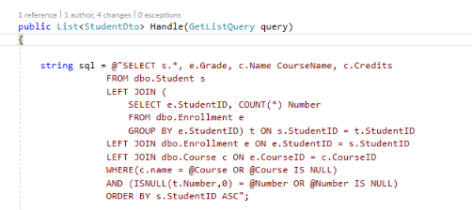

We will first create a “custom-query” which does the data-retrieval in a more efficient way (single query which JOINS all required data instead of multiple queries as before …).

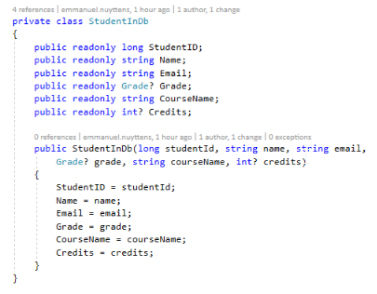

Next we will create a “private” class which **Dapper** will use to map the retrieved data to.

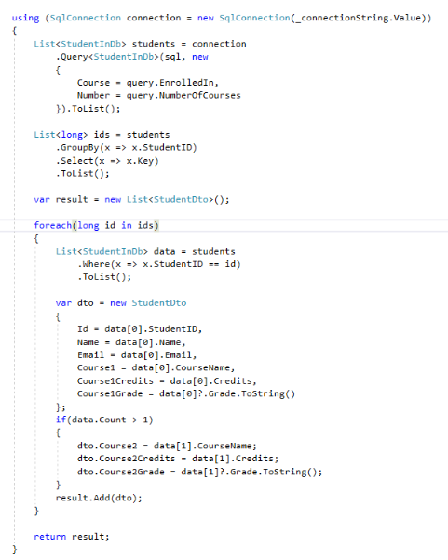

Finally in the remainder of the handle-method, we map the retrieved data to the Dto as required by the UI.

### The Read Model and the DDD Onion Architecture

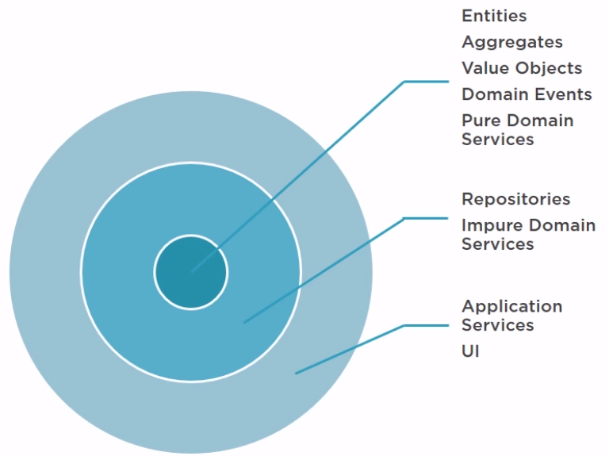

There is a small inconsistency when we implemented the query-handler method, which relates to **the onion architecture**.

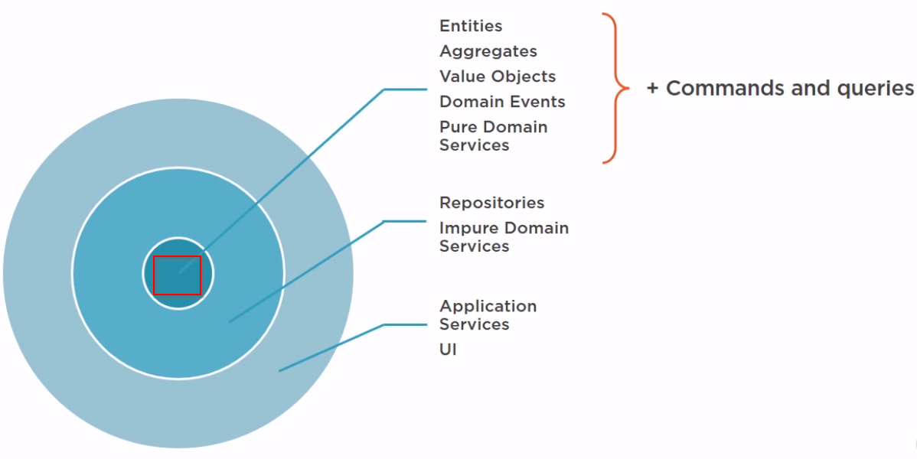

We discussed that **commands and queries and events** are part of the **core domain model** (the most inner circle in the onion).

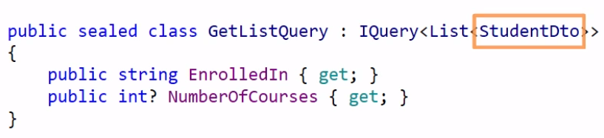

But at the same time, look how we defined our Query (GetListQuery). The problem with this query is that it implements the **IQuery<List<StudentDto>>,** which return **Dto objects** and belong to **the UI layer** !

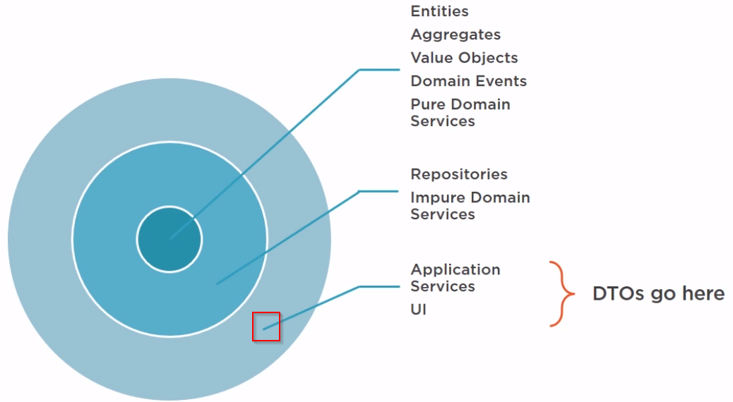

The **StudentDto** does not belong to the **core domain model** in the **onion architecture** but **belongs** to the **outermost layer** of our application, the **UI-layer.** This is because the **Dto is the data contract** that we define for our **clients.**

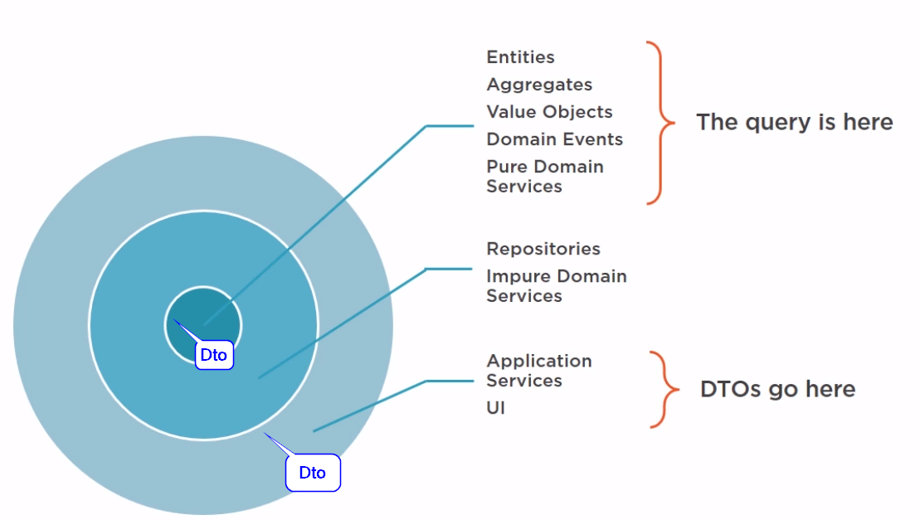

But now, the Dto is known within the core domain layer and the UI, so we **violated the isolation principle** here. This principle says that a layer in the onion structure can only access classes from the same layer or inner layer, but UI is in an upper layer !

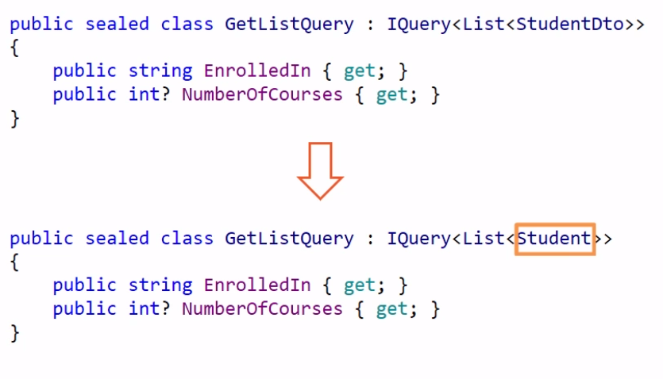

In fact, to be correct we should return a list of Students for the query, not Student DTOs, and then convert them into DTOs in the **API Controller**  !

|  |  |
| --- | --- |
|  | *However this is a minor issue, because we do no longer* ***use the domain model*** *in our* ***queries****, so these classes do not belong to the real* ***core domain model anymore.*** *Queries now reside in their own* ***read-model*** *that is* ***outside*** *of the* ***onion structure.*** *It is just a* ***thin-wrapper*** *on top of our database.* |

# Module-7: Introducing A Separate Database for Read-Side

## Introduction

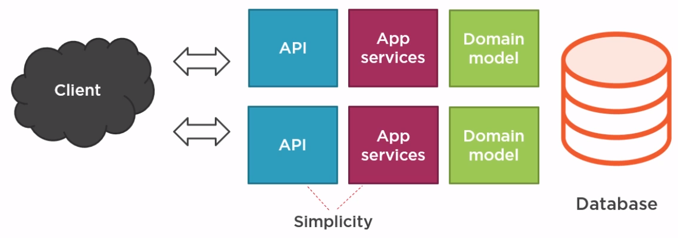

A we removed our “domain model” classes totally from our “queries”, it became much easier to both optimize the “read” and the “write” side of our application. Read for the Queries and Write for the Commanding.

This separation of models also gave us some gains in “simplicity”, as we were able to focus on the “domain-model” only for the **command processing** part, and remove from it all code that were specifically related to **queries.**

## Scalability vs Performance

No we will go a step further and also introduce a **separation** on the **physical data level**, which means that we will create a separate database for the **read part** (queries)and that will lead us to the 3rd benefit of CQRS 🡪 **SCALABILITY !**

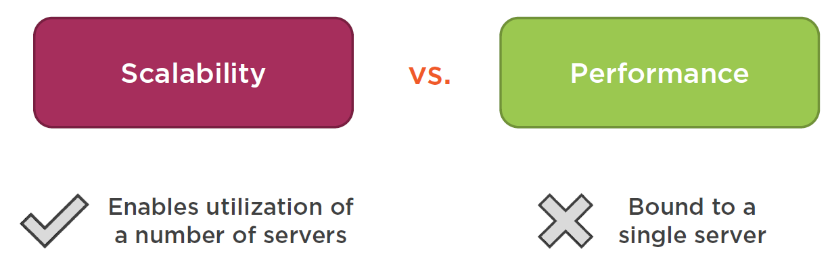

So what is scalability ? It is similar to **PERFORMANCE** but it’s not the same thing ! With performance optimizations you can achieve good results but you are still bound to the **resources of a SINGLE SERVER**.

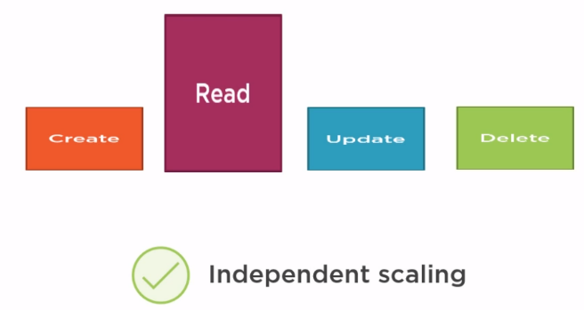

In typical enterprise level application, when it comes to CRUD operation, the one that is most used is the READ. So it makes a lot of senses to **SCALE** the **READ** part **independently** from the **WRITE** part. That is what the separation at the **physical data level** allows us to achieve this.

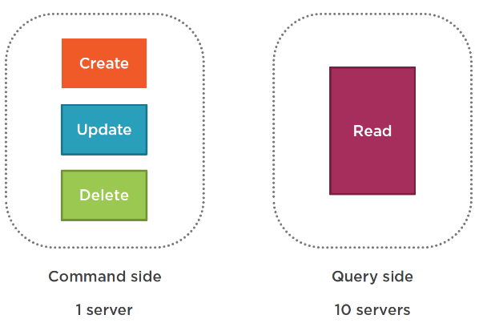

Even if you still have a single server which handles all the commands, by creating a separate **clusters of server**  for the **read side (queries)**, then you will drastically increase the application output because processing of commands and queries are typically **asymmetrical** and scaling these services **asymmetrical** will be beneficial too !

## Master Storage vs Queries Storage

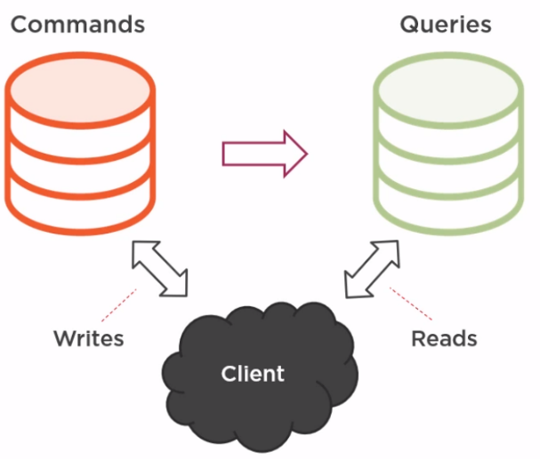

The commands database is the **master storage (write-side)** for all data in the enterprise application and should synchronize the **queries storage** when things get updated.

The **queries database** **(read-side)** synchronize with that **master-storage (write-side)**  and then serve the **reads on their own.** These reads are typically requested by the **client** (user-interface) and are returned as so-called **DTO** objects.

This way they **offload** the pressure from the commanding side.

|  |  |
| --- | --- |
|  |  |

The command part (write-side) is still bound to the resources of a single machine. CQRS itself doesn’t provide any guidance on scaling of the command, only the queries ! To scale the commanding side, we need to introduce **sharding.**

**https://en.wikipedia.org/wiki/Shard_(database_architecture)**

|  |  |
| --- | --- |
|  | ***Note:***  *The introduction of a separate database (or multiple databases) for reads is usually more then enough to meet the requirements of a CQRS based application.* |

## Separation at the Data Level in the Real World

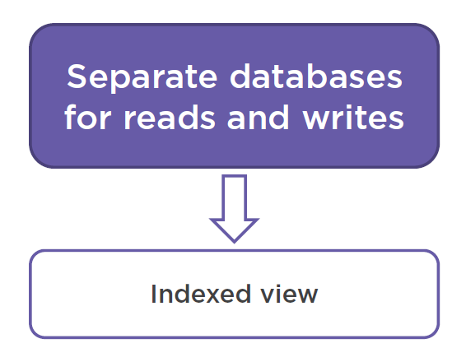

There are a lot of examples of how to separate CQRS Read vs Write, where you keep separate database for reads and writes, and you don’t necessarily need to create and maintain a **separate physical database** , because you can e.g. use **indexed views in SQL-Server** to achieve this separation.

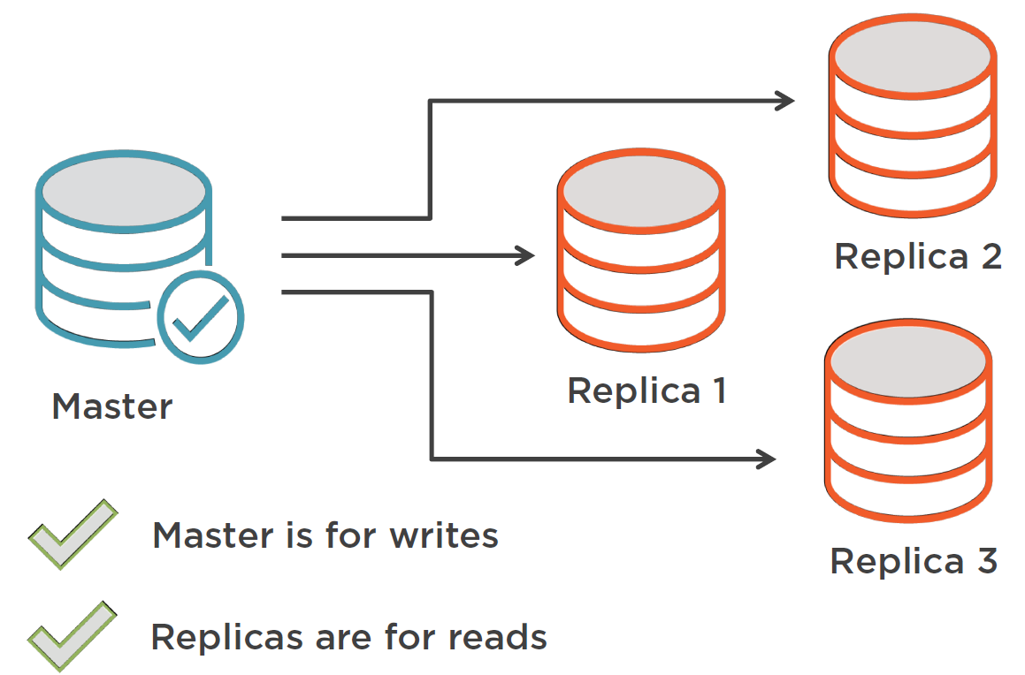

Another example of separation is **database replication** where you have one **master database** and several **replicas** that get all the updates which were propagated on the master database.



A final example is **elastic search** which is a **full-text** search engine which works by indexing data, usually from a relational database, and providing reach capabilities to query it.

|  |  |
| --- | --- |
|  | ***Important Note:***  *In order to achieve scalability in CQRS, you don’t necessarily need to implement the separation at the data level yourself because you can leverage an already existing software which can be good enough.* |

## Designing a Database for Queries

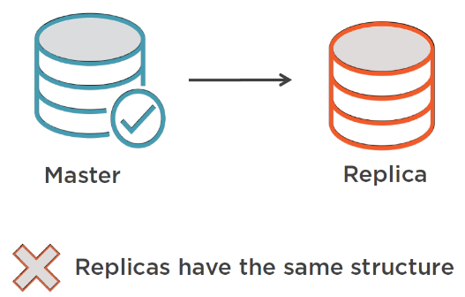

Although existing tools like replication database will help us in separating the database for reads and writes, e.g. replication we still have an issue: Although we have a separate physical database for reads (replica) and writes (master) they will **still have the same structure.**

But as we now reads and writes have very different needs ! And this might not fit well for the **read** side, because the master database is structured for the commanding side of things and is domain-model oriented.

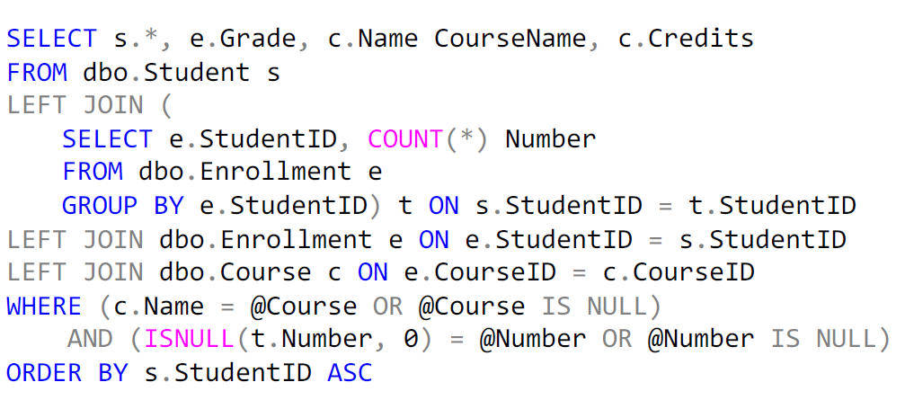

For example if you look at our SQL-query what we created for the read side, to make it appropriate for our DTO return object, we had to create quit a complex query by joining different tables, here’s the structure:

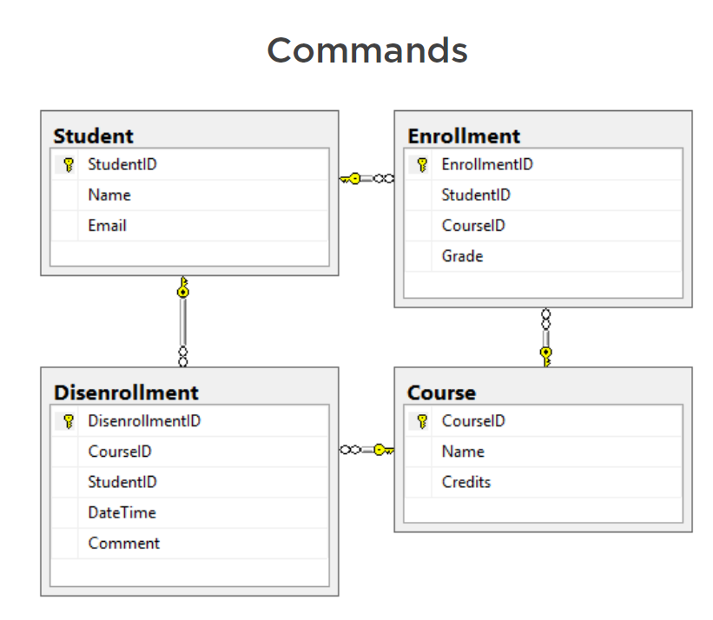

The query could have been simpler if we have a structure that had a better “fit” for the read side of our application ! The structure above is more specific to the **commanding side.**

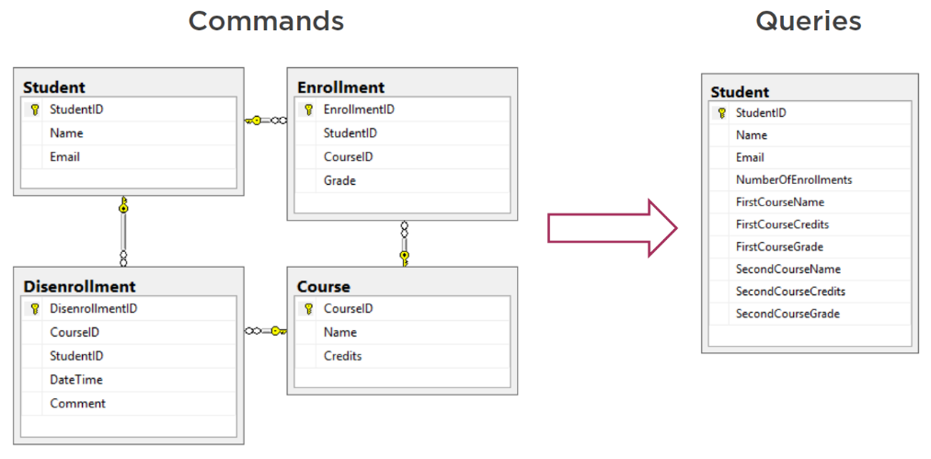

To be more appropriate for our **“read”** side we could denormalize the schema like mentioned above. So we make a single table out of it. But what’s the reason behind such a drastic change ? In other words:

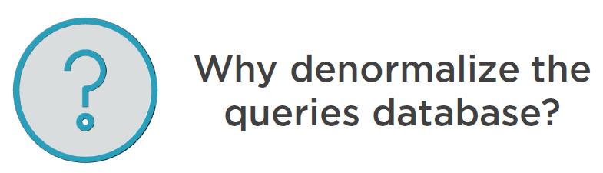

This is because the denormalized table as shown on the right is a much better fit for our **Read-Model** as required by the UI-Client !

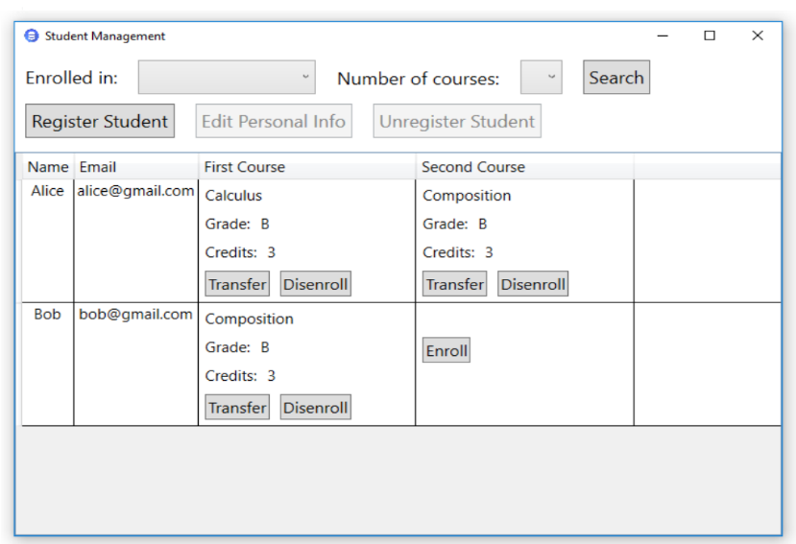

So, if we look at our UI, what data do we need to compose such an UI ?

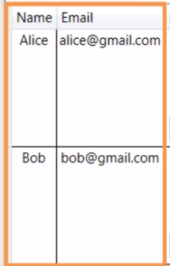

First of all, we need the students themselves of course ! , their names and emails in our case.

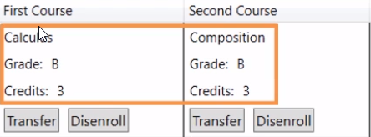

Next we need the info about their (possible) first and second enrollments : the name of the course, the grade and the number of credits they get to accomplish the course.

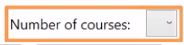

And we also need the total number of courses to support our filter functionality here.

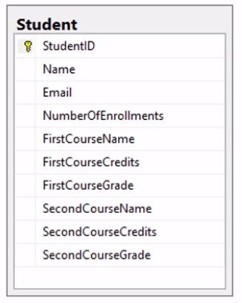

And that is exactly the information we need as structured in our “single” new denormalized table !

|  |  |  |
| --- | --- | --- |
|  |  |  |
| We have the name and email from the student. | We have the number of enrollements for the student. | And we have the details of the course enrollments of the student. |

We have adapted the structure of the database to exactly match to the **needs of the read side of our application.** No more needs for a complicated **SQL-Query** anymore !

Finally, let’s look how we can simplify the SQL-Query, let’s first look at the old one, as mentioned below:

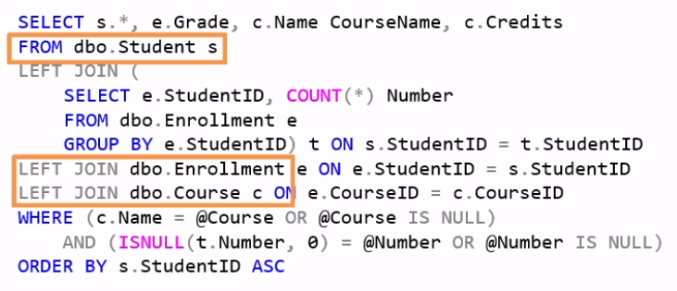

You see it joins the data from 3 tables of our commanding (write-side) type domain-centric database: student, enrollment and course. And with the new denormalized database, the resulting query is much simpler:

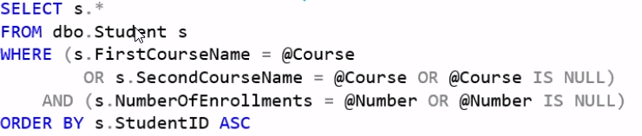

## Creating a separate database for Queries (Read-Side)

Here is the new database and table that we need for our read-side:

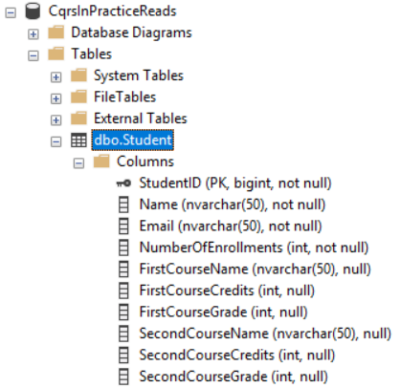

We now have 2 databases:

* One for reads (Query)
* One for writes (Commanding)

So back in our application, we need a new class to represent the **read-side** database connection string:

|  |  |
| --- | --- |
|  |  |

Next add the **ConnectionString Value** to our **JSON config file:**

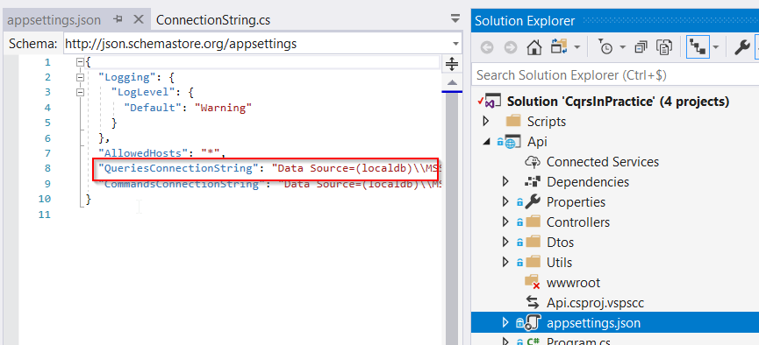



Next in the **Startup.cs** class of the **Api** project, add & register the new connection string for our **read-database:**

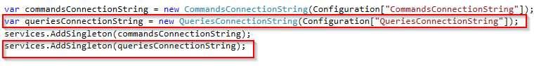

We also have to **refactor** the **queryhandler** method **GetListQuery()** handle method, which resides in the **Logic.Students.QueryHandlers** namespace of the **Logic** project:

* Refactoring of the query-definition:

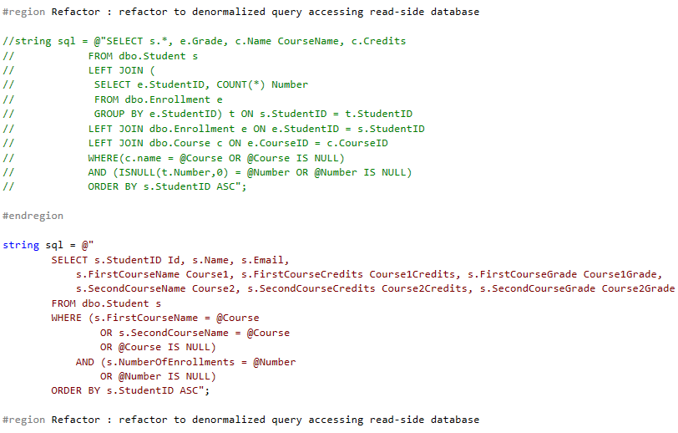

* Refactoring of the query-execution:

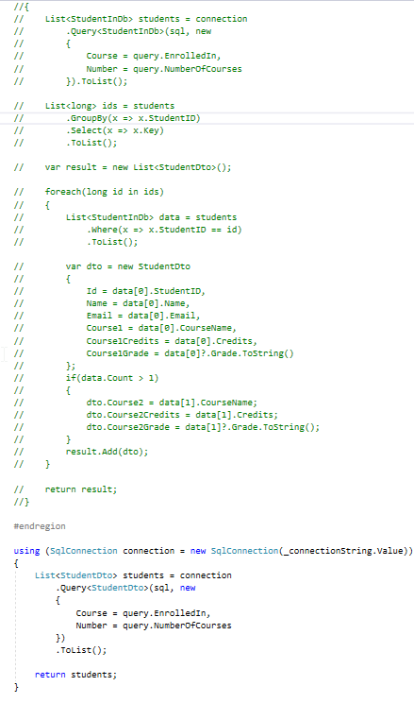

**Now we still have to synchronize the read- and write- databases, we will covert that in module-8 !**

## Scalability

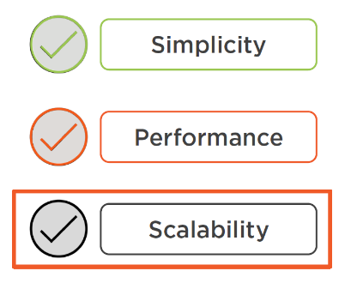

Above are the **3-benefits** of CQRS. Now, what about scalability ? Where can we find this in our current codebase ?

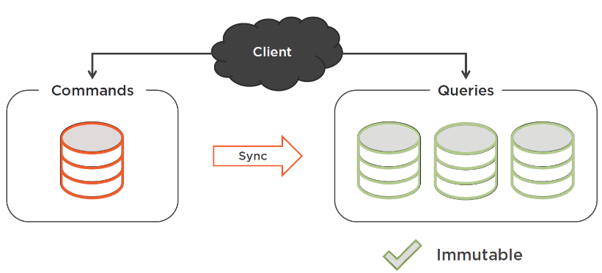

Now that we have separated our database into 2 distinct data storages, it’s easy to **scale the read-side** of the application. Just create as many databases for reads as you need and make them **synchronize** with **the database for the writes.** We will be talking about the synchronization strategies in the next module, but we need to implement this process only once.

The queries side is also **immutable,** this is because it does not **mutate any state,** it doesn’t leave any **side effects**, and so it can be **scaled indefinitely.**

On the other hand, it is not so easy to implement **scaling** in the write-side **commanding model.** This is because of the **data mutation.**

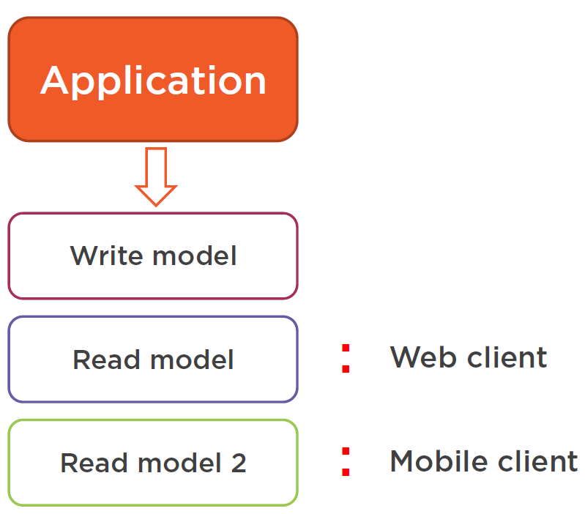

In fact we could even have more than 1 read-model which can result in more the 1 database with specific schema for each implementation and specific synchronization mechanism too. E.g. a mobile versus a web-client application. This is because usually a mobile application has other data needs then a web one, a mobile may request less data due to the limited bandwidth, and thus require another model.

# Module-8: Synchronizing the Commands and Queries Database

## Module Content

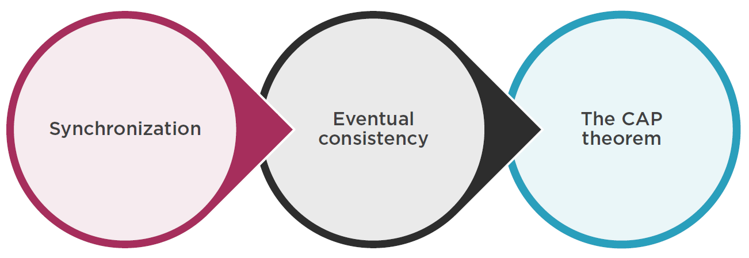

In this module we will take about synchronizing the read with the write model, eventual consistency and the CAP theorem.

## Introduction

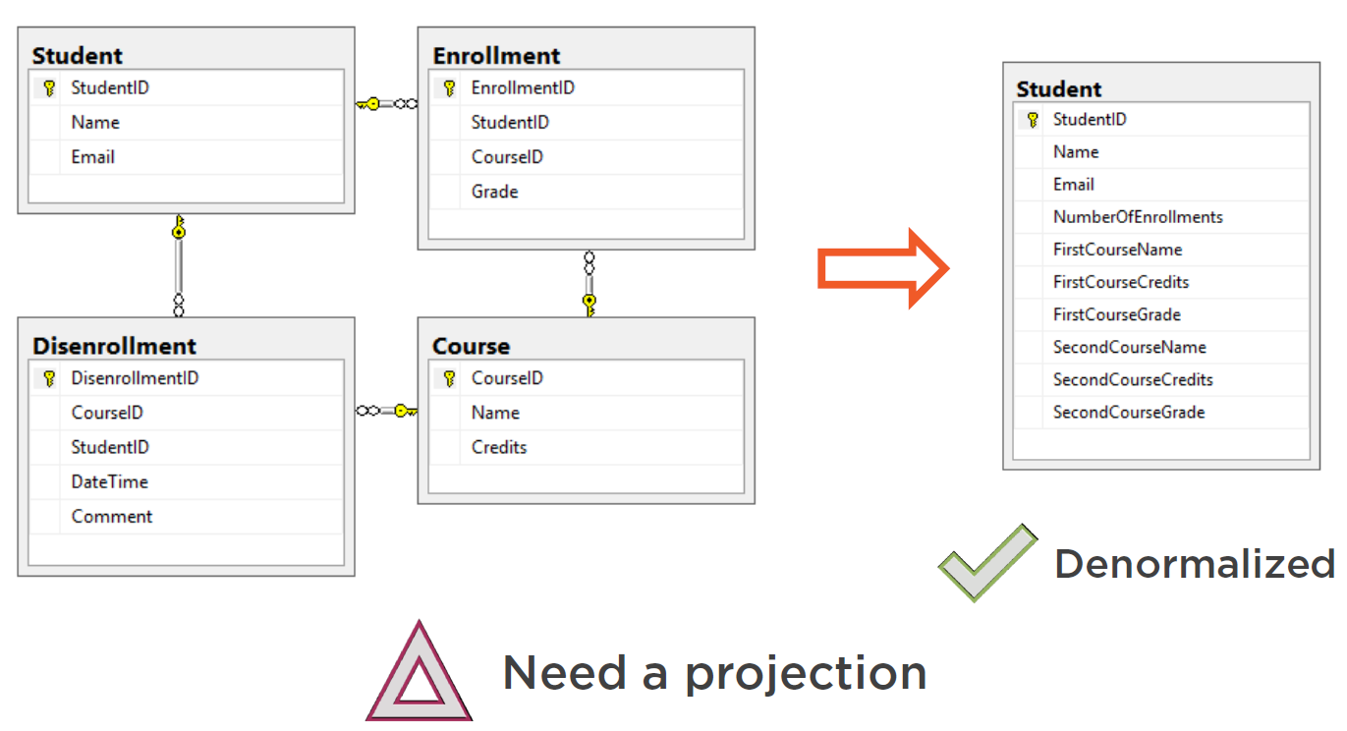

In the previous module, we introduced a new **database**  for the **read-part** of our CQRS-based application.

This new database is perfectly aligned with the needs of our **queries** because it is **denormalized,** and consists of a single table to effectively retrieve the data with optimized queries for the read-side.

The fact that we now have **2 databases** instead of a single, means that we have to **synchronize** between them. Such a synchronization is also called a **projection.** The words **“synchronization”** and **“projection”** are synonyms in the context of CQRS.

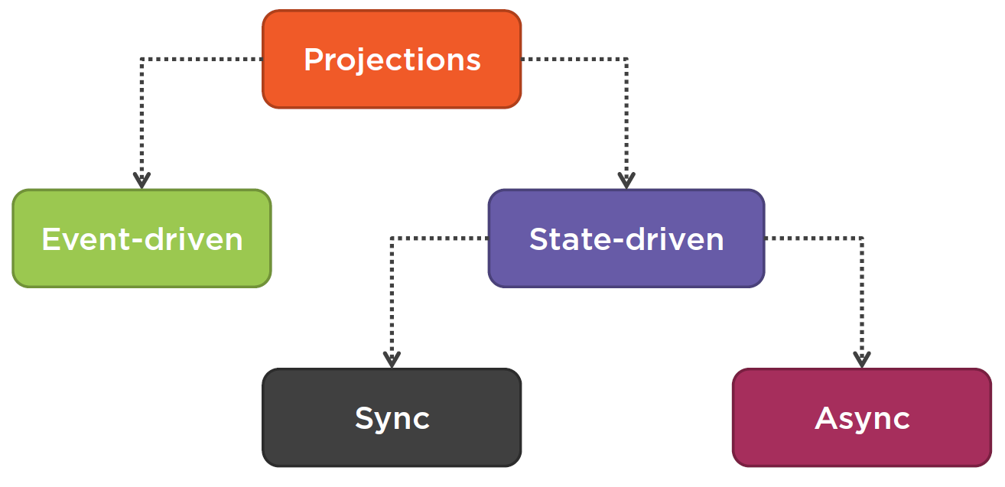

Next are the strategies we could employ to implement such a projection. These projections can be divided into 2 categories, this by the type who drives them:

1. Projections driven by State.
2. Projections driven by Events.

## State-driven projections

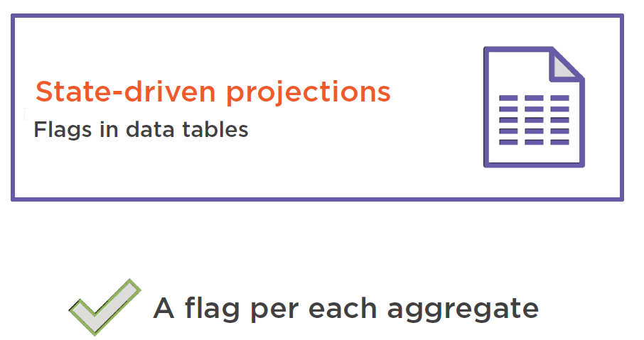

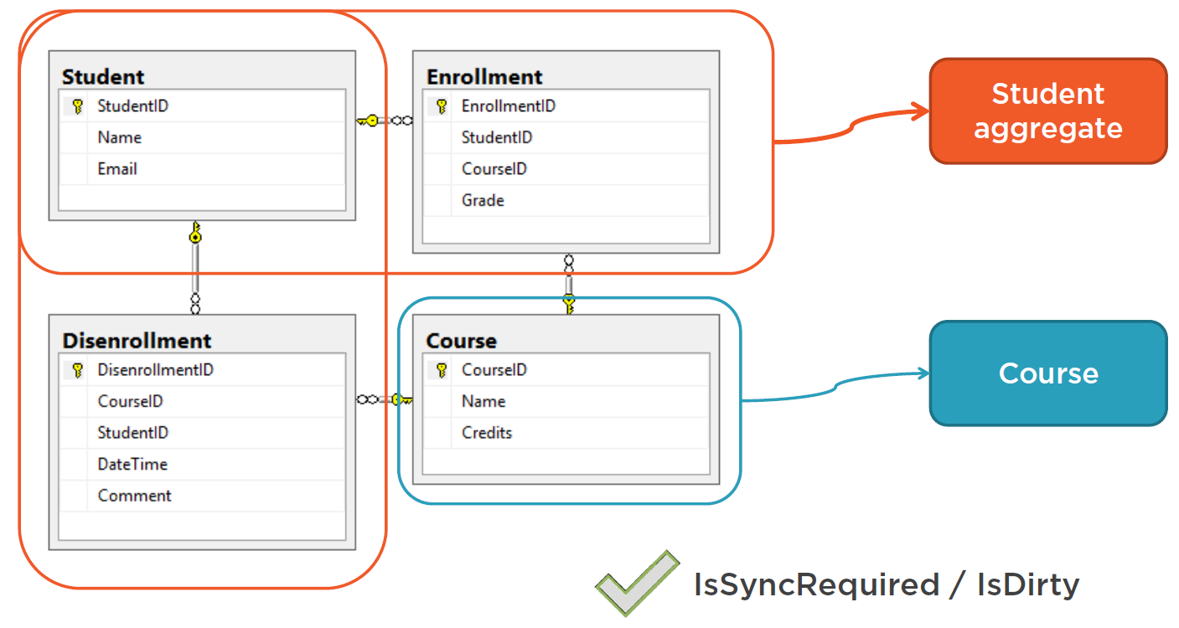

Can be divided into 2 sub-categories, **synchronous** and **asynchronous.** The idea behind it is that you have a **flag** in each **aggregate’s table** that tells that the aggregate has been **updated** and this since the last **synchronization** and you need to synchronize it once again. In our example, in the command side, we have 2 aggregates, Student and Course. You wouldn’t need to add four new columns, one for each table, but rather just two, one per **aggregate type.** You can call it **IsSyncRequired / IsDirty** or something similar.

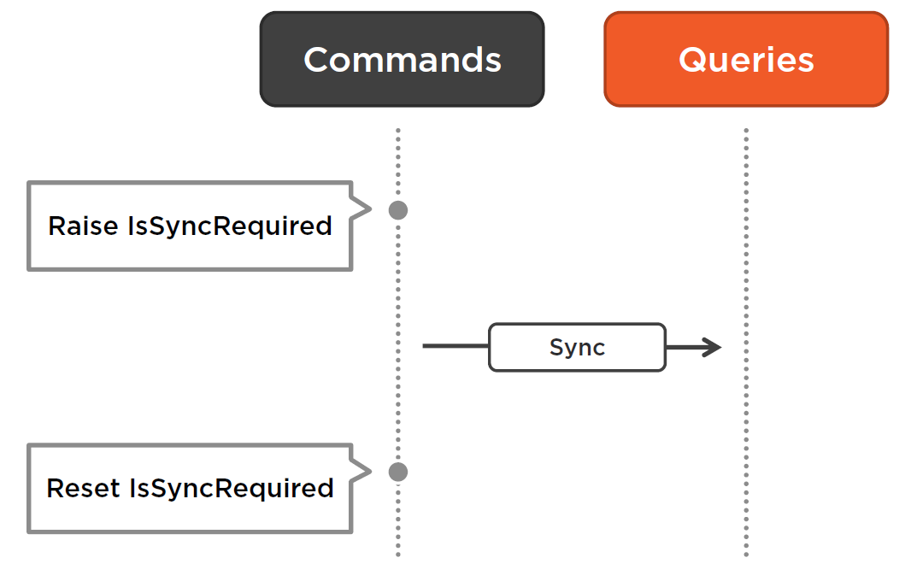

So whenever a **student** gets updated, and that includes the data in the student, enrollment and disenrollment tables , then you raise the **IsSyncRequired** flag in the **Student** table.

A separate **synchronization process** that runs in the **background** then picks it up and either **inserts an new row**  into the **read database** or **updates an existing row** in the **read database.** After that it **resets the flag.**

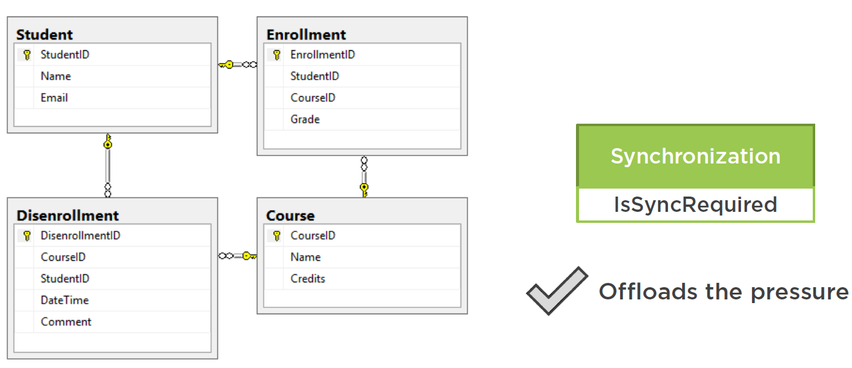

Alternatively, you can also add a small **separate table**, named **synchronization** with another flag in it called **IsSyncRequired.** This table will just have 1 row. Whenever any flag in the database is raised, the flag in that small table will be raised as well.

The reason for this separate table is that the **background synchronization process** will be sampling changes in the **commands database** pretty often, and may potentially put a pressure on the student and course tables.

The use of the additional table will enable you to **offload** that pressure. Now the synchronization process will be sampling just this **one table** instead of all students and courses. It will query the students and courses only if the flag in the synchronization table is set to true.

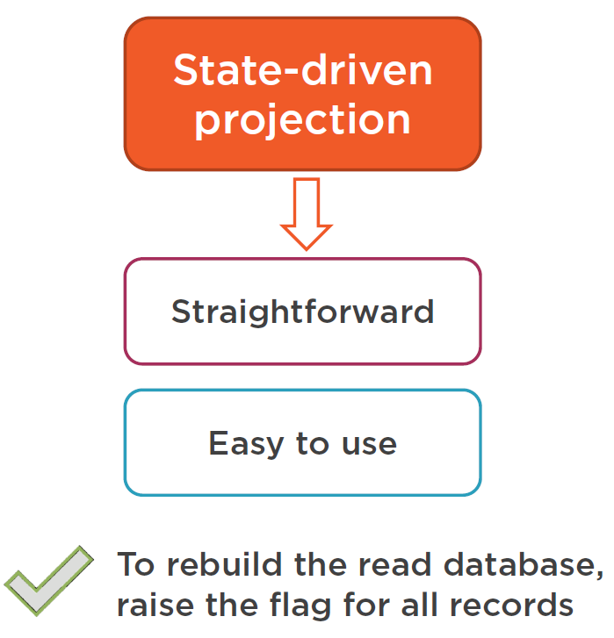

This synchronization mechanism is straightforward, simple and also easy to implement.

If you would ever need to **rebuild the read database**, you just need to raise the flag for **all records.** And you can do that **selectively too,** for just a subset of records.

There are 2 ways to implement the **commands part** of this mechanism:

### Database Trigger Synchronization

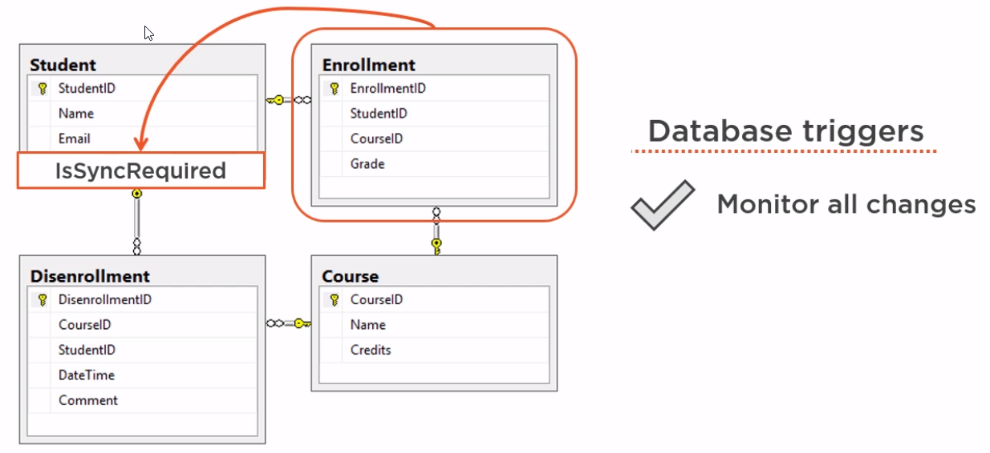The part for raising the **IsSyncRequired** flags. First create a database trigger. This trigger would monitor all changes in all of your database tables and update the flags accordingly. E.g. if we **enroll a student in a new course**, an **new enrollment row will be inserted.** The trigger can interpret this insertion as an **update** of the corresponding **student aggregate,** and can raise the flag for that specific **student record**, as shown below:

As well as the flag in the **synchronization table** to let the synchronization background process to do its job.

Note that, in order to make the deletion possible, you would need to modify the way of **unregistering of a student.** Instead of actually “deleting” them, you need instead to implement a **soft-delete** with an **IsDeleted** flag. Then the deletion of a record will be treated the same way as a modification is.

### Domain model based Synchronization

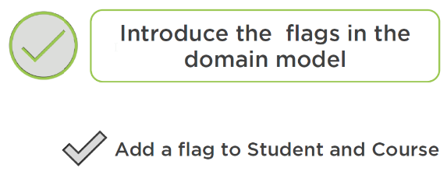

The second way to raise a **synchronization flag** is to **introduce the flags in the domain model** itself **explicitly,** instead of relying on a database trigger.

To do that you can add 2 new **IsSyncRequired** properties to both the student and course domain model and next update those properties whenever the **client code** modifies anything in those **aggregates**.

That is pretty simple to do if you domain model is **encapsulated.** Here is an example:

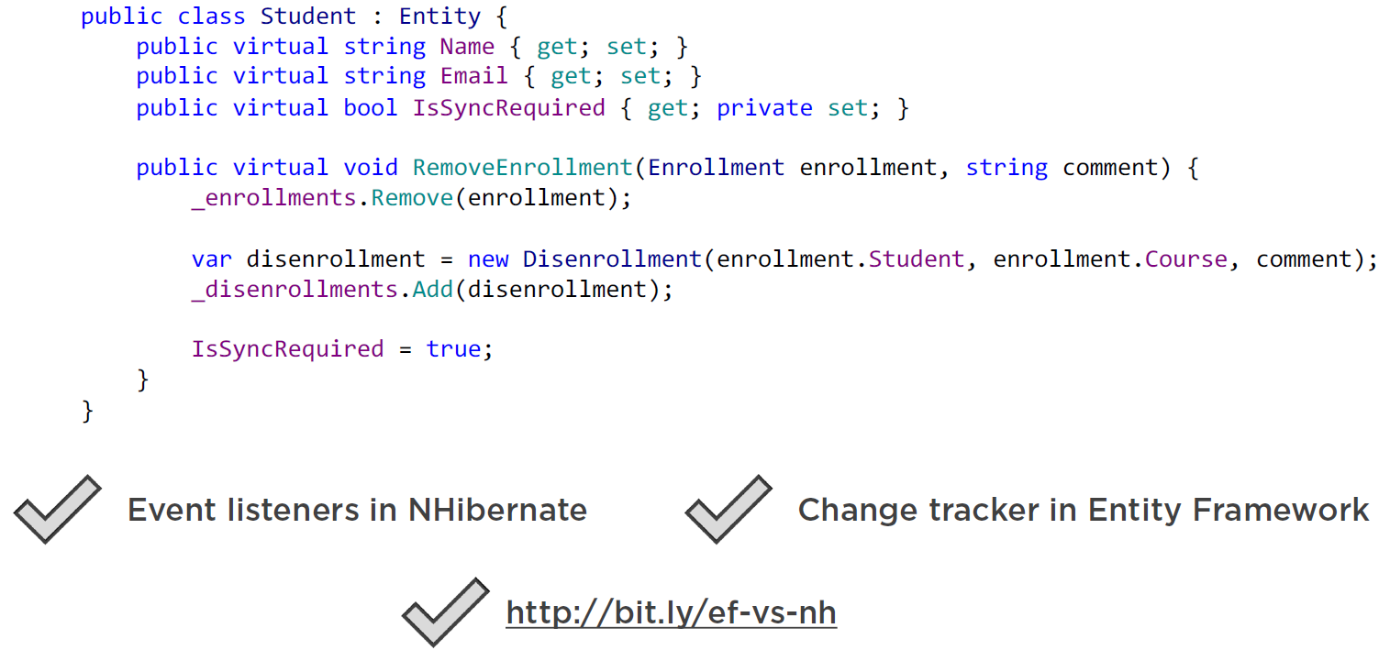

When we remove an enrollment, we raise the **IsSyncRequired** flag . To make this work you would need to overwrite the setters of the “name” and the “email” properties. To raise the flag in the separate synchronization table, you can use **Event listeners** in **NHibernate** or the **Change tracker** in entity framework.

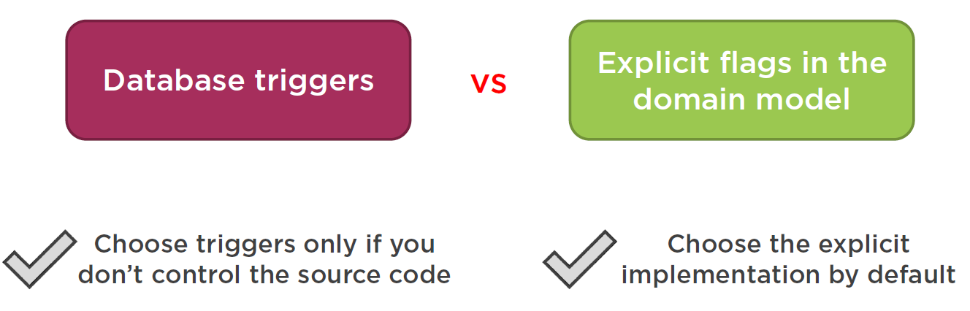

So which one should you choose to raise the synchronization flag ? If you have the control over the domain model, then go for the explicit route, with explicit flags in the domain model else choose for the database triggers 🡪 **so prefer domain model.**

## Synchronous State-Driven projections

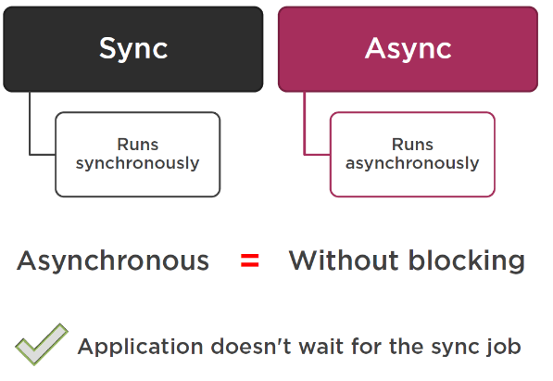

In §10.3 we discussed **an asynchronous state-driven projection strategy.** This is because the projection is driven by the state of the database, particularly the **IsSyncRequired** flags, and there is a separate **background process** that does the actual **projection.**

It monitors those flags, and **rebuilds the query database** if it sees any changes.

Let’s next look at **synchronous** state-driven projection strategies. The word **async** means without blocking the main worker thread. In this case the application is able to update a student in the database and continue working. A separate process then picks up this modification and does the projection. In this case our application won’t wait for that process to complete its job, and so we can say that the projection is done in a async way.

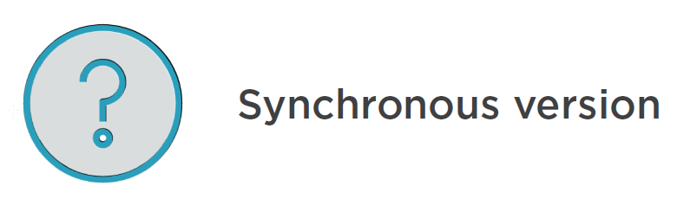

So how looks the **synchronous version** then ? This is when the application itself does all the synchronization work **or waits** until the **background process** completes the projection before returning an OK to the **client.**

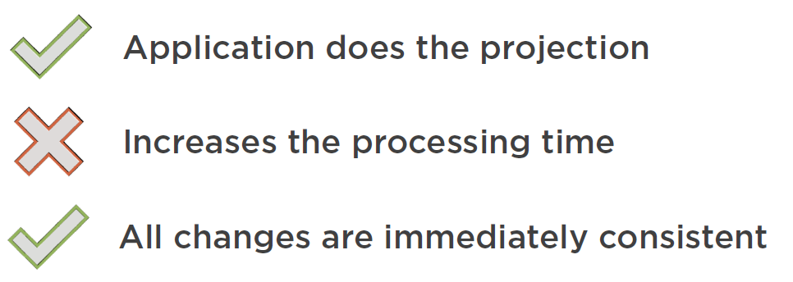

This approach is rarely applied in case you have **2 separate databases for reads and writes,** mainly because it **increases the processing times dramatically.** The benefit here is that the read and write models are **immediately consistent**; which eliminates confusion for the users when they don’t see their changes immediately appear in their UI.

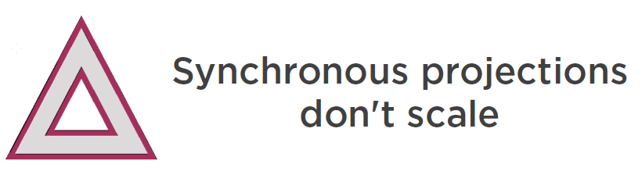

## Examples of Synchronous and Asynchronous Projections

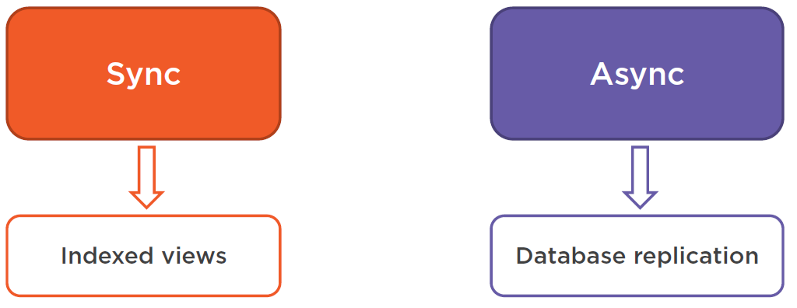

Indexed views is an example of **synchronous projections,** this is because all indexed views in relational databases are **updated immediately,** along with the tables **they derive their data from.**

On the other hand, **Database replication** is an example of **asynchronous projections,** because the replicas are updated asynchronously.

## Event-driven Projections

* 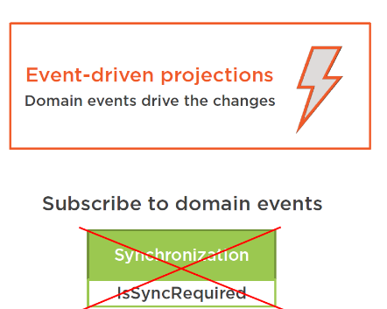

Event driven projections are not driven by **state**, but instead are driven by **domain events.** Instead of the **IsSyncRequired**  flags and the **Synchronization tables** the projection process will subscribe to **domain events** that the **command side raises** instead.

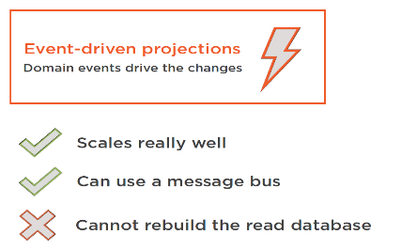

Next the information from within these raisen events will be used to update the **Read-Database.**

* The biggest benefit of the **Event-Driven-Projection** approach is that it **Scales-Really-well ! 🡪 Even better then the approach with the async-state-driven-projections.**
* This is because the application can publish the **domain events** on a **message bus,** and you can have as many projection processes subscribing to those events as you want. They will not put additional pressure on the **commands database !**
* But the significant drawback to this approach is that there is no easy way to rebuild the **read-database** from scratch or **re-run** the projection in case of an error.

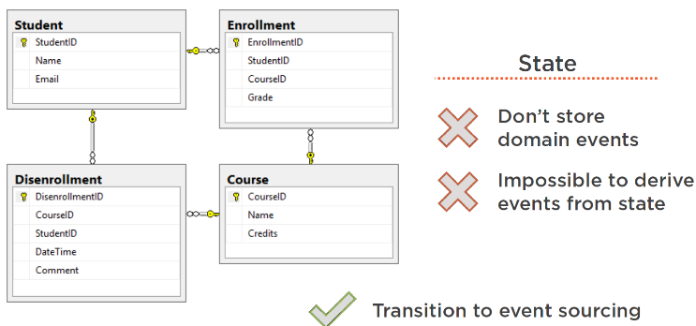

In our commands database, the source of all data is the **state.** This is the current state of the **student** and the **courses.** We do not store the **domain events** that led to that state, and because it’s impossible to derive the domain events from the latest state, your read databases will become out of sync if they miss **any domain events** for some reason …

You can avoid this by storing the domain events along with the current state in the commands database, but this would be a complex and significant overhead and you should transit to an **event-sourcing** based architecture in this case. **Event Sourcing is out of scope for this course !**

So, the rule of thumb is :

If your are implementing the CQRS pattern **without event-sourcing**, which means that you don’t store **the domain events in your commands database,** and just **persist the latest state instead**, then **don’t employ** the **event-driven projection** approach.

In this case the **state-driven projection** would be a better fit.

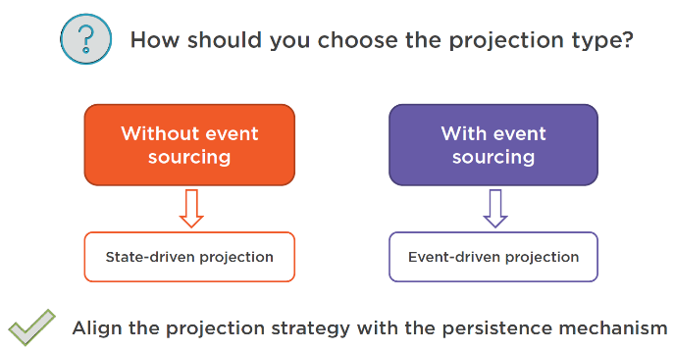

On the other hand, if we are using **event sourcing** then use the **event-driven** projections, because in this case you will be able to **rebuild the database** from the event-store.

## Consistency

Introducing separate databses for the **read-** and **write** side will introduce **latency** in synchronization between the write and the read models.

This brings in a potential confusen for our end users of the application, and we should carefully consider this drawback.

E.g. immediately after registration of a student, the end user may not immediately see that new student appear on his screen, and the user may decide to create the same student again, ending with duplication. In case this is a problem, consider for using a single database for reads and writes. You will still gain most of the benefits of the CQRS pattern.

However, there are some ways to avoid these latency confusions. First, there will be unique constraints on the data in the commands database, and that will avoid duplication of data.

The consistency issues will only envolve the query database, because the commands database will be always immediately consistent !

**Important Note:**

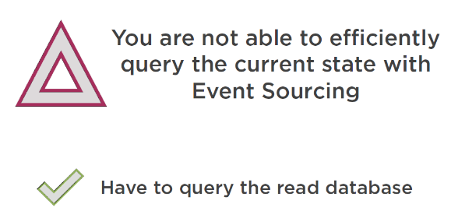

We are not able to efficiently query the **current state** from the **commands database,** this is because the **commands database** stores events, **not the state.** So we will have to query the **Read-Database** instead in this case.

## Eventual Consistency

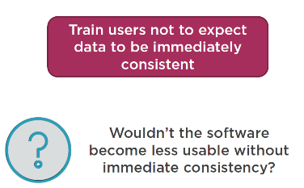

Imposing **unique constaints** are a way to deal with **consistency.** Another way to do that is to train your users to don’t expect that the **data they see on their screen to be immediately consistent.** This is because **immediat consistency** is not how things work in the real world !

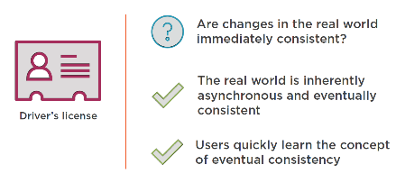

For example, if you move to a new home, do you expect for example that your drivers’s licence to reflect that change immediately ? Of course not, because your driver’s licence will show the old address until you go to the right instance to let it correct ! And in between this time, the information on your current driver’s licence will remain stale (not correct).

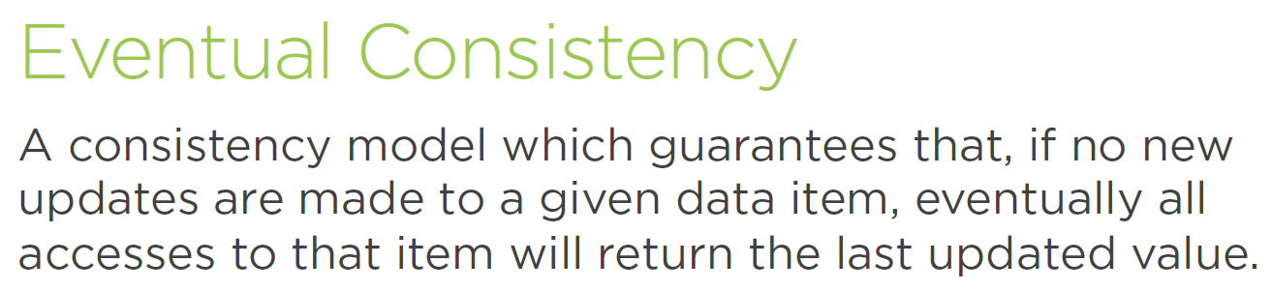

So, in our example with the commands and the queries databases, it means that if we **modify a student,** this change will **eventually propagete to the Read-database,** and users will be able to see it on the UI (with some latency …).



In mean time you can put a message to the user that the action is processed and may take some time to be reflected in his UI.

An alternative is to show the “local-updates” in mean time, and then send push notifications from the read-database when the read-part finally got updated !

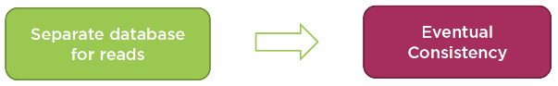

So to summerize, if you have chosen to have a separate read-database, then this read-database will not be immediately consistent after writes have been ton through the commands database. It will be **eventually** consistent, which might or might not be acceptable, depending on the requirements of your **business.**

|  |  |
| --- | --- |
|  | ***Info:***  *There is a great article on how consistency is handled in the real-world, called “Star Bucks doesn’t use two-phase commit”, you can find the link here:*  [*https://www.enterpriseintegrationpatterns.com/ramblings/18_starbucks.html*](https://www.enterpriseintegrationpatterns.com/ramblings/18_starbucks.html) |

## Versioning

You can keep a version of an aggregate in both the read- and the write databases, and then if you see that the user tries to update the stale (outdated) record, them show them an error. This is called optimistic concurrency control.

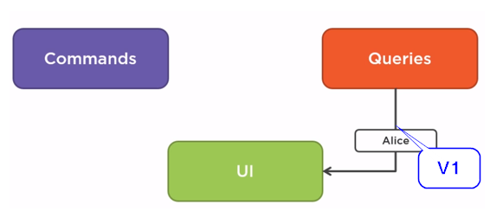

Let’s illustrate this by example: Let’s say we request a list of Students from the read-database of our application an this returns Alice’s record with version 1, as shown above.

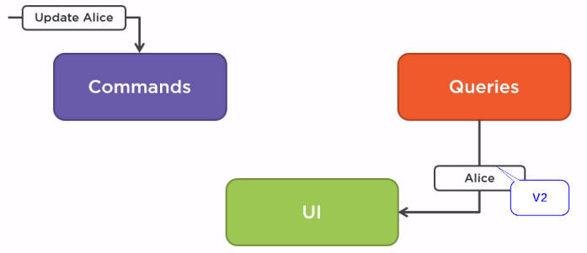

Let’s also assume that in mean time another user updates Alice’s personal information, and thus the version of this record becomes 2 in the commands database, as shown above.

The you update the information based on the V1 version which has become “stale” (outdated). So to handle this we should add the version number in each communication between the UI, the command and the read-models.

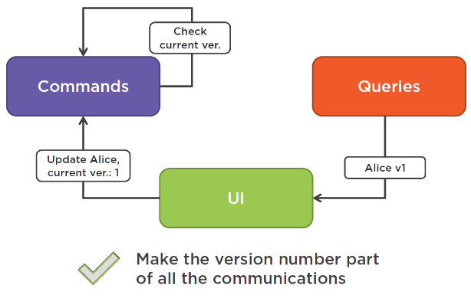

So when the UI queries the read model, it receives the record and version number of the record at time of read. And on update it includes the version number as part of the command which will be sent to the write-model and compare the versions before update (check with version number of the loaded aggregates from the write-side), so an exception can be thrown saying that the user has not the last version, an depending on the requirements, reloads the data from the database.

## CQRS and the CAP Theorem

There is a close relationship between CQRS and the CAP theorem. The CAP theorem states that it is impossible for a distributed data store to simultaneously guarantee 2 out of the following 3 guarantees:

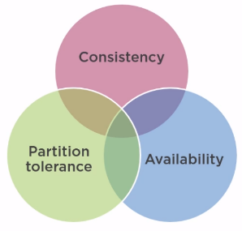

* Consistency means that every read receives the most recent write or an error.
* Availability means that every request receives a response, part from outage.
* Partition tolerance means that the system continues operate despite messages being dropped.

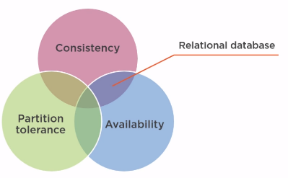

E.g. if you go for availability and consistency, that would be a typical database server running on a single node. All read requests always get the latest version of the data, and this server is always available. **Drawback:**  No partition tolerance, meaning that you rely on a single server or node.

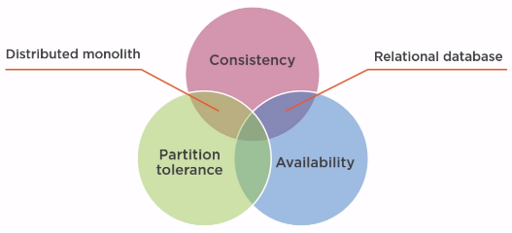

On the other hand if you choose consistency and tolerance, that would be an anti-pattern called distributed monolith. All reads to such a system will be fully consistent with the writes. **Drawback:** Because of partition tolerance, there are multiple servers, and because of consistency between them, we need to “block” the whole system until all nodes are updated (consistent). This would make the system unresponsive and unavailable for a certain amount of time.

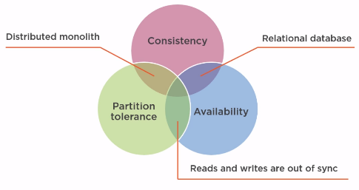

Finally, if you choose availability and partition tolerance, then this is on expense of consistency. E.g. connectivity loss between server nodes, they go out of sync.

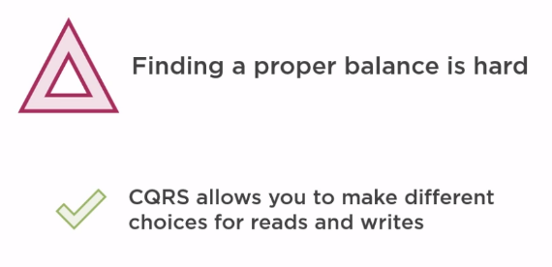

So you can never guarantee on the 3 which means that you have to find a “balance” for your CQRS implementation. And CQRS makes it possible to make different choices for reads and writes.

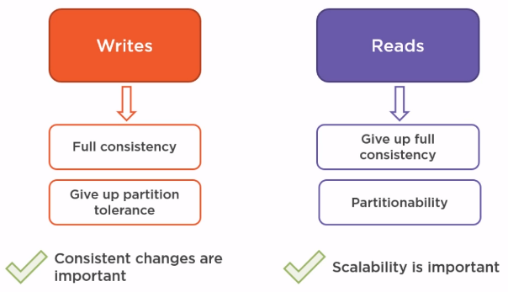

In most cases you can have full consistency and the commands side, and give up a level of partition tolerance. That’s the typical “relational-database-server” scenario. In this case you can only do that as long as all your command-handlers can operate on a “single-machine”.

At the same time, you can give-up the full consistency on the “queries” (read-side) in order to scale the reads up on several machines.

# Module 9: CQRS Best Practices and Misconceptions

## Introduction

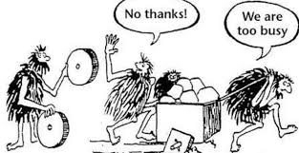

In this last module we will talk about some of the best practices and common misconception around the use of CQRS.

## CQRS and Event Sourcing

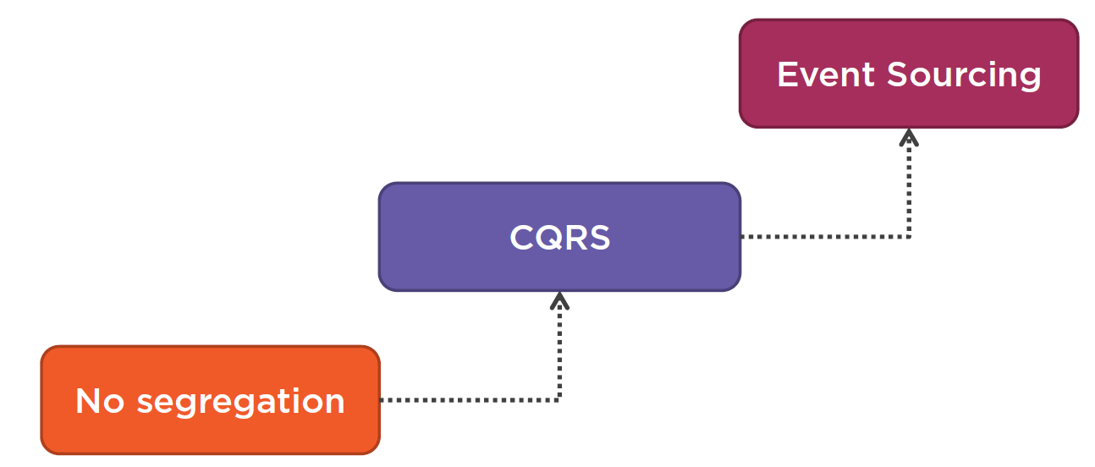

Some argue that CQRS is the base for Event-Sourcing architecture, but that’s not immediately the case. CQRS can be applied on its own, without the underlying implementation of Event-Sourcing.

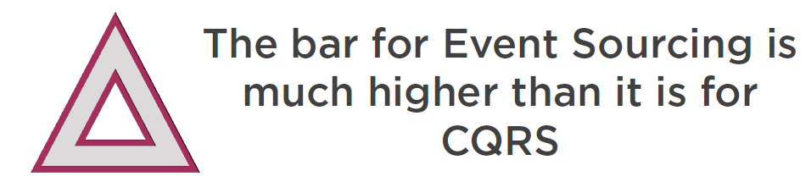

Even more Event-Sourcing brings a lot of “Complexity” which is sometimes only useful in rare cases, so Event-Sourcing shouldn’t be the default either …

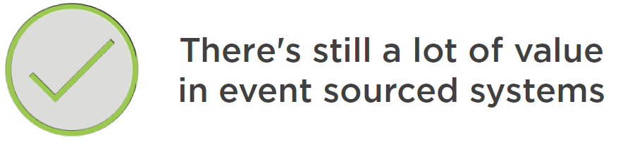

But despite this added complexity, there is still a lot of add value when applying Event-Sourcing in you CQRS-based applications. Usually the applications that benefit from Event-Sourcing are a special kind of systems, more specific those for which the storage of the separate events are important to come to a particular state of the system, other then the current state.

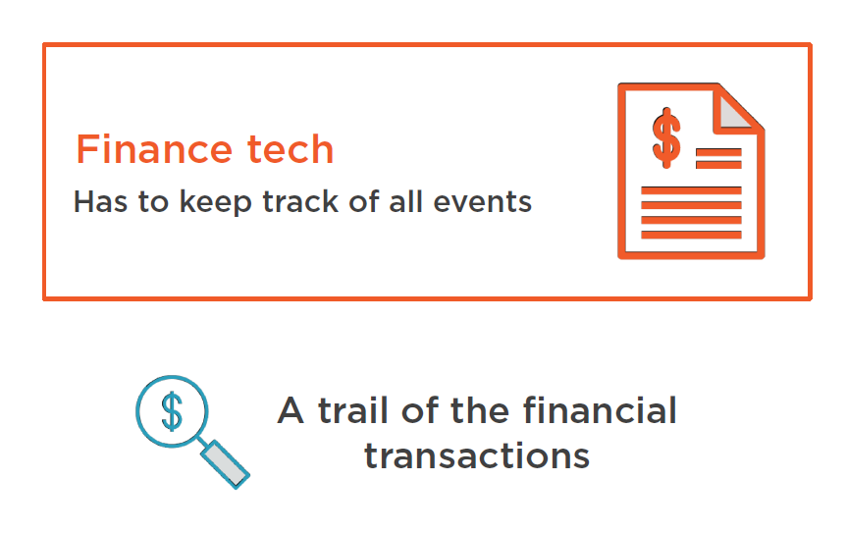

E.g. almost everything from the financial world will benefit from Event-Sourcing, this is because Event-Sourcing enables to have a trail of the financial transactions, (aka: audit-log).

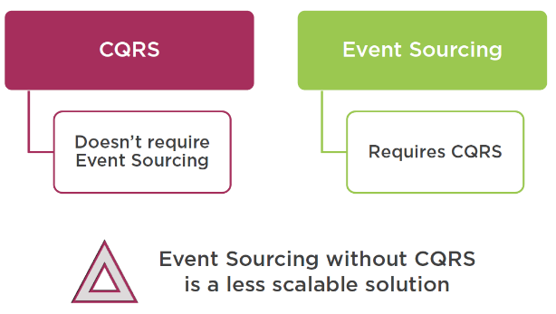

To summarize : you don’t need Event-Sourcing to implement CQRS, but you usually need CQRS to implement Event-Sourcing ! Event-Sourcing without CQRS (means: without separation between reads and writes) is a less common and less scalable solution !

## Evolutionary Design

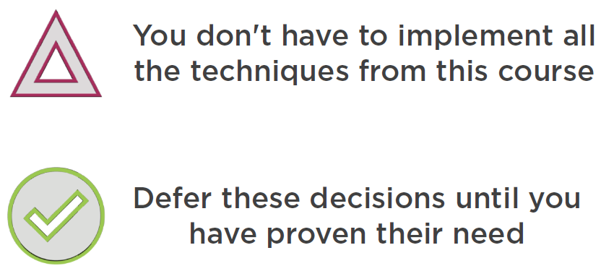

You don’t have to apply all the techniques which are related to CQRS. You must first always prove their need first !

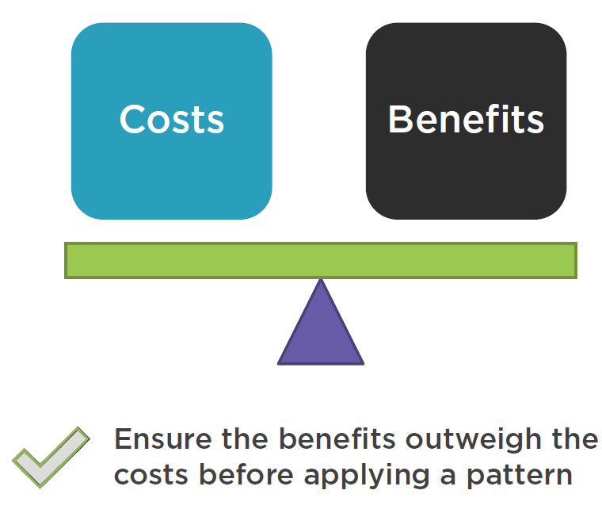

This does not only apply to the CQRS-design-pattern but is of application to all software design-patterns. Each design has it’s “Costs” & “Benefits”, and you must be sure that the benefits outweigh the costs before starting the implementation !

## Using Commands and Queries from Handlers

Can you use other commands from you Command- or Query handlers ? The short answer is: NO. But the long answers differs depending of the situation …

**There are quite a few :**

Can you use another command within a command handler ?

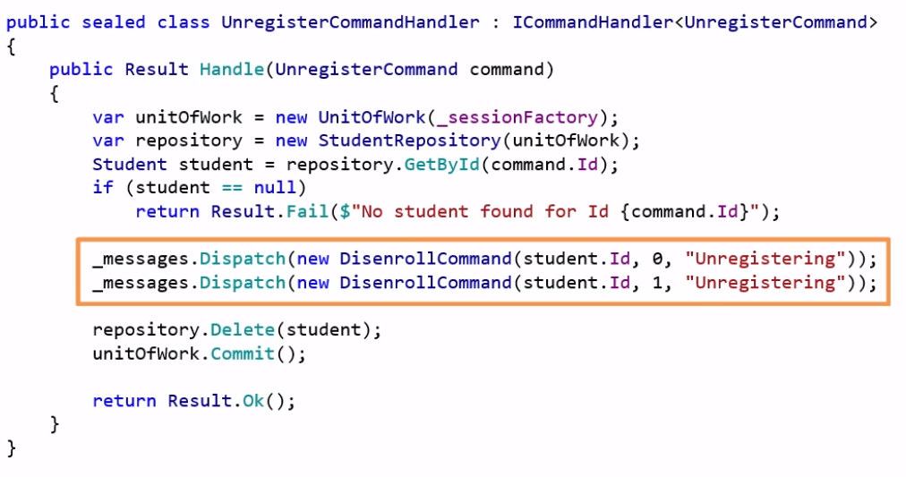



In the example above we use 2 new commands within an existing command handler. This is contrary to the notion of commands that says : **“It should be only the client that triggers commands, not our system !”.**

Our system reacts to those commands and produces **domain events** to notify other systems that something has changed in the domain ! It should not create subsequent commands on its own !

And if you need to reuse some code between command handlers, extract them in a **domain service** instead but don’t **reuse command handlers.**

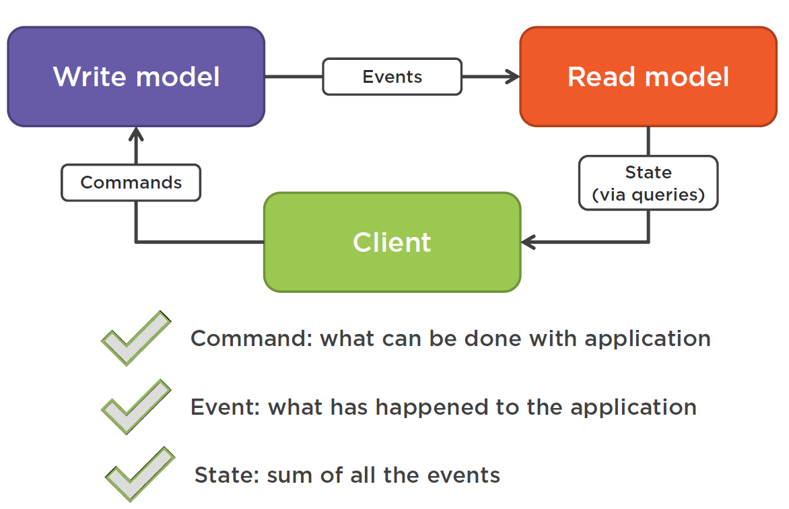

The picture above clarifies the relationships between our **application**, the **client,** and the **type of messages** they exchange with each others.

Next: can you use a query (read-model) from a command-handler ? Here the answer depends on whether or not you can have a reliable way to request the current state from inside the command side.

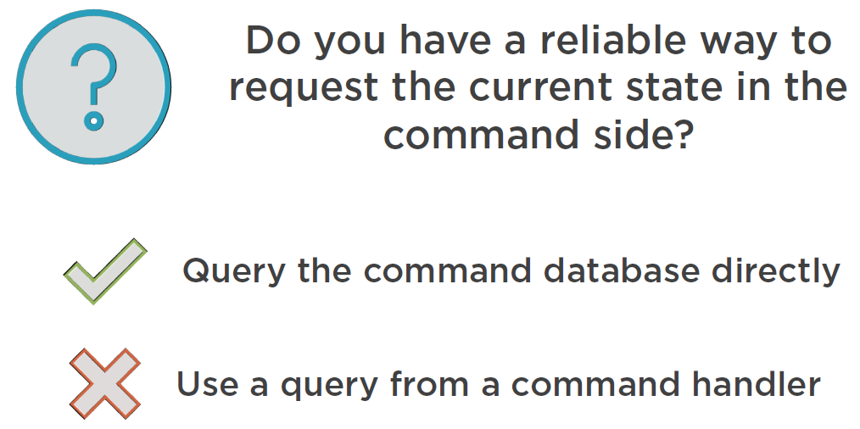

If you do, then don’t use a query, just refer to the command database directly to retrieve the piece of data the command needs.

On the other hand, if there is no reliable way to know the current state then you don’t have any choice other then using a “Read-side” query (from the read) model, from within the command.

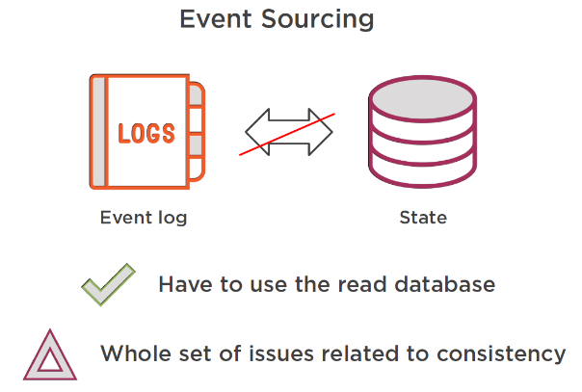

Having no reliable way can be the case when you apply Event-Sourcing on the command side. Because in this case we have to “replay” all the events from the Event-Sourcing log. In this case you will need the read database instead of loading all events from the commanding database !

Finally, can you use a command or a query from a Query Handler ? For commands this is NO of course, because a query handler should not mutate state ! For using another query from within a query-handler, the usage is not as strict, because the read-model is immutable, so you can’t mess up things … But in general : don’t reuse the query handlers either ! 🡪 use a domain service instead if needed !

And here is the summary ☺ :

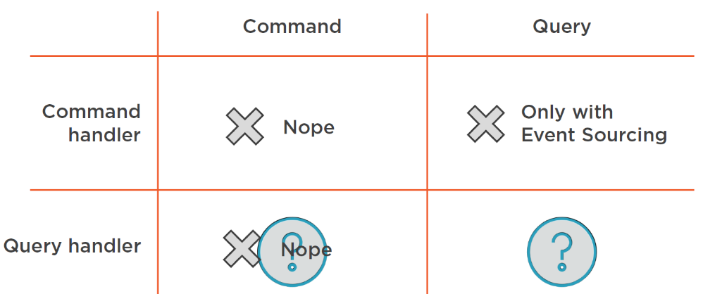

## One-Way Commands

Should commands always be “Uni-Directional” ? In other words: shoud they always implement a “fire and forget” pattern, and return “void” (nothing) ?

So returning something from a Command would be a violation from the CQRS pattern. So instead, if it is necessary to “know” the result of the command, once can use a separate “polling mechanism” and poll and external source for the execution result.

E.g. in case of “RegisterStudentCommand”, the Command side shouldn’t do that right away, it shouldn’t provide you with the **result** in a **synchronous** way ! But it shoulder rather execute the request for the result in an **async** way by polling a separate **API-endpoint** to know the result. But this is another misconception !

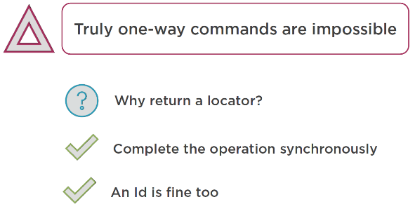

Truly one-way commands are impossible, they always need to return some kind of acknowledgement, either an ok or failure or a kind of locator to poll the results from with the use of a separate API-endpoint.

So why return this locator if you can return the results right-away ? If the operation is small and can quickly return, then let it execute in a sync way and return the result. In this case it’s also fine to return and ID or newly created entity.This looks like a true “violation” of the CQRS principle ! It’s ok for commands that return a locator of the resources they create.

## CQRS vs. the Specification Pattern

There is a big controversy between 2 DDD design patterns, CQRS and the Speicification pattern.

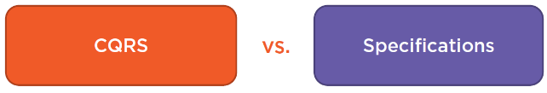

The controversy is that these 2 patterns are incompatible amongs each others.

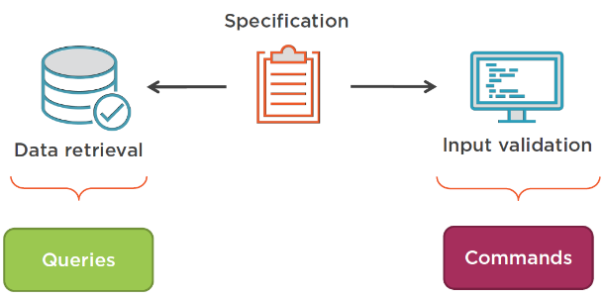

* Specification pattern allows us to encapsulate a piece of domain knowledge into a single place and then reuse them in 3 scenarios : data-retrieval, user input validation and creation of a new object.
* At the same time, the CQRS propose the separation of the data-retrieval and user input validation objects. Validation belongs to the commands side (write-side) and data-retrieval to the read-side, and may have totally other models.

So there is a big contradiction, because the Specification pattern propagates a “Single domain model”, as the CQRS pattern propagates a separate model for reads and writes !

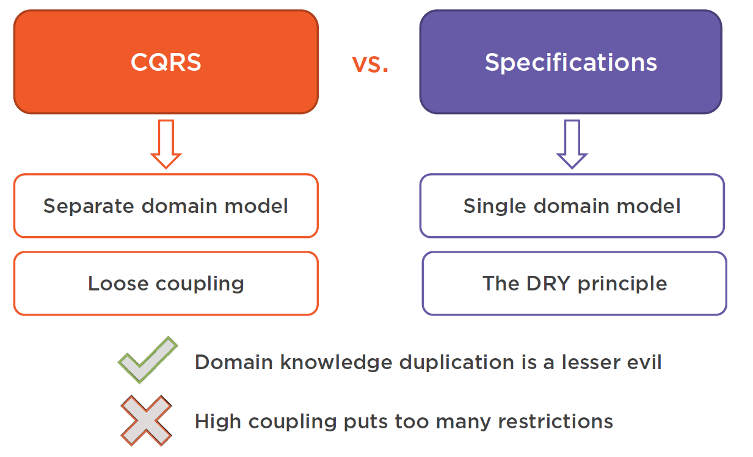

This is the difference about applying the DRY[9] principle (Specification pattern) and loosely coupling principle (CQRS).

# Course Summary

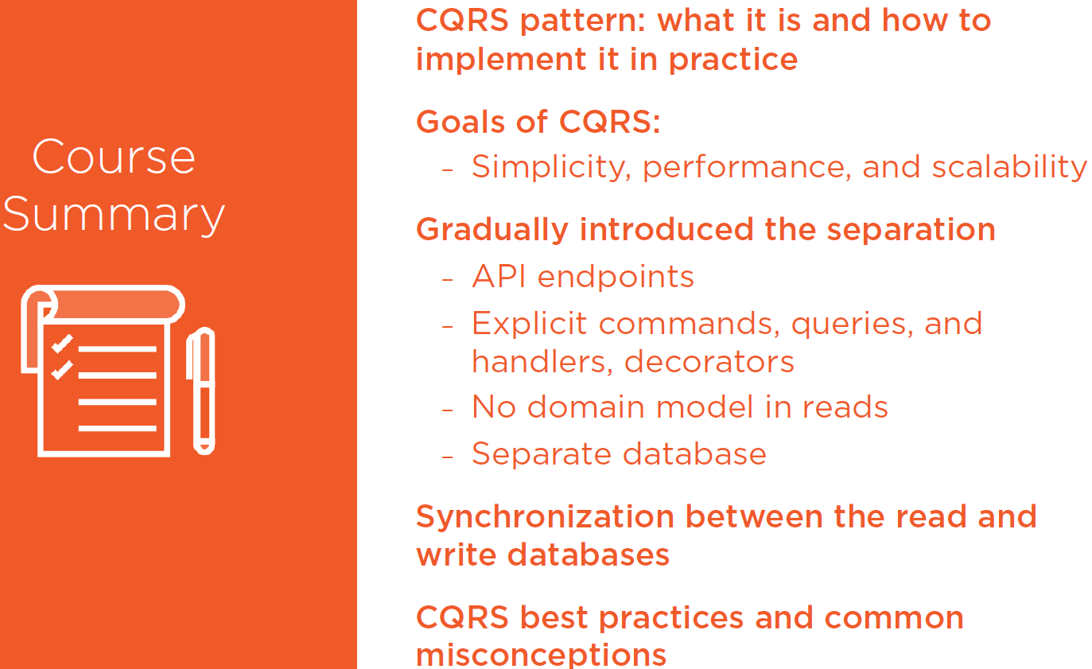

# Appendix A : Brief Introduction to MVVM Architecture Pattern

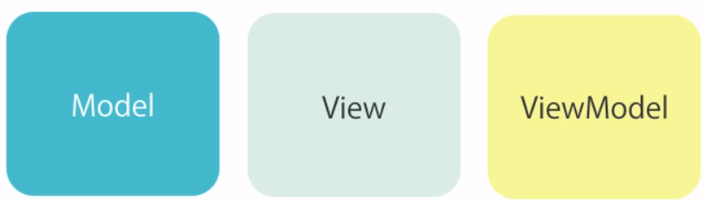

MVVM stands for Model-View-ViewModel and it is an architectural pattern for implementing **user interfaces.**

It consists of **3 parts:**

* **Model**, which represents the business objects that encapsulate both the **data** and the **behavior** of the application domain.
* **View,** which is what the **user sees.** A page, a form, an MVC View, etc
* **ViewModel,** which is specifically **designed for the view.**  It is a class with properties that represent the **state** of the view and methods the implement the logic behind the view.

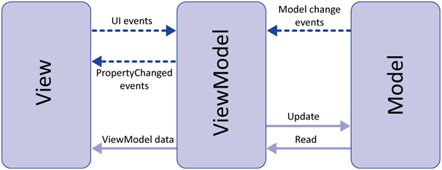

So the **ViewModel** is an intermediate between the **Model** and the **View.** Let’s have a look what this means for our **Student-Update-UI** view: (StudentView.cs)



|  |  |
| --- | --- |
|  | * Model:   + StudentDto * View:   + StudentView * ViewModel:   + StudentViewModel |

The **StudentView** represents the UI and has an instance of the **StudentViewModel** set as its **DataContext:**



For example, the “OK-Button” (which is the SaveButton) in the View is linked to the **OkCommand** of the corresponding **StudentViewModel:**



Finally the **StudentViewModel** has a property to represent the **OkCommand:**



The **OkCommand** get’s created when the Ctor get’s called:

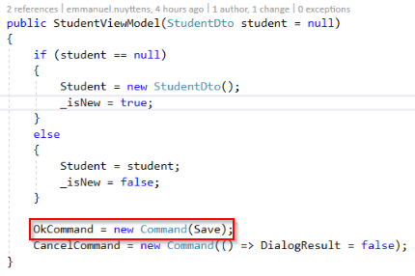

The command is wired to the **Save()** method of the ViewModel class:

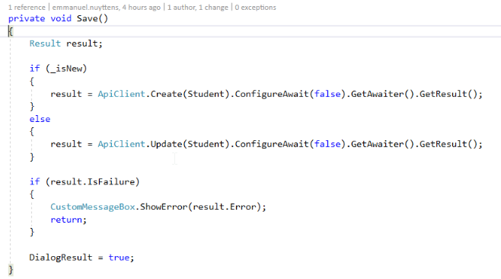

Here depending on the request, the API CREATE (New) or PUT (Update) will be called.

# Appendix B : WPF User Interface Explained

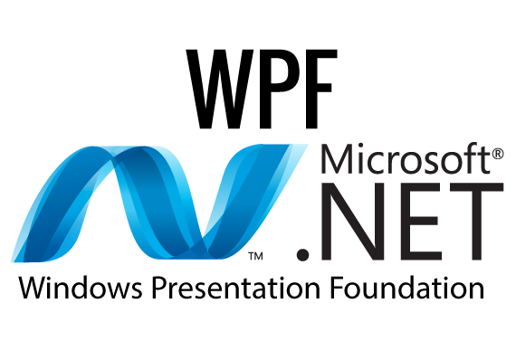

* We use a WPF[10] front-end for our UI. Next I’ll explain how this application is setup.

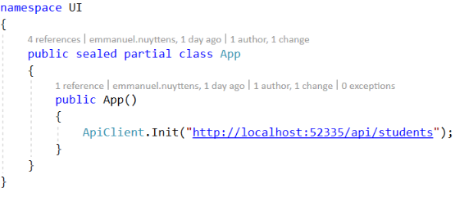

* The **App.xaml.cs** class is the startup class where we set the **URL** to the **backend API**. This file can be found in the **root** of the application.

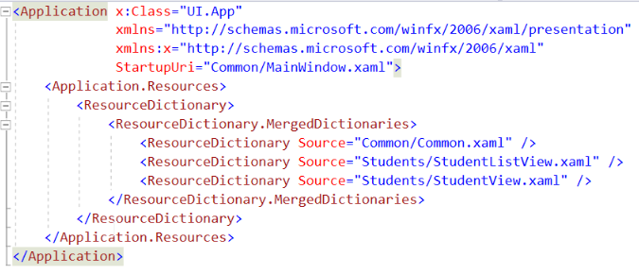

* The corresponding **App.xaml** stores the XAML code for the **startup** of the application. This refers to the **Common/MainWindow.xaml** file which contains the default startup window. **App.xaml** also contains a **ResourceDictionary** which points to all the **Views** of the application.

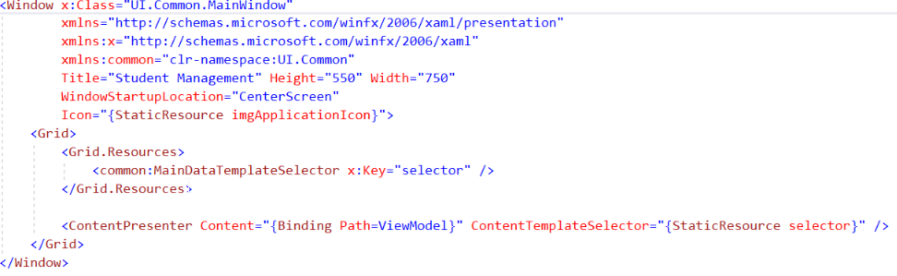

* The **Mainwindow.xaml** design file contains a binding to the **Common/ViewModel.cs** file

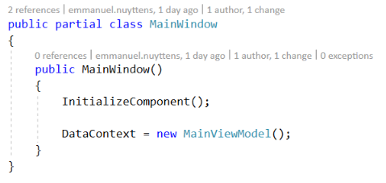

* The corresponding code file sets the **DataContext** of the MainWindow to an instance of the **Common/MainViewModel.**

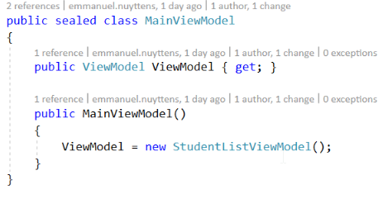

* And finally an instance of the startup view model, **Students/StudentListViewModel** in our case is created.

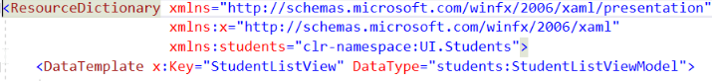

* StudentListView which has StudentListViewModel as it’s DataContext is startup.

# Appendix C : CQRS in Context of DDD

## Introduction

This reference is intended to provide some context for the main subject of this guide: a discussion of the Command Query Responsibility Segregation (CQRS) pattern.

It is useful to understand some of the origins of the CQRS pattern and some of the terminology you will encounter in this guide and in other material that discusses the CQRS pattern. It is particularly important to understand that the CQRS pattern is not intended for use as the top-level architecture of your system; rather, it should be applied to those subsystems that will gain specific benefits from the application of the pattern.

Before we look at the issues surrounding the use of different architectures within a complex application, we need to introduce some of the terminology that we will use in this chapter and subsequent chapters of this reference guide. Much of this terminology comes from an approach to developing software systems known as domain-driven design (DDD). There are a few important points to note about our use of this terminology:

• We are using the DDD terminology because many CQRS practitioners also use this terminology, and it is used in much of the existing CQRS literature.

• There are other approaches that tackle the same problems that DDD tackles, with similar concepts, but with their own specific terminologies.

• Using a DDD approach can lead naturally to an adoption of the CQRS pattern. However, the DDD approach does not always lead to the use of the CQRS pattern, nor is the DDD approach a prerequisite for using the CQRS pattern.

• You may question our interpretation of some of the concepts of DDD. The intention of this guide is to take what is useful from DDD to help us explain the CQRS pattern and related concepts, not to provide guidance on how to use the DDD approach.

## What is Domain Driven Design (DDD) ?

As previously stated, DDD is an approach to developing software systems, and in particular systems that are complex, that have everchanging business rules, and that you expect to last for the long term within the enterprise. The core of the DDD approach uses a set of techniques to analyze your domain and to construct a conceptual model that captures the results of that analysis. You can then use that model as the basis of your solution. The analysis and model in the DDD approach are especially well suited to designing solutions for large and complex domains. DDD also extends its influence to other aspects of the software development process as a part of the attempt to help you manage complexity:

• In focusing on the domain, DDD concentrates on the area where the business and the development team must be able to communicate with each other clearly, but where in practice they often misunderstand each other. The domain models that DDD uses should capture detailed, rich business knowledge, but should also be very close to the code that is actually written.

• Domain models are also useful in the longer term if they are kept up to date. By capturing valuable domain knowledge, they facilitate future maintenance and enhancement of the system.

• DDD offers guidance on how large problem domains can be effectively divided up, enabling multiple teams to work in parallel, and enabling you to direct appropriate resources to critical parts of the system with the greatest business value. The DDD approach is appropriate for large, complex systems that are expected to have a long lifespan. You are unlikely to see a return on your investment in DDD if you use it on small, simple, or short-term projects.

## Domain-driven design: concepts and terminology

This guide is not intended to provide guidance on using the DDD approach. However, it is useful to understand some of the concepts and terminology from DDD because they are useful when we describe some aspects of CQRS pattern implementations. These are not official or rigorous definitions; they are intended to be useful, working definitions for the purposes of this guide.

### Domain model

At the heart of DDD lies the concept of the domain model. This model is built by the team responsible for developing the system in question, and that team consists of both domain experts from the business and software developers. The domain model serves several functions:

• It captures all of the relevant domain knowledge from the domain experts.

• It enables the team to determine the scope and verify the consistency of that knowledge.

• The model is expressed in code by the developers.

• It is constantly maintained to reflect evolutionary changes in the domain.

DDD focuses on the domain because that’s where the business value is. An enterprise derives its competitive advantage and generates business value from its core domains. The role of the domain model is to capture what is valuable or unique to the business. Much of the DDD approach focuses on how to create, maintain, and use these domain models. Domain models are typically composed of elements such as entities, value objects, aggregates, and described using terms from a ubiquitous language.

### Ubiquitous language

The concept of a ubiquitous language is very closely related to that of the domain model.

One of the functions of the domain model is to foster a common understanding of the domain between the domain experts and the developers.

If both the domain experts and the developers use the same terms for objects and actions within the domain (for example, conference, chair, attendee, reserve, waitlist), the risk of confusion or misunderstanding is reduced.

More specifically, if everyone uses the same language, there are less likely to be misunderstandings resulting from translations between languages.

For example, if a developer has to think, “if the domain expert talks about a delegate, he is really talking about an attendee in the software,” then eventually something will go wrong as a result of this lack of clarity.

### Entities, value objects, and services

DDD uses the following terms to identify some of the internal artifacts (or building blocks, as Eric Evans calls them) that will make up the domain model.

* **Entities.**
  + Entities are objects that are defined by their identity, and that identity continues through time. For example, a conference in a conference management system will be an entity; many of its attributes could change over time (such as its status, size, and even name), but within the system each particular conference will have its own unique identity. The object that represents the conference may not always exist within the system’s memory; at times it may be persisted to a database, only to be re-instantiated at some point in the future.
* **Value Objects.**
  + Not all objects are defined by their identity. For some objects—value objects—what is important are the values of their attributes. For example, within our conference management system we do not need to assign an identity to every attendee’s address (one reason is that all of the attendees from a particular organization may share the same address). All we are concerned with are the values of the attributes of an address: street, city, state, and so on. Value objects are usually immutable.
* **Services.**
  + You cannot always model everything as an object. For example, in the conference management system it may make sense to model a third-party payment processing system as a service. The system can pass the parameters required by the payment processing service and then receive a result back from the service. Notice that a common characteristic of a service is that it is stateless (unlike entities and value objects).

|  |  |
| --- | --- |
|  | ***Important Note:***  *Services are usually implemented as regular class libraries that expose a collection of stateless methods. A service in a DDD domain model is not a web service; these are two different concepts.* |

### Aggregates and aggregate roots.

Whereas entities, value objects, and services are terms for the elements that DDD uses to describe things in the domain model, the terms aggregate and aggregate root relate specifically to the lifecycle and grouping of those elements. When you design a system that allows multiple users to work on shared data, you will have to evaluate the trade-off between consistency and usability. At one extreme, when a user needs to make a change to some data, you could lock the entire database to ensure that the change is consistent. However, the system would be unusable for all other users for the duration of the update. At the other extreme, you could decide not to enforce any locks at all, allowing any user to edit any piece of data at any time, but you would soon end up with inconsistent or corrupt data within the system. Choosing the correct granularity for locking to balance the demands of consistency and usability requires detailed knowledge of the domain:

* You need to know which set of entities and value objects each transaction can potentially affect. For example, are there transactions in the system that can update attendee, conference, and room objects?
* You need to know how far the relationships from one object extend through other entities and value objects within the domain, and where you must define the consistency boundaries. For example, if you delete a room object, should you also delete a projector object, or a set of attendee objects?

DDD uses the term aggregate to define a cluster of related entities and value objects that form a consistency boundary within the system. That consistency boundary is usually based on transactional consistency. An aggregate root (also known as a root entity) is the gatekeeper object for the aggregate. All access to the objects within the aggregate must occur through the aggregate root; external entities are only permitted to hold a reference to the aggregate root, and all invariants should be checked by the aggregate root. In summary, aggregates are the mechanism that DDD uses to manage the complex set of relationships that typically exist between the many entities and value objects in a typical domain model.

### Bounded contexts

So far, the DDD concepts and terminology that we have briefly introduced are related to creating, maintaining, and using a domain model. For a large system, it may not be practical to maintain a single domain model; the size and complexity make it difficult to keep it coherent and consistent. To manage this scenario, DDD introduces the concepts of bounded contexts and multiple models. Within a system, you might choose to use multiple smaller models rather than a single large model, each one focusing on some aspect or grouping of functionality within the overall system. A bounded context is the context for one particular domain model. Similarly, each bounded context (if implemented following the DDD approach) has its own ubiquitous language, or at least its own dialect of the domain’s ubiquitous language.

### Anti-corruption layers

Different bounded contexts have different domain models. When your bounded contexts communicate with each other, you need to ensure that concepts specific to one domain model do not leak into another domain model.

An anti-corruption layer functions as a gatekeeper between bounded contexts and helps you keep your domain models clean.

### Context maps

A large complex system can have multiple bounded contexts that interact with one another in various ways.

A context map is the documentation that describes the relationships between these bounded contexts. It might be in the form of diagrams, tables, or text.

A context map helps you visualize the system at a high level, showing how some of the key parts relate to each other. It also helps to clarify the boundaries between the bounded contexts. It shows where and how the bounded contexts exchange and share data, and where you must translate data as it moves from one domain model to another.

A business entity, such as a customer, might exist in several bounded contexts. However, it may need to expose different facets or properties that are relevant to a particular bounded context.

As a customer entity moves from one bounded context to another you may need to translate it so that it exposes the relevant facets or properties for its current context.

### Bounded contexts and multiple architectures

A bounded context typically represents a slice of the overall system with clearly defined boundaries separating it from other bounded contexts within the system.

If a bounded context is implemented by following the DDD approach, the bounded context will have its own domain model and its own ubiquitous language.

Bounded contexts are also typically vertical slices through the system, so the implementation of a bounded context will include everything from the data store, right up to the UI.

The same domain concept can exist in multiple bounded contexts. For example, the concept of an attendee in a conference management system might exist in the bounded context that deals with bookings, in the bounded context that deals with badge printing, and in the bounded context that deals with hotel reservations. From the perspective of the domain expert, these different versions of the attendee may require different behaviors and attributes.

For example, in the bookings bounded context the attendee is associated with a registrant who makes the bookings and payments. Information about the registrant is not relevant in the hotel reservations bounded context, where information such as dietary requirements or smoking preferences is important.

One important consequence of this split is that you can use different implementation architectures in different bounded contexts. For example, one bounded context might be implemented using a DDD layered architecture, another might use a two-tier CRUD architecture, and another might use an architecture derived from the CQRS pattern.

Figure below illustrates a system with multiple bounded contexts, each using a different architectural style. It also highlights that each bounded context is typically end-to-end, from the persistence store through to the UI.

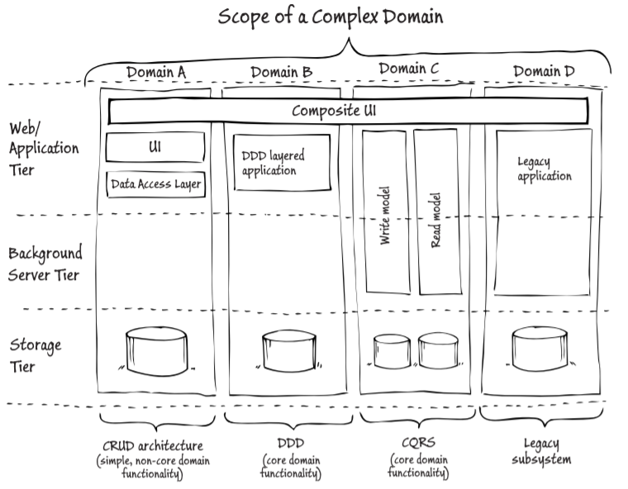

In addition to managing complexity, there is another benefit of dividing the system into bounded contexts.

You can use an appropriate technical architecture for different parts of the system to address the specific characteristics of each part.

For example, you can address such questions as whether it is a complex part of the system, whether it contains core domain functionality, and what is its expected lifetime.

### Bounded contexts and multiple development teams

Clearly separating out the different bounded contexts, and working with separate domain models and ubiquitous languages also makes it possible to parallelize the development work by using separate teams for each bounded context.

This relates to the idea of using different technical architectures for different bounded contexts because the different development teams might have different skill sets and skill levels.

### Maintaining multiple bounded contexts

Although bounded contexts help to manage the complexity of large systems because they’re divided into more manageable pieces, it is unlikely that each bounded context will exist in isolation.

Bounded contexts will need to exchange data with each other, and this exchange of data will be complicated if you need to translate between the different definitions of the same elements in the different domain models.

In our conference management system, we may need to move information about attendees between the bounded contexts that deal with conference bookings, badge printing, and hotel reservations.

The DDD approach offers a number of approaches for handling the interactions between multiple models in multiple bounded contexts such as using anti-corruption layers, or using shared kernels.

|  |  |
| --- | --- |
|  | ***Important Note:***  *At the technical implementation level, communication between bounded contexts is often handled asynchronously using events and a messaging infrastructure.* |

## CQRS and DDD

Many of the ideas that informed the CQRS pattern arose from issues that DDD practitioners faced when applying the DDD approach to real-world problems.

As such, if you decide to use the DDD approach, you may find that the CQRS pattern is a very natural fit for some of the bounded contexts that you identify within your system, and that it’s relatively straightforward to move from your domain model to the physical implementation of the CQRS pattern.

Some experts consider the DDD approach to be an essential prerequisite for implementing the CQRS pattern.

However, many people can point to projects where they have seen real benefits from implementing the CQRS pattern while not using the DDD approach for the domain analysis and model design.

In summary, the DDD approach is not a prerequisite for implementing the CQRS pattern, but in practice they do often go together.

# Appendix D : Introducing the Command Query Responsibility Segregation Pattern

## What is CQRS ?

CQRS is based on the principles of CQS (Command Query Separation) which describes the principle that an object’s methods should be either commands or queries.

A query returns data and does not alter the state of the object; a command changes the state of an object but does not return any data.

The benefit is that you have a better understanding what does, and what does not, change the state in your system.

CQRS takes this principle a step further to define a simple pattern. What is important and interesting about this simple pattern is how, where, and why you use it when you build enterprise systems.

Using this simple pattern enables you to meet a wide range of architectural challenges, such as achieving scalability, managing complexity, and managing changing business rules in some portions of your system.

|  |  |
| --- | --- |
|  | ***Note:***  *“CQRS is a simple pattern that strictly segregates the responsibility of handling command input into an autonomous system from the responsibility of handling side-effect-free query/read access on the same system. Consequently, the decoupling allows for any number of homogeneous or heterogeneous query/read modules to be paired with a command processor. This principle presents a very suitable foundation for event sourcing, eventual-consistency state replication/fan-out and, thus, high-scale read access. In simple terms, you don’t service queries via the same module of a service that you process commands through. In REST terminology, GET requests wire up to a different thing from what PUT, POST, and DELETE requests wire up to.”* |

## Read and Write Sides

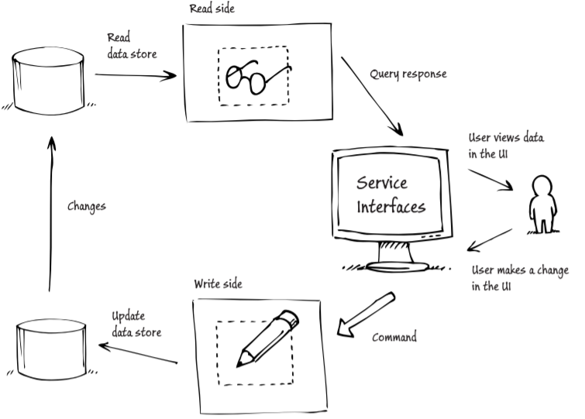

The figure above shows a typical application of the CQRS pattern to a portion of an enterprise system. This approach shows how, when you apply the CQRS pattern, you can separate the read and write sides in this portion of the system.

The object or objects or the read side contain only query methods, and the objects on the write side contain only command methods. There are several motivations for this segregation including:

* + - In many business systems, there is a large imbalance between the number of reads and the number of writes. A system may process thousands of reads for every write. Segregating the two sides enables you to optimize them independently. For example, you can scale out the read side to support the larger number of read operations independently of the write side.
    - Typically, commands involve complex business logic to ensure that the system writes correct and consistent data to the data store. Read operations are often much simpler than write operations. A single conceptual model that tries to encapsulate both read and write operations may do neither well. Segregating the two sides ultimately results in simpler, more maintainable, and more flexible models.
    - Segregation can also occur at the data store level. The write side may use a database schema that is close to third normal form (3NF) and optimized for data modifications, while the read side uses a denormalized database that is optimized for fast query operations.

|  |  |
| --- | --- |
|  | ***Important Note:***  *Although Figure above shows two data stores, applying the CQRS pattern does not mandate that you split the data store, or that you use any particular persistence technology such as a relational database, NoSQL store, or event store (which in turn could be implemented on top of a relational database, NoSQL store, file storage, blob storage and so forth.). You should view CQRS as a pattern that facilitates splitting the data store and enabling you to select from a range of storage mechanisms.* |

There are some questions that might occur to you about the practicalities of adopting architecture such as the one shown in the figure above.

• Although the individual models on the read side and write side might be simpler than a single compound model, the overall architecture is more complex than a traditional approach with a single model and a single data store. So, haven’t we just shifted the complexity?

• How should we manage the propagation of changes in the data store on the write side to the read side?

• What if there is a delay while the updates on the write side are propagated to the read side?

• What exactly do we mean when we talk about models?

## CQRS and domain-driven design

The reasons for identifying context boundaries for your domain models are not necessarily the same reasons for choosing the portions of the system that should use the CQRS pattern.

In DDD, a bounded context defines the context for a model and the scope of a ubiquitous language.

You should implement the CQRS pattern to gain certain benefits for your application such as scalability, simplicity, and maintainability. Because of these differences, it may make sense to think about applying the CQRS pattern to business components rather than bounded contexts.

In summary, you should not apply the CQRS pattern to the top level of your system. You should clearly identify the different portions of your system that you can design and implement largely independently of each other, and then only apply the CQRS pattern to those portions where there are clear business benefits in doing so.

## Introducing commands, events, and messages

DDD is an analysis and design approach that encourages you to use models and a ubiquitous language to bridge the gap between the business and the development team by fostering a common understanding of the domain.

Of necessity, the DDD approach is oriented towards analyzing behavior rather than just data in the business domain, and this leads to a focus on modeling and implementing behavior in the software.

A natural way to implement the domain model in code is to use commands and events. This is particularly true of applications that use a task-oriented UI.

|  |  |
| --- | --- |
|  | ***Important Note:***  *DDD is not the only approach in which it is common to see tasks and behaviors specified in the domain model implemented using commands and events. However, many advocates of the CQRS pattern are also strongly influenced by the DDD approach so it is common to see DDD terminology in use whenever there is a discussion of the CQRS pattern.* |

### Important difference between commands and events

**Commands are imperatives;** they are requests for the system to perform a task or action. For example, “book two places for conference X” or “allocate speaker Y to room Z.” Commands are usually processed just once, by a single recipient.

**Events are notifications;** they report something that has already happened to other interested parties. For example, “the customer’s credit card has been billed $200” or “ten seats have been booked for conference X.” Events can be processed multiple times, by multiple consumers.

Both commands and events are types of message that are used to exchange data between objects. In DDD terms, these messages represent business behaviors and therefore help the system capture the business intent behind the message.

### Separate data stores for the read and for the write side

A possible implementation of the CQRS pattern uses separate data stores for the read side and the write side; each data store is optimized for the use cases it supports.

Events provide the basis of a mechanism for synchronizing the changes on the write side (that result from processing commands) with the read side.

If the write side raises an event whenever the state of the application changes, the read side should respond to that event and update the data that is used by its queries and views.

The image below shows how commands and events can be used if you implement the CQRS pattern.

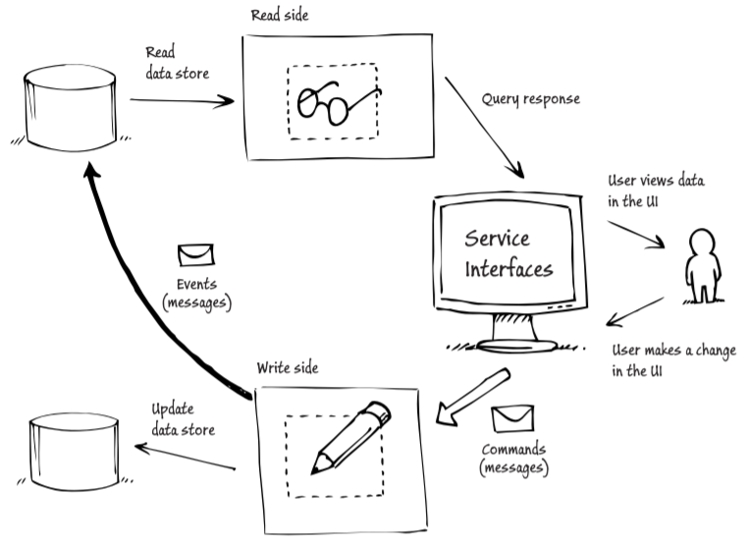

## Why should we use CQRS ?

Stepping back from CQRS for a moment, one of the benefits of dividing the domain into bounded contexts in DDD is to enable you to identify and focus on those portions (bounded contexts) of the system that are more complex, subject to ever-changing business rules, or deliver functionality that is a key business differentiator.

You should consider applying the CQRS pattern within a specific bounded context only if it provides identifiable business benefits, not because it is the default pattern that you consider.

The most common business benefits that you might gain from applying the CQRS pattern are enhanced **scalability**, the **simplification** of a complex aspect of your domain, increased flexibility of your solution, and **greater adaptability** to changing business requirements.

### Scalability

In many enterprise systems, the number of reads vastly exceeds the number of writes, so your scalability requirements will be different for each side.

By separating the read side and the write side into separate models within the bounded context, you now have the ability to scale each one of them independently.

For example, if you are hosting applications in Windows Azure, you can use a different role for each side and then scale them independently by adding a different number of role instances to each.

|  |  |
| --- | --- |
|  | ***Important Note:***  *Scalability should not be the only reason why you choose to implement the CQRS pattern in a specific bounded context: “In a non-collaborative domain, where you can horizontally add more database servers to support more users, requests, and data at the same time you’re adding web servers, there is no real scalability problem (until you’re the size of Amazon, Google, or Facebook). Database servers can be cheap if you’re using MySQL, SQL Server Express, or others.”* |

### Reduced complexity

In complex areas of your domain, designing and implementing objects that are responsible for both reading and writing data can exacerbate the complexity.

In many cases, the complex business logic is only applied when the system is handling updates and transactional operations; in comparison, read logic is often much simpler.

When the business logic and read logic are mixed together in the same model, it becomes much harder to deal with difficult issues such as multiple users, shared data, performance, transactions, consistency, and stale data.

Separating the read logic and business logic into separate models makes it easier to separate out and address these complex issues.

However, in many cases it may require some effort to disentangle and understand the existing model in the domain. Like many patterns, you can view the CQRS pattern as a mechanism for shifting some of the complexity inherent in your domain into something that is well known, well understood, and that offers a standard approach to solving certain categories of problems.

Another potential benefit of simplifying the bounded context by separating out the read logic and the business logic is that it can make testing easier.

### Flexibility

The flexibility of a solution that uses the CQRS pattern largely derives from the separation into the read-side and the write-side models.

It becomes much easier to make changes on the read side, such as adding a new query to support a new report screen in the UI, when you can be confident that you won’t have any impact on the behavior of the business logic.

On the write side, having a model that concerns itself solely with the core business logic in the domain means that you have a simpler model to deal with than a model that includes read logic as well. In the longer term, a good, useful model that accurately describes your core domain business logic will become a valuable asset.

It will enable you to be more agile in the face of a changing business environment and competitive pressures on your organization. This flexibility and agility relates to the concept of continuous integration in DDD: In some cases, it may be possible to have different development teams working on the write side and the read side, although in practice this will probably depend on how large the particular bounded context is.

### Focus on the business

If you use an approach like CRUD, then the technology tends to shape the solution. Adopting the CQRS pattern helps you to focus on the business and build task-oriented UIs.

A consequence of separating the different concerns into the read side and the write side is a solution that is more adaptable in the face of changing business requirements.

This results in lower development and maintenance costs in the longer term.

### Facilitates building task-based UIs

When you implement the CQRS pattern, you use commands (often from the UI), to initiate operations in the domain.

These commands are typically closely tied to the domain operations and the ubiquitous language. For example, “book two seats for conference X.”

You can design your UI to send these commands to the domain instead of initiating CRUD-style operations. This makes it easier to design intuitive, task-based UIs.

### Barriers to adopting the CQRS pattern

Although you can list a number of clear benefits to adopting the CQRS pattern in specific scenarios, you may find it difficult in practice to convince your stakeholders that these benefits warrant the additional complexity of the solution.

### When should I use CQRS?

Although we have outlined some of the reasons why you might decide to apply the CQRS pattern to some of the bounded contexts in your system, it is helpful to have some rules of thumb to help identify the bounded contexts that might benefit from applying the CQRS pattern.

In general, applying the CQRS pattern may provide the most value in those bounded contexts that are collaborative, complex, include ever-changing business rules, and deliver a significant competitive advantage to the business. Analyzing the business requirements, building a useful model, expressing it in code, and implementing it using the CQRS pattern for such a bounded context all take time and cost money.

You should expect this investment to pay dividends in the medium to long term. It is probably not worth making this investment if you don’t expect to see returns such as increased adaptability and flexibility in the system, or reduced maintenance costs.

### When should I avoid CQRS?

Simple, static, non-core bounded contexts are less likely to warrant the up-front investment in detailed analysis, modeling, and complex implementation.

Again, non-collaborative bounded contexts are less likely to see benefits from applying the CQRS pattern. In most systems, the majority of bounded contexts will probably not benefit from using the CQRS pattern.

You should only use the pattern when you can identify clear business benefits from doing so.

### Summary

The CQRS pattern is an enabler for building individual portions (bounded contexts) in your system. Identifying where to use the CQRS pattern requires you to analyze the trade-offs between the initial cost and overhead of implementing the pattern and the future business benefits.

Useful heuristics for identifying where you might apply the CQRS pattern are to look for components that are complex, involve fluid business rules, deliver competitive advantage to the business, and are collaborative.

The next chapters will discuss how to implement the CQRS pattern in more detail. For example, we’ll explain specific class-pattern implementations, explore how to synchronize the data between the write side and read side, and describe different options for storing data.

1. Command Query Responsibility Segregation
2. Single ResPonsibility
3. Windows Presentation Foundation
4. Object Oriented Design
5. Data Transfer Object
6. The other 2 pillars of DDD are Bound-Context and Core-Domain
7. Model View ViewModel
8. Data Transfer Object
9. Don’t repeat yourself
10. Windows Presentation Foundation